Series and Parallel Circuits Basics

Name:_____________________________________________

Part 1: Exploration

Directions:
- Log on to your computer
- Go to the following website: https://phet.colorado.edu/en/simulation/legacy/circuit-construction-kit-dc
- Click the button that says “Download”
- Save the Simulation to your school folder (the simulation may already be saved to the school computers, you can look on the desktop for the link)
- Open the simulation

You now have the raw material to create a circuit. Take a moment to look over the site and find all the different materials. To build a circuit you will need several wires, a light bulb, battery (voltage source), a voltmeter, and a non – contact ammeter. Play and explore with it to see how to grab and manipulate these tools.
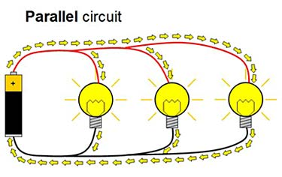
Then, click the reset button.

Part 2: Series Circuits

Directions: Build a simple series circuit (or path) similar to the picture above that consists of 6 pieces of wire, 1 light bulb, and 1 battery (voltage source). In order to complete the circuit, the red circles at the end of each must overlap. Please note that the light bulb also has TWO circles. Your circuit is complete and working when the light comes on and the blue dots begin moving.

Draw a picture of your circuit here.

Use the tools at the side to get a voltmeter and a non-contact ammeter. Put the voltmeter near the battery and place the red tab at one end and the black at the other.

What is the voltage? __________

Place the non-contact ammeter over the moving blue dots. What is the reading? _______

Helpful Information: Voltage is a measure of energy or push for each blue circle (electrons), and amps is a measure of how fast the blue circles (electrons) are moving or flowing. Resistance and resistivity is a measure of how hard it is for the blue circles (electrons) to move through the circuit or path.

Directions: Right click on the battery and then click “change voltage”. Change the voltage for the battery and make observations on how this changes the readings on the voltmeter and ammeter. Record your observations below. Be sure to record the changes you made and then the effects.

Right click on the battery and then click “change internal resistance”. Change the resistance for the battery and make observations on how this changes the readings on the voltmeter and ammeter. Record your observations below. Be sure to record the changes you made and then the effects.

Click the advanced tab and alter the resistivity of the wire. Record your observations.

Raise your hand and let your teacher check off your working series circuit.
Click the reset button to begin working on Part 3.

Part 3: Parallel Circuits

Parallel circuits provide more than one path for electrons to move.

Directions: Create a parallel circuit using 12 wires, 3 light bulbs and 1 battery (voltage source) with the simulator tool, similar the picture above. The blue dots will be moving through all the light bulbs and all the lights will be lit up once the circuit is complete. Raise your hand so that your teacher can check off your parallel circuit.

Use the tools at the side to get a voltmeter and a non-contact ammeter. Put the voltmeter near the battery and place the red tab at one end and the black at the other.

What is the voltage? __________

Place the non-contact ammeter over the moving blue dots near a lightbulb. What is the reading? __

How does this compare with your observations in the series circuit?

Is this surprising? WHY or WHY NOT?

Right click on the battery and then click “change voltage”. Change the voltage for the battery and make observations on how this changes the readings on the voltmeter and ammeter. Record your observations below. Be sure to record the changes you made and then the effects.

Right click on the battery and then click “change internal resistance”. Change the resistance for the battery and make observations on how this changes the readings on the voltmeter and ammeter. Record your observations below. Be sure to record the changes you made and then the effects.

Now right click on one of the wires connected to a light bulb. Remove the wire and record your observations.

Does this affect the voltage, amps, or visually change the appearance of the light bulb?

Replace the wire. Now remove one of the wires touching the battery (voltage source). What happened?

What is the difference between removing the first wire and the second? Why is this significant?

Replace the wire.

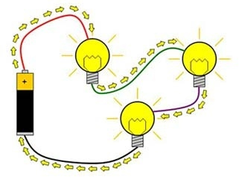

Part 4: Comparing Series and Parallel Circuits

Directions: Create a second series circuit (similar to the picture above and next to the parallel circuit from Part 3) that has 3 light bulbs in one continuous path and record your observations about the two (series circuit and parallel circuit) once they are side by side.

Review Questions:

- In which circuit (series or parallel) did all the electrons or blue dots move through all the objects?
  - Did this circuit have brighter or less bright light bulbs?
  - Did this circuit have higher or lower voltages?
  - Did this circuit have higher or lower amps?
- In which circuit (series or parallel) did some of the electrons or blue dots split up among the different light bulbs?
  - Did this circuit have brighter or less bright light bulbs?
  - Did this circuit have higher or lower voltages?
  - Did this circuit have higher or lower amps?

Part 5: Extra Credit

Directions: You may use the tools to explore. Create a circuit using a switch. Diagram your circuit below and show your working circuit to the teacher to receive extra credit points.

Record any observations below.

Directions: Use the tools to explore. How can you cause a fire to occur in the circuit?

