Name________________________________________
DC Series and Parallel Circuit Online Lab
PhET http://phet.colorado.edu/en/simulation/circuit-construction-kit-dc

- This lab is to be printed out and handed in.
- Click on the PhET link above and create an account.
- Click play on the video to access the lab.

Part 1 – Series Circuits
First draw a schematic diagram of a 10 Ω, 20 Ω, and 50 Ω light bulb in series with a 30 volt battery.

Calculate the total resistance.

R_{T} = __________

Draw the reduced equivalent circuit here.

Calculate the total current in the circuit.

I_{T} = ___________

What are the currents through each resistor?

I₁ = ___________

I₂ = ___________

I₃ = ___________

Calculate the voltage drops.

V₁ = __________

V₂ = __________

V₃ = __________

Create the above circuit on the PhET website. Check the voltage drops with the voltmeter and check the current with the non-contact ammeter.

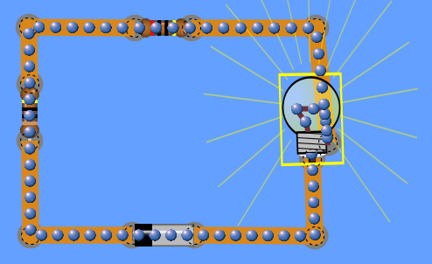

How did your predictions compare with the answers from PhET?

Now right click on one of the resistors. Here you can change the resistance. Change the voltage of each resistor. You can repeat this with the battery to change the voltage. What do you need to do to get the light bulb to glow the brightest?

What do you need to do to get the light bulb to glow the dimmest?

Part 2 – Parallel Circuits
First draw a schematic diagram of a 10 Ω, 20 Ω, and 50 Ω light bulb in parallel with a 30 volt battery.

Calculate the total resistance.

R_{T} = ___________

Draw the reduced equivalent circuit here.

What are the voltages through each resistor?

V₁ = ___________

V₂ = ___________

V₃ = ___________

Calculate the total current in the circuit.

I_{T} = ___________

Calculate the current through each resistor.

I₁ = __________

I₂ = __________

I₃ = __________

Create the above circuit on the PhET website. Check the current and voltages with the voltmeter and check the current with the non-contact ammeter.

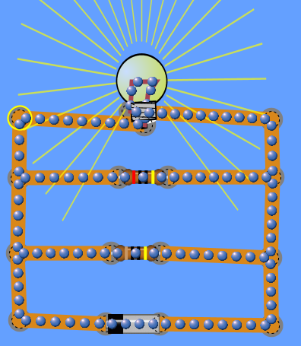

How did your predictions compare with the answers from PhET?

Now right click on one of the resistors. Here you can change the resistance. Change the voltage of each resistor. You can repeat this with the battery to change the voltage. What do you need to do to get the light bulb to glow the brightest?

What do you need to do to get the light bulb to glow the dimmest?

Change the resistance of the light bulb to 2 Ω. What happens? Explain.

