[…] A boat’s engine / vibrated through land, through waves, through my feet / into my torso. Slow – slowly moving, I stepped on.
JO SHAPCOTT, “La Serenissima”

WORK SHEET «ENERGY CHAINS»

◎
Class …………………, Date ……………………………………………
To deepen the correct vocabulary for energy:
Energy can be stored, can be transferred, can be conversed…

Group ……………………………………………………………………………
………………………………………………………………………………………

Step #1

From the PhET’s Simulations site, Run now! or Download “Energy Forms and Changes” simulation (see http://goo.gl/v3gklE ). Click the “Energy System” tab on the left and, on the right, tick the “Energy Symbols” indicator.

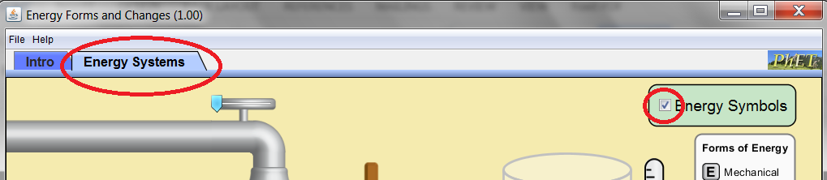

Step #2

From the three panels at the bottom of the simulation choose devices and construct a working Energy System, e.g.

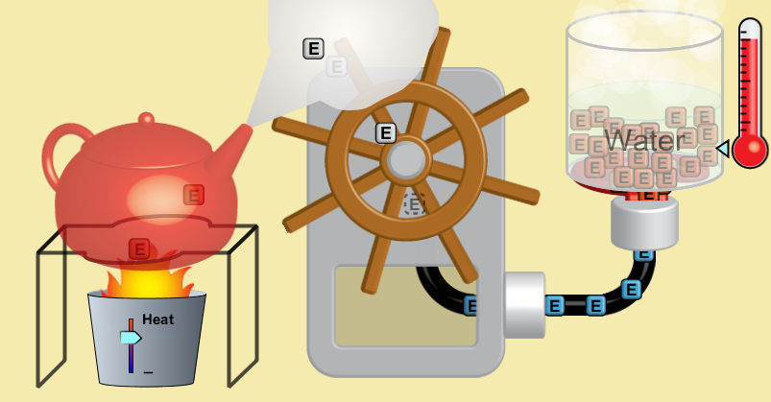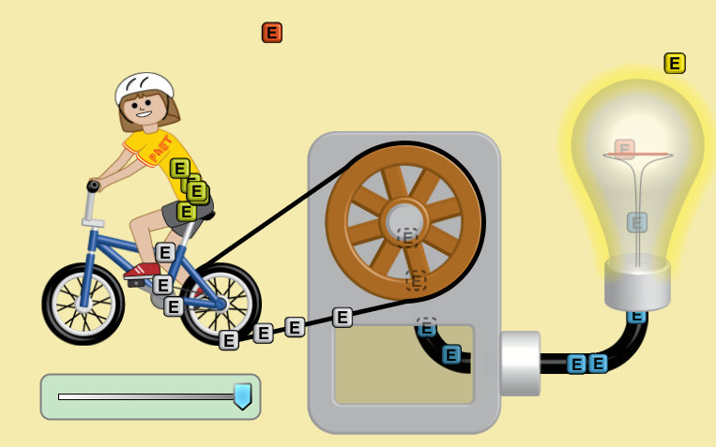

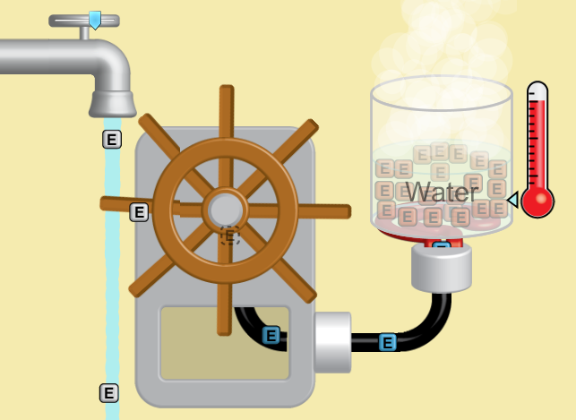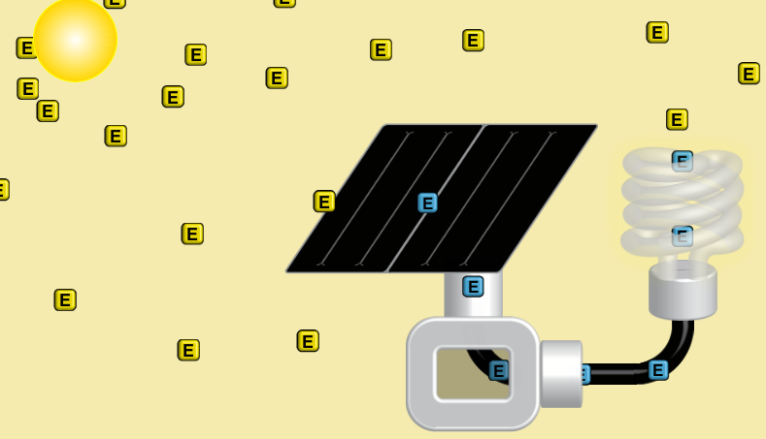

Step #3

Now, you’ll draw the Energy Chain for the Energy System you choose. The rules are:

1st . A complete energy chain starts and ends with a reservoir
2nd . In each indicate the corresponding object (or the objects) in the experiment
3rd . In each indicate the corresponding object (or the objects) in the experiment
4th . Under each arrow indicate the mode of transfer. If there are several modes of transfer use one arrow for each mode of transfer (between two rectangles).

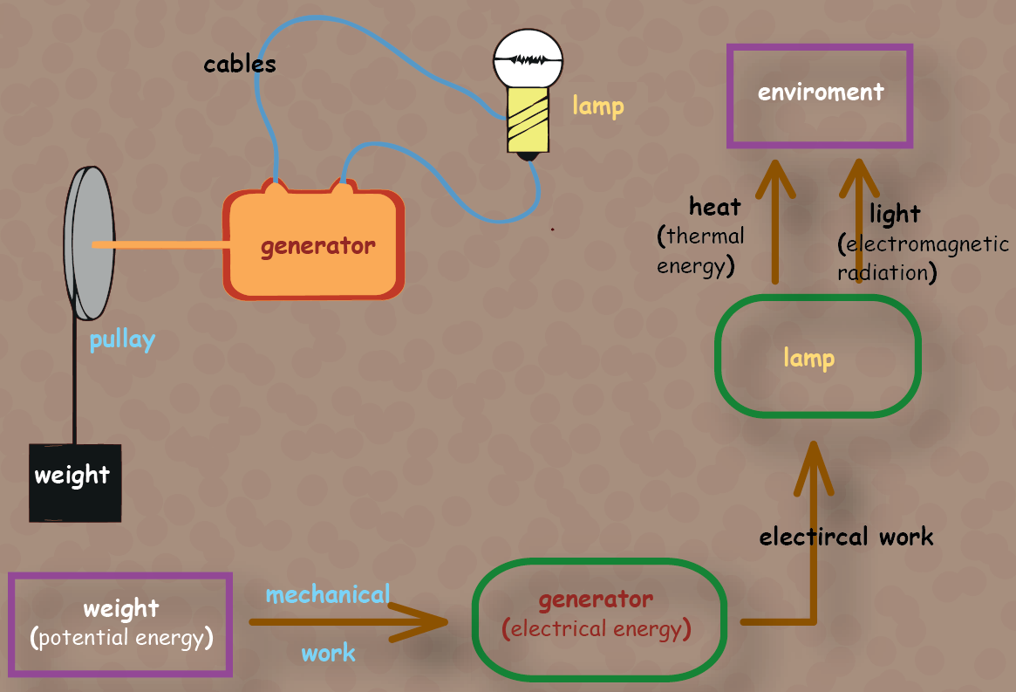
…for example:

Now you…

Final Step

Share, with the rest of the class, your Energy System and show your Energy Chain. Note the comments . . . . . . . . . . . . . . . . . . . . . . . . . . . . . . . . . . . . . . . . . . . . . . . . . . . . . . . . . . . . . . . . . . . . . . . . . . .

. . . . . . . . . . . . . . . . . . . . . . . . . . . . . . . . . . . . . . . . . . . . . . . . . . . . . . . . . . . . . . . . . . . . . . . . . . . . . . . . . . . . .

. . . . . . . . . . . . . . . . . . . . . . . . . . . . . . . . . . . . . . . . . . . . . . . . . . . . . . . . . . . . . . . . . . . . . . . . . . . . . . . . . . . . .

. . . . . . . . . . . . . . . . . . . . . . . . . . . . . . . . . . . . . . . . . . . . . . . . . . . . . . . . . . . . . . . . . . . . . . . . . . . . . . . . . . . . .

. . . . . . . . . . . . . . . . . . . . . . . . . . . . . . . . . . . . . . . . . . . . . . . . . . . . . . . . . . . . . . . . . . . . . . . . . . . . . . . . . . . . .

. . . . . . . . . . . . . . . . . . . . . . . . . . . . . . . . . . . . . . . . . . . . . . . . . . . . . . . . . . . . . . . . . . . . . . . . . . . . . . . . . . . . .

. . . . . . . . . . . . . . . . . . . . . . . . . . . . . . . . . . . . . . . . . . . . . . . . . . . . . . . . . . . . . . . . . . . . . . . . . . . . . . . . . . . . .

. . . . . . . . . . . . . . . . . . . . . . . . . . . . . . . . . . . . . . . . . . . . . . . . . . . . . . . . . . . . . . . . . . . . . . . . . . . . . . . . . . . . .

. . . . . . . . . . . . . . . . . . . . . . . . . . . . . . . . . . . . . . . . . . . . . . . . . . . . . . . . . . . . . . . . . . . . . . . . . . . . . . . . . . . . .

. . . . . . . . . . . . . . . . . . . . . . . . . . . . . . . . . . . . . . . . . . . . . . . . . . . . . . . . . . . . . . . . . . . . . . . . . . . . . . . . . . . . .

. . . . . . . . . . . . . . . . . . . . . . . . . . . . . . . . . . . . . . . . . . . . . . . . . . . . . . . . . . . . . . . . . . . . . . . . . . . . . . . . . . . . .

. . . . . . . . . . . . . . . . . . . . . . . . . . . . . . . . . . . . . . . . . . . . . . . . . . . . . . . . . . . . . . . . . . . . . . . . . . . . . . . . . . . . .

. . . . . . . . . . . . . . . . . . . . . . . . . . . . . . . . . . . . . . . . . . . . . . . . . . . . . . . . . . . . . . . . . . . . . . . . . . . . . . . . . . . . .

. . . . . . . . . . . . . . . . . . . . . . . . . . . . . . . . . . . . . . . . . . . . . . . . . . . . . . . . . . . . . . . . . . . . . . . . . . . . . . . . . . . . .

. . . . . . . . . . . . . . . . . . . . . . . . . . . . . . . . . . . . . . . . . . . . . . . . . . . . . . . . . . . . . . . . . . . . . . . . . . . . . . . . . . . . .

Work at home

1. From the PhET’s Simulations site, scroll down at “Energy Forms and Changes” simulation page (http://goo.gl/v3gklE) and pick one of the Related Simulations. Draw the Energy Chain for an Energy System you like. Alternatively, you can draw the Energy Chain for a “real life’s” physical phenomenon (boiling water, travelling with a car etc)

2. Answer the on-line questioner at http://......

Do see

• The poster for Energy at http://goo.gl/gFIqLF

• The infographic at http://visual.ly/wonderful-world-energy-infographic-design

