Building Fractions
Introductions:
In this activity you will investigate fractions by finding equivalent fractions using both pictures and numbers. You will first get a chance to explore the simulation at Level 1 to become familiar with the way the simulation works. Next, you will create a data table based on the investigations you complete at Level 4 on the build a fraction exploration and the mixed number exploration. From the data table, you will explain if it is possible to create equivalent fractions that have different denominators using your data as evidence. If you can create equivalent fractions with different denominators, explain why you think this is possible. Finally, you will prove your explanation by creating 3 equivalent fractions with different denominators.

1. Click this link: http://phet.colorado.edu/
This is a screen shot of the website:
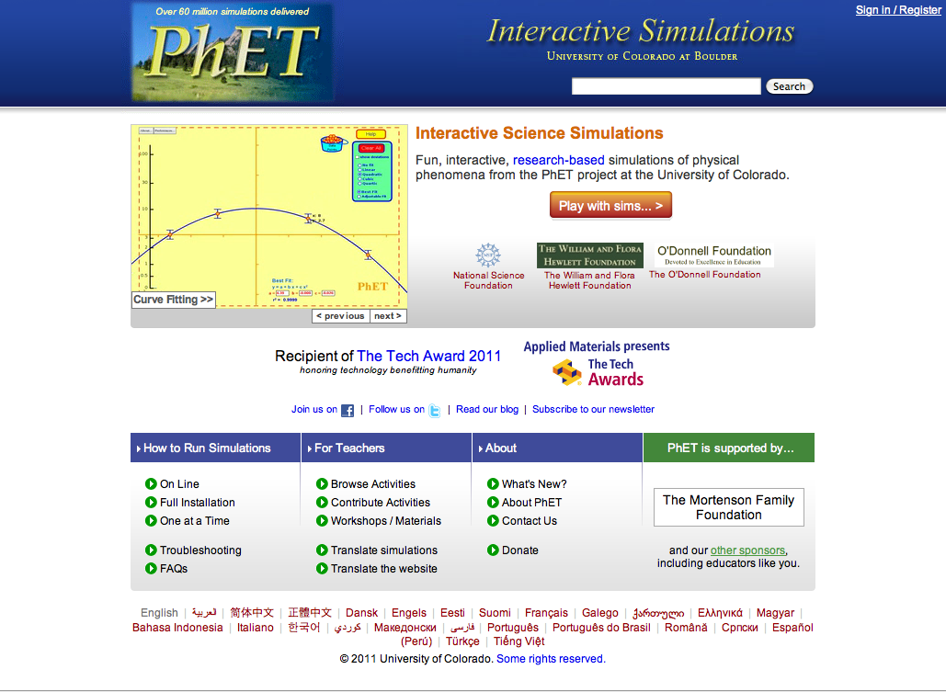

2. In the search bar type in: build a fraction
3. Click on Build a Fraction -> Click “Run Now!”
4. It will take time to load and then this screen appears:
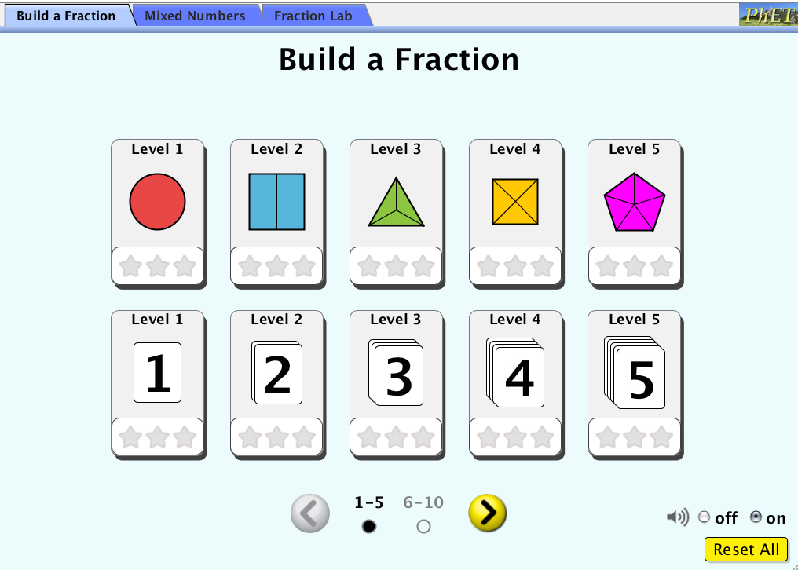
Switch between this document and the sim to complete the activity.
Exploration Phase:
1. Click the Level 1 box with the red circle

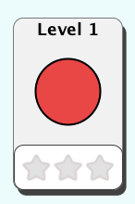

2. Look to the right of the sim. These are the fractions you will need to create.
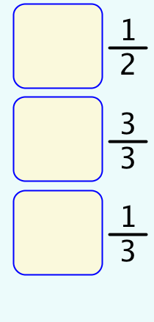
Look to the bottom of the sim. You will use the shaded pieces to shade in the box in the middle of the sim to create the fractions.
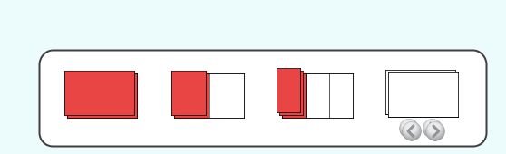
Look to the fractions and think, which shaded regions will give me the fraction I want. Move as many of those pieces as needed into the box in the middle of the sim, then over to the box next to the fraction on the right.

**You will know if your answer is correct when the box on the right accepts your fraction and dings!**

3. Play the sim!

4. Go back to the starting menu by clicking the link in the upper left hand corner.
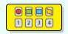

5. Repeat above steps after clicking the Level 1 box with the number 1.
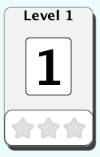

Explanation Phase:
Aim: Explain if it is possible to create equivalent fractions with different denominators. Then explain why this is possible.

1. Click back to the main screen by clicking the link in the upper left hand corner.
2. Click on level 4 with the yellow square.
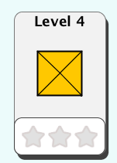
3. Create the fractions that you see on the right hand of the sim.

Look to the fractions and think, which shaded regions will give me the fraction I want. Move as many of those pieces as needed into the box in the middle of the sim, then over to the box next to the fraction on the right.

**You will know if your answer is correct when the box on the right accepts your fraction and dings!**

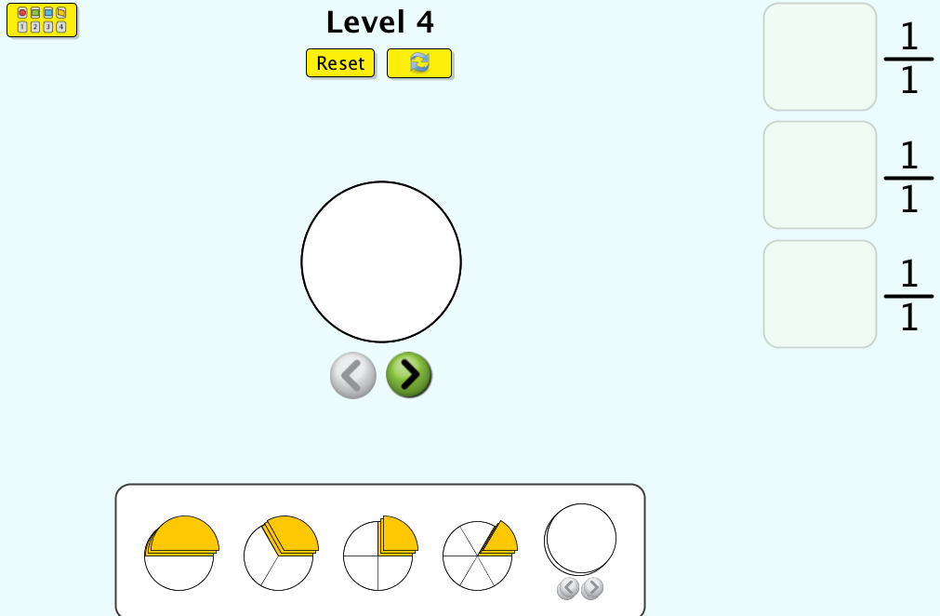

4. Record the 3 ways you were able to make the fraction 1/1 on the data table below.

5. Click back to the main screen by clicking the link in the upper left hand corner.
6. Click on the mixed number tab in the top of the sim.
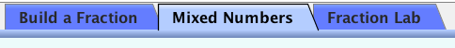

7. Click on level 4 with the two yellow squares.
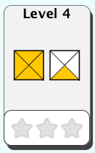
8. Record the 3 ways you were able to make the fraction 1 1/3 on the data table below.

Equivalent Fractions Data Table
Trial | Numerator | Denominator | Given Fraction
1 | 2 |  | 1/1
2 |  |  | 1/1
3 | 6 | 6 | 1/1
4 |  |  | 1 1/3
5 |  | 6 | 1 1/3
6 |  |  | 1 1/3

Come up with an explanation if it is possible to create equivalent fractions that have different denominators. If you can create equivalent fractions with different denominators, explain why this is possible.

Write here:

Application Phase:
Create your own equivalent fractions using the fractions outlines below. Use the table button to create 3 fractions equivalent for ½.
1. Click table -> insert table -> select the size -> table properties -> table -> borders and shading -> shading (to fill your table in!)

Example:
1/2 = 3/6

1.

-----------------------------------------------------------------------------------------------------------
2.

-----------------------------------------------------------------------------------------------------------
3.

-----------------------------------------------------------------------------------------------------------

Concluding Question:

How did you make your tables in the application section? Did you use a strategy?

