The relationship between volume and temperature. Answer the questions in COMPLETE sentences.
1. Start the PhET simulation on gases. Spend a MINUTE to explore the simulation. Play with it to see what it can do.

2. List 3 things that you can manipulate in the simulation. How do you control each one?
a.

b.

c.

3. Locate the reset button on the simulation and push it to return the screen to the original state. What does the pressure dial read? ___________

**Special note: For any mathematical work involving gases, temperatures MUST BE IN KELVIN! (K = ºC + 273)**
Set up the simulation as follows:
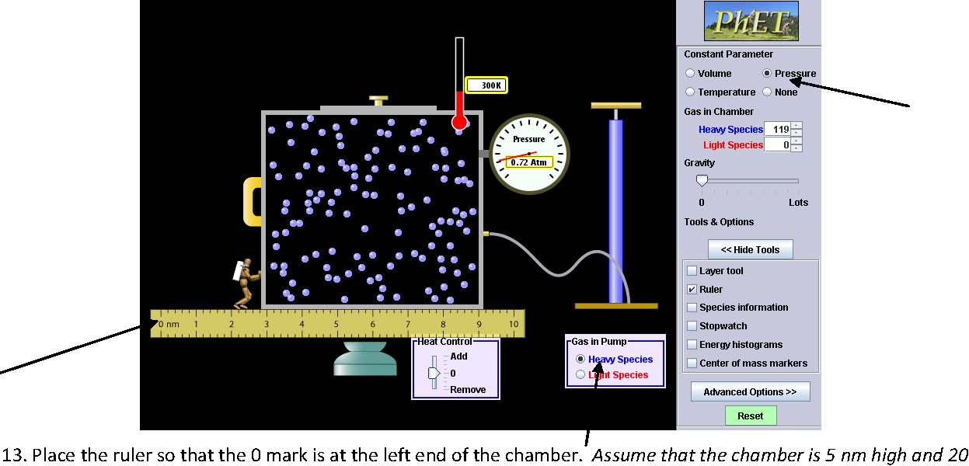
• Click the heavy species (blue) molecules button on the pump.
• Pump the handle twice and allow the pressure to stabilize.
• You want to increase the temperature to about 500 K.
• Click the “Pressure” button in the “Constant Parameter” control panel.
• Set Gravity to 0.
• Click the “Ruler” button in the “Tools” menu.

4. Place the ruler so that the 0 mark is at the left end of the chamber. Assume that the chamber is 5 nm high and 20 nm deep. What is the volume of the chamber? ________________(HINT---volum=length*width*height)

5. Record the temperature and volume of the chamber below. What is the stable pressure? ________atm

6. Manipulate the system by removing heat. In each case, record the temperature and reposition the ruler with the “0” mark on the left end of the chamber and measure the size of the chamber. Record the temperature and volume values for 7 different temperatures in the table below. Make sure the pressure is not changing.
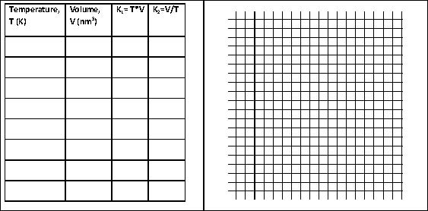7. Graph the results of your experiment with volume on the horizontal axis and temperature on the vertical axis. Sketch your graph above.

8. The k values represent a constant. This tells us about the relationship between the two variables. Find the values for k1 and k2 in the table. Which value remains the most consistent in the data table? k1 or k2

b. Describe the relationship (indirect or inverse) your graph represents. Be sure to use the variables and constant in your answer (note which is the manipulated and which is the responding variable). Your answer should contain the words temperature, volume, and pressure and provide a specific example from your data.

9. a. What is the mathematical relationship present between temperature and volume using either an equation with T₁, V₁ and T₂, V₂ or a proportional statement?

b. What would happen if the temperature is doubled? Mathematically, how could the quantity of volume be represented?

c. As the temperature gets colder and approaches 0 Kelvin, what happens to the volume of the gas and why do you think this is (HINT—make sure you discuss the average kinetic energy of the particles)?

d. The volume of a sample of gas is 2.00 L when the temperature is 284K. While the pressure remains constant, the temperature is changed to a new value, which causes the volume to become 3.00 L. What was the temperature changed to?

The relationship between pressure and volume.
Reset the simulation and set it up as follows:
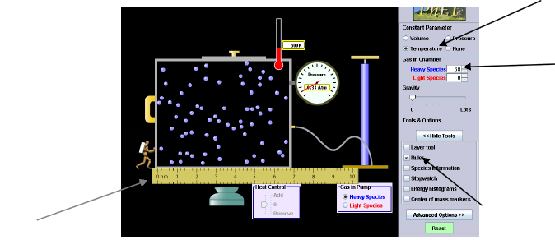
- Click the heavy species (blue) molecules button on the pump. Pump the handle once.
- Click the “Temperature” button in the “Constant Parameter” control panel.
- Be sure ‘Gravity’ is set to 0.
- Click the “Ruler” button in the “Tools” menu.
- Position the ruler on the bottom of the chamber so that the “0 nm” mark is aligned with the left end of the chamber. Your screen should look like this:

1. Manipulate the system by moving the left handle of the chamber to reduce the volume. Move the handle to the right. Reposition the ruler so the 0 mark is at the left side of the chamber. a) What are the graduations on the ruler? (How much is each notch worth?) _______________

2. To calculate the volume of the chamber, record what the ruler says *100 (the rest of the chamber is 10*10). Record it in the table. Record the pressure as well. Describe, is there a limit to how far you can push the handle in? _____Why do you think this is?

3. Record your results in the following table. Record pressures for at least 7 sets of different measurements on the ruler besides 0 nm. It is helpful to do this going from largest volume to smallest or vice versa.
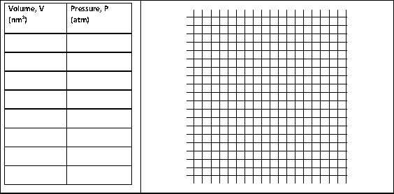
4. Graph the results of your experiment with pressure on the y-axis and volume on the x-axis. Sketch your graph above.

5. Based on the graph above, express the relationship between pressure and volume mathematically (using a proportional statement or an equation) and verbally (specifically describe it in words)
Mathematically

Verbally

6. a) What would happen to the pressure in a container if the volume of the container is doubled (say it expands)? Mathematically, how could the quantity of pressure be represented?

b) Explain in terms of the collisions of particles why the change has the effect you predicted.

c) Select three regions on the graph (one at each end and one in the middle) that are consistent with what was observed and account for the graphical relationship observed. Sketch boxes of appropriate size with 5 particles in each that illustrates the relationship observed in the activity.

7. You have 3.05 cm³ of a gas in a cylinder with a moveable piston. P = 104.2 kPa. At constant T, the gas in compressed to a new volume of 0.86 dm³. What is the new pressure, P₂?

Combined Gas Law: how do they all work together???
1. Place two pumps in, leave the gravity at zero.

2. Select one variable, ______________________ (write the variable). Circle if you want it to go up or down.

3. Predict how changing that variable will impact the other two. If ____________ goes ______ then ______________ will ___________ and _________________ will ______________.

4. Record your initial values for everything under trial 1, initial conditions.
 | Trial 1 |  |  | Trial 2
 | Initial Conditions, 1 | Final Conditions, 2 |  | Initial Conditions, 1 | Final Conditions, 2
Pressure

Volume

Temperature
Results
5. Change the one variable you listed above in the direction you said (up or down).

6. Once the variables have settled, record the final conditions. Comment on how your close predictions in #3 were to the results. What insights have you gained here?

7. Time permitting, conduct a second trial with all the variables. Select one variable, ______________________ (write the variable). Circle if you want it to go up or down. Predict how changing that variable will impact the other two. If ____________ goes ______ then ______________ will ___________ and _________________ will ______________.

The combined gas law has a predictive power that is supported by the explanatory power within the kinetic molecular theory.

8. The combined gas law combines the other two laws we have discussed. It is:

9. Suppose that 25.0 mL of a gas at 125 kPa and 293K are moved to standard temperature and pressure. What would the new volume of the gas be?

10. The pressure in a bicycle tire is 105 kPa at 298K here in Saranac Lake during the summer. The volume of the bike tire is 250 cm³ of gas. You ride the bike to Maine, where the temperature drops to 268 K. What is the new pressure in the tire?

