Exploring Newtons’ Second Law using a Simulations

Name:
Background:

Newtons second law states that when a force acts upon an object, it will cause the object to accelerate.
The greater the force the greater the acceleration.

The simulation forces-1d allows you to explore the relationship between force, mass and acceleration. The simulation allows to select different objects (each with a different mass) to which a horizontal force can be applied (by a fellow named Joe). Different aspects of the objects motion can then be measured.

Activity 1: Explore the Sim

A screenshot of the simulation is shown below.

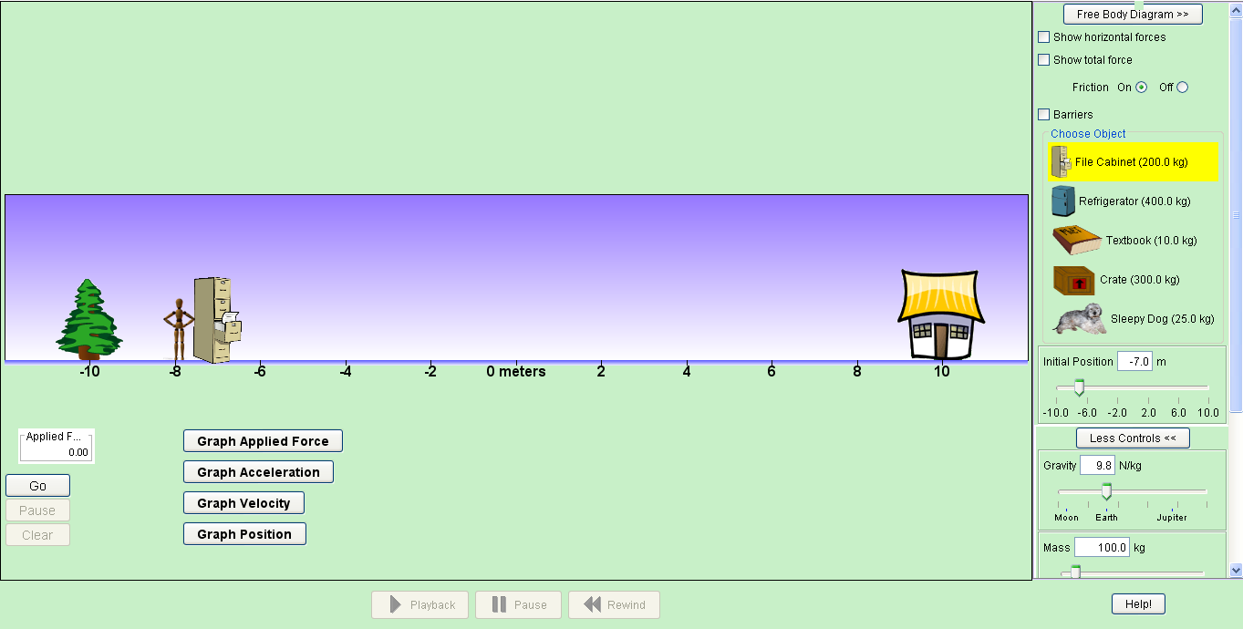

Spend 5 minutes exploring the sim. Find out the following:
How do you select an object? How do you change the mass of the object?
How do you apply a push? How do you change the force of the push?
How do you determine the total (net) force being applied to the object?
Can you turn the free body diagram on?
How can you find out about the motion of the object?
Can you quantify the acceleration of the object?
Can you turn friction off?
How do you ‘reset’ the sim?
What other settings can you change? Should these be changed?
Are you able to record your experiments so you can review what happened?

Use this space to make notes about the sim

Activity 2: Explore the effect of force on acceleration (with no friction)

Now you have had a chance to explore the sim, let’s see if you can figure out the relationship between the total force applied and the acceleration of an object.

Prediction: What effect will increasing the force have on the acceleration of an object?

Start by turning friction off.
Select an object for Joe to push.
Record the mass of the object.
Have Joe push the object with different magnitudes of force, record the acceleration of the object for each force.
Calculate the quotient of force and mass (force ÷ mass)

Table 1: Activity 2 Results
Mass of object (kg)  Keep this constant | Total force (N) | Acceleration (m/s²)

What did you notice about the magnitude of acceleration and the quotient of force and mass?

Try and write a rule to describe the relationship between force mass and acceleration.

Activity 3: Explore the effect of force on acceleration (with friction)

Repeat the experiment from activity 2, but this time have friction turned on.

Will you be able to use the rule you developed in activity 2?

How will adding friction change your results?

Table 2: Activity 3 Results
Mass of object (kg)  Keep this constant | Total force (N) | Acceleration (m/s²)

How did your results from activity 3 compare to your results from activity 2?

Can you explain the relationship between the force applied to an object, the mass of an object and the acceleration of the object.

Activity 4: Using what you have learned·

Now let’s see if you can apply what you have learned. Some of the cells in the table below have been left blank. Predict what the answer should be, then use the simulation to find out if you were correct.

Total Force (N) | Mass (kg) | Acceleration (m/s²) |  | Predicted answer | Simulation answer
200 | 10 | ?
500 | 20 | ?
? | 50 | 10
? | 100 | 15
250 | ? | 5
1000 | ? | 20
? | 150 | 15
? | 250 | 25

And finally ......

What do you now understand about the relationship between Force, Mass and Acceleration?

