Title: States of Matter

Introductions:
In this activity you will investigate the physical science of the different states of matter. You are going to see how different atoms and molecules change state (solid, liquid, and gas) when they are heated or cooled.
- Click on the link: http://phet.colorado.edu/
This is a screen shot of the website:
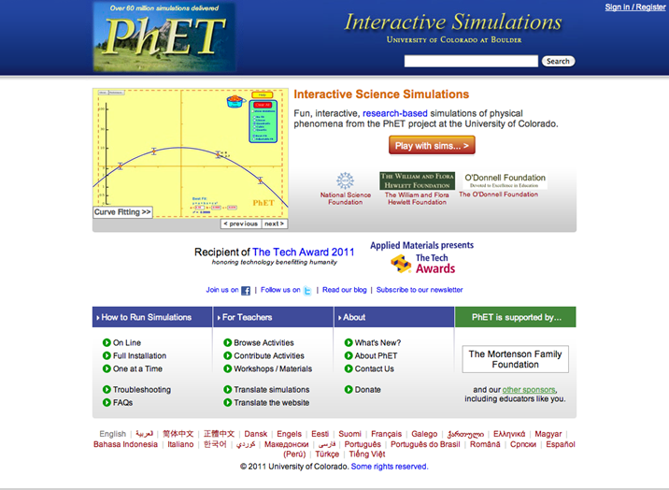
- Click the “Play with sims” button.
- Click “New Sims”->Click “States of Matter: Basics”->Click “Run Now”
This is a screen shot of the simulation once loaded:
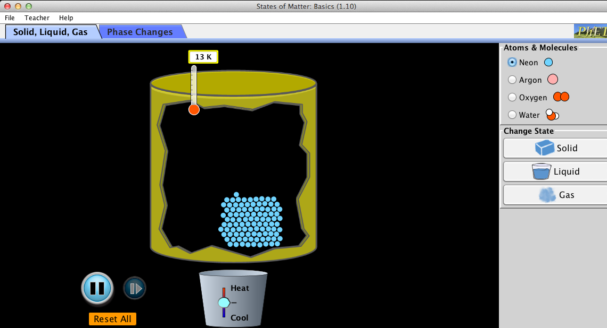
- Switch between this document and the simulation “States of Matter: Basics” to complete this activity.
Exploration Phase:
- When you open the sim, click the “Solid, Liquid, Gas” on the upper left hand corner.
- On the right hand side, you will notice that there are different atoms and molecules for you to explore with. There is neon, argon, oxygen, and water.
- First click the “neon” button and increase the heat and observe what happens to the particles. Then decrease the heat and observe what happens to the particles. Observe the temperature as well.
- Repeat step 3 for the argon, oxygen, and then water.
Questions:
- A.What did the neon particles do when the pot was heated?

B. How about when the pot was cooled?

- Do you think the neon particles changed their state? (i.e. did it change to solid, liquid, or gas?) How can you tell?

- When the neon particles were cooled again, did they go back to it’s original square formation? Why do you think it did/did not?

- Are the argon, oxygen, and water particles similar to the neon particles? Why/why not?

Explanation Phase:
Aim: Create a rule to determine when the particles have changed their state from a solid, to liquid, and then to gas using just water.
*Click on water under Atoms and Molecules to determine the following. The screen should appear as follows:
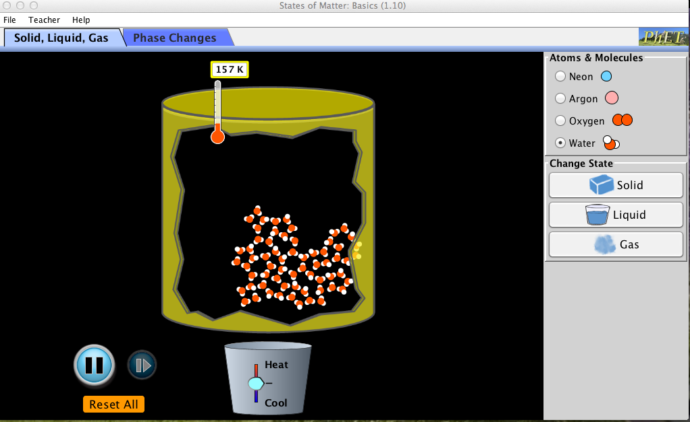
- When the container is heated the particles become... solid, liquid, or gas?

- When the container is cooled the particles become...solid, liquid, or gas?

- How does one determine phase change (i.e. solid to liquid, liquid to gas) by viewing the arrangement of atoms?

4. Why do you think particles change their state after a certain temperature?

5. By looking at the temperature, record the temperature that you believe is when the phase changes occur for water.
Solid (Freezing point): _________
Liquid (Melting point): _________
Gas (Boiling point): __________
*Take a screen shot of when you believe the particles are in each phase.
Concepts:
When you heat up the container the atom/molecules will change from a solid, to a liquid, and then into a gas if heating continues. When you cool the container the atom/molecules will change from a gas, to a liquid, and then into solid if cooling continues. Each atom and molecule changes its state of matter at different temperatures. When the particles appear to be close together, they are in the solid state, as the particles drift, they become liquid, and then gas when they have reached it’s maximum separation.
When a particle becomes a solid it is known as a freezing point. When a particle becomes a liquid it is known as a melting point. Liquids take form to it’s surrounding space. When a particle becomes a gas it is known as a boiling point.
The “K” next to the temperature represents Kelvin. Kelvin shows the thermodynamic temperature. 0 degrees Kelvin is approximately -273.15 degrees Celsius, and -459.67 degrees Fahrenheit.
Application Phase #1:
*Now press reset all button on the lower left hand side.
Using the Sim, fill in the blanks of the following table. At what temperature do the particles reach their melting point, boiling point, and freezing point? Please complete in this order.
Temperature: | Neon: | Argon: | Oxygen: | Water:
Melting Point
Boiling Point
Freezing Point

- How do you know that the particles have changed state?

- Is there a similar temperature that determines when the particles change their state?

3. Why do the particles not form back into it’s original square shape when cooled from a liquid back into a solid?

Application Phase #2:
- Now go back to the sim and click “Reset All”.
- On the right side it says “Change State” and underneath it says Solid (Freezing Point), Liquid (Melting Point), and Gas (Boiling Point). Click on neon first then click on solid, look at what the thermometer reads, record it on the table below.
- Then click on liquid, look at what the thermometer reads and record it on the table below.
- Click on gas, look at what the thermometer reads and record it on the table below.
- Do this for all four atoms and molecules.
At what temperature did the particles change their state?
Temperature: | Neon: | Argon: | Oxygen: | Water:
Melting
Boiling
Freezing

Conclusion:
Compare the data in both tables and explain if you were able to accurately measure when the atoms/molecules changed their state? What helped you determine when the particles changed from freezing point, to melting point, and to boiling point?

