Title: The Moving Man

Introduction In this activity you will investigate velocity using charts. Velocity is the rate of speed in which something happens. You will use charts to describe the velocity, direction, and time a man’s movement.

1. Click on the following link: http://phet.colorado.edu/en/simulation/moving-man
This is a screen shot of the website.

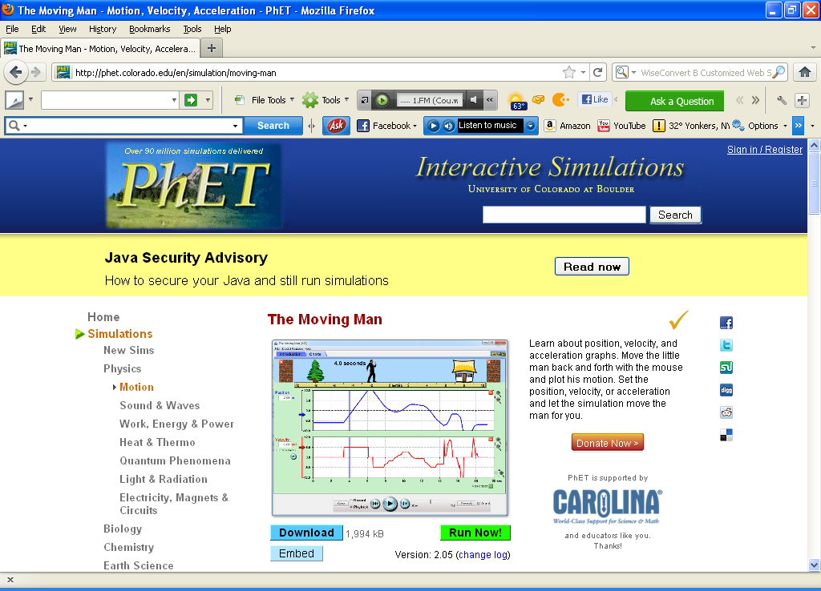

2. Click: Run Now!
It should take time to load. When it loads this screen should appear:

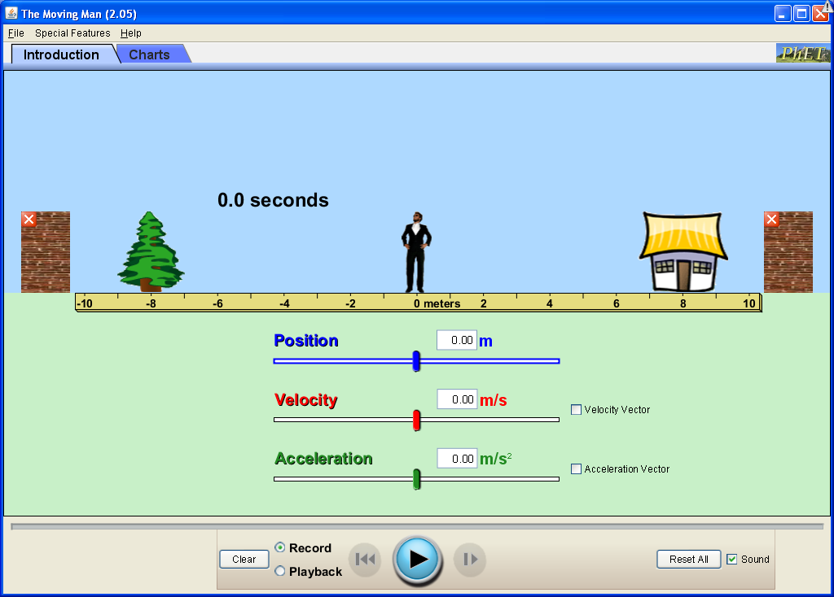

Use this Sim to complete today’s activities.

Exploration Phase
On the introduction tab, check the velocity vector box.
Explore the introduction page by either moving the man (by clicking and dragging him) or by moving the blue, red, and green tabs. You can also type in a position, velocity, or acceleration amount in the box (between -10 to 10) and press return.
Be sure to view the playback. Before you press play chose how fast or slow you want to view the playback.

Directions:
- Reset all.
- Slowly move the man to the tree, stop, and press pause.
- Press Playback. Slide the tab so that the playback will play at a slow speed. Press play.
  - What do you notice about the position, velocity, and acceleration bars?

- Reset all.
- Quickly move the man to the house, stop, and press pause.
- Press Playback. Slide the tab so that the playback will play at a slow speed. Press play.

  - What do you notice about the position, velocity, and acceleration bars?

Explanation Phase

Aim: How can charts help us track movement?

Click on the Charts tab on the left top corner of the page. A screen that looks like this should appear:

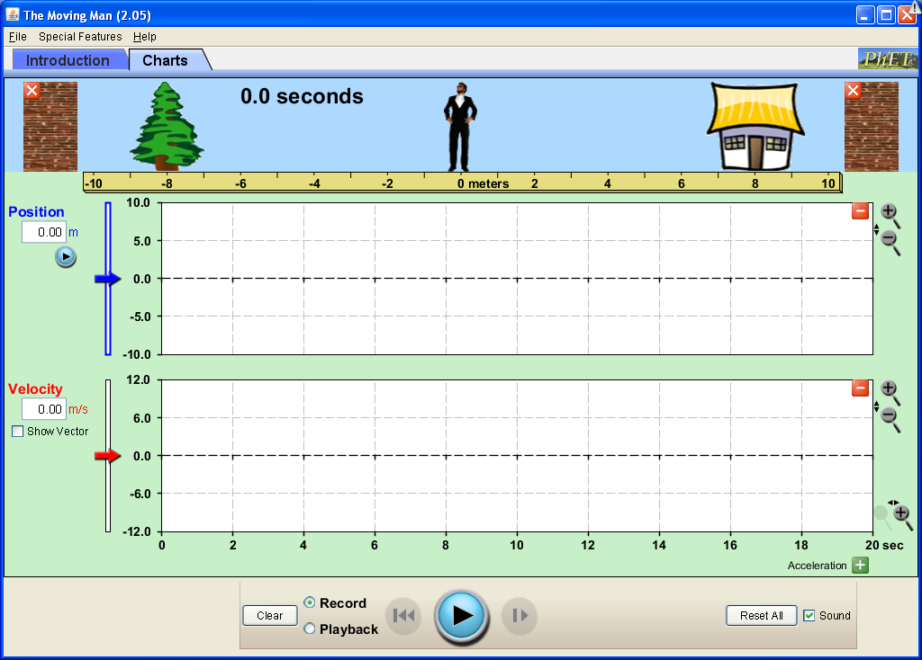

Familiarize yourself with the charts page by moving the man in different directions and velocities. Make sure to playback, slow down, watch the movement on the charts and pay attention to the velocity rate.
To set the man at a specific position:
First move him to the position you want him to start. Then press pause. Last press clear. At this point the time should return to 0 and the charts will be clean. When you are ready to begin, move the man.

Activity 1:
Look at the charts below. Complete the fill-in which describes the moving man’s velocity, the direction he takes, and the time it takes for him to move about.

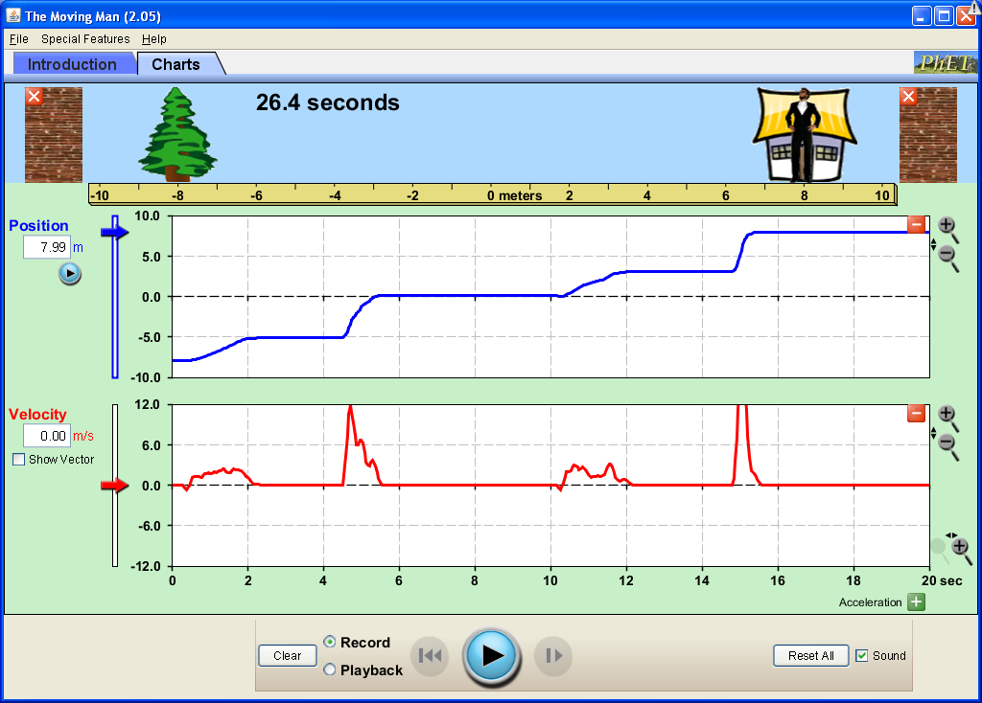

Word Bank (words may be used more than once)
house quickly tree stops slowly *Use the charts for time

The moving man starts at the _______________. He begins walking _______________ towards the _______________. He soon _______________ for __________ seconds to say hello to a neighbor. He then begins walking _______________ and immediately _______________. He realizes his shoe is untied. It takes him __________ seconds to tie his shoe. He _______________ begins walking towards the _______________. He _______________ when he realized he dropped his wallet. He picks up his wallet and the change that fell out. It takes __________ seconds to pick everything up. He then walks _______________ to the house. He stops walking when he reaches the _______________. It took him __________ seconds to reach the ________________.

Briefly explain your description. (For example, What on the charts tell you that the moving man was moving quickly, slowly, has stop, or what direction he is moving?)

Application Phase

Activity 2:
a. Play with the moving man for 2 minutes on the Charts page. Move the man around using various velocities, directions, and make him stop once or twice.
b. Copy a screen shot of the moving man’s movement below and describe his movements.

Questions:
- What do you notice about the time it takes to travel when the velocity is low?

- What do you notice about the time it takes to travel when the velocity is high?

- It takes a _______________ (shorter, longer) time to reach a destination if your velocity is _______________ (low, high).

Activity 3:
Share your charts with your partner. Take a few minutes to read the charts and then share your findings.

Conclusion
How do the charts help you track movement?

If there is extra time try making the letters M, N, or W on the charts by moving the man and describe it.

