Constant Velocity

Motion Simulation - The Moving Man

Today you will learn how to get information from a simulation program. Our goal is to play with the simulation to find the rules that it follows. Simulations are designed to follow the rules that govern the rest of the universe.
You will use the simulation called The Moving Man. To get to it, you can Google: the moving man. It is the first link. Click on Run Now to start the program.
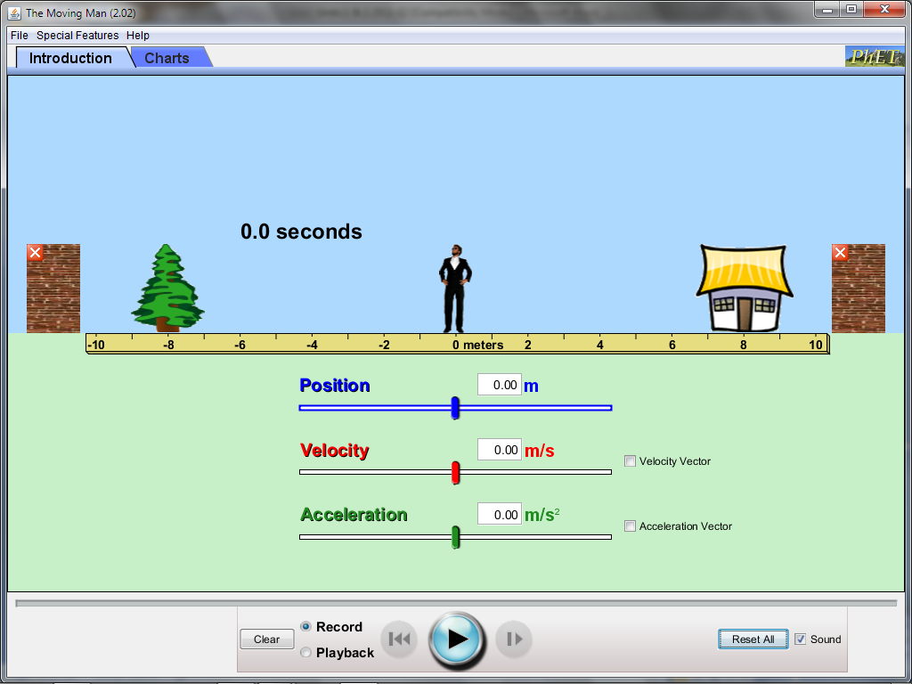
Part 1 – Introduction
Notice the two tabs at the top left of the screen. For now, leave it on Introduction. We will not investigate the Acceleration (green) slider today.
1. How does the Moving Man react when you adjust the blue Position slider? (you can also type a number into the box).

2. How does the Moving Man react when you adjust the red Velocity slider? (you can also type a number into the box).

3. Click on Velocity Vector to the right of the red slider. Play with the simulation. What rule does the Velocity Vector follow?

4. How does time relate to velocity?

Part 2 – Charts
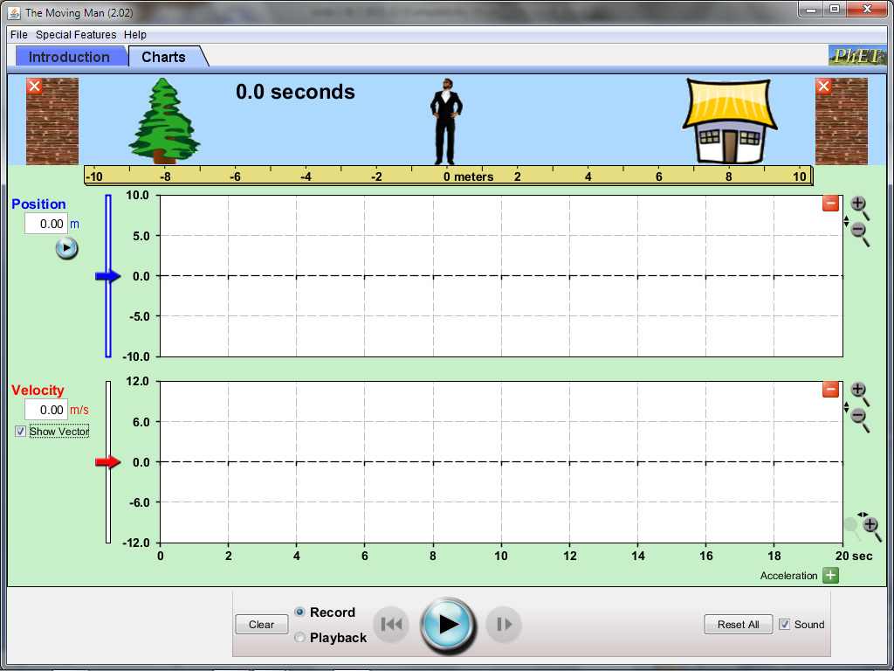
Now click on Charts at the top left.
Click on the red Minus button on the top right of the bottom (acceleration) graph.
Then click on the Show Vector box under the Velocity heading.
Now investigate the simulation by typing (or dragging the arrow) to different numbers into the position or velocity boxes and pressing the Play button.
Find the following rules of the simulation:
5. The position graph line is on the positive side when:

6. The position graph line is on the negative side when:

7. The position graph line has a positive slope when:

8. The position graph line has a negative slope when:

9. The position graph line has a slope of zero when:

10. The velocity graph line is on the positive side when:

11. The velocity graph line is on the negative side when:

12. The velocity graph line is on zero when:

13. The slope of the line on the position graph is steep when:

14. The line on the velocity graph is closer to zero when:

15. The line on the velocity graph is far from zero when:

16. Draw an example of The Moving Man moving forward from 0 meters at a velocity of 2m/s for 4 seconds.
a. How far would he move? HDYK?

b. How far would he move if he went twice as fast? HDYK?

c. How far would he move if he went for twice as long? HDYK?
17. Draw an example of The Moving Man moving backward from zero at a velocity of -5m/s.

18. What could be happening to The Moving Man according to this graph?
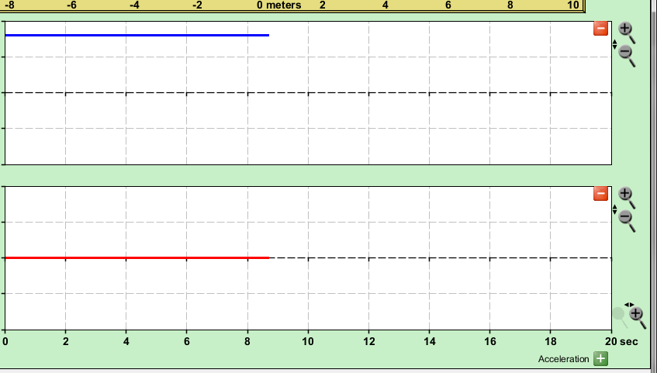

19. Click on the Clear button at the bottom. Make sure the program is paused. Type into the Position box -10 and +4 into the Velocity box. Draw what you think both graphs will look like in the picture.
How long do you think it will take for the Moving Man to get to the other side? HDYK?

8. Now, click on the play button. What happened? Draw the results here:
Were you correct? What might be a surprising result?

9. Click on the Clear button at the bottom. Make sure the program is paused. Type into the Position box 8 and -2 into the Velocity box. Draw what you think both graphs will look like in the picture.
How long do you think it will take for the Moving Man to get to the other side? HDYK?

10. Now, click on the play button. What happened? Draw the results here:
Were you correct? What might be a surprising result?

11. Describe what happened to make this graph:
Starting Position:
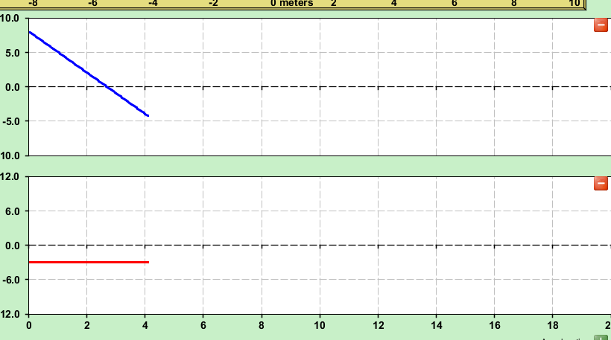

Direction:

Velocity:

Time interval:

Displacement:

12. Now draw into the box the graphs you want the moving man to make. Next, trade your booklet to a neighbor and check to see if they can figure out how to make the graphs.

Stamp for a correct answer:

Uniform Acceleration

The Moving Man with Uniform Acceleration

You will use the simulation called The Moving Man. To get to it, you can Google: the moving man. It is the first link. Click on Run Now to start the program.
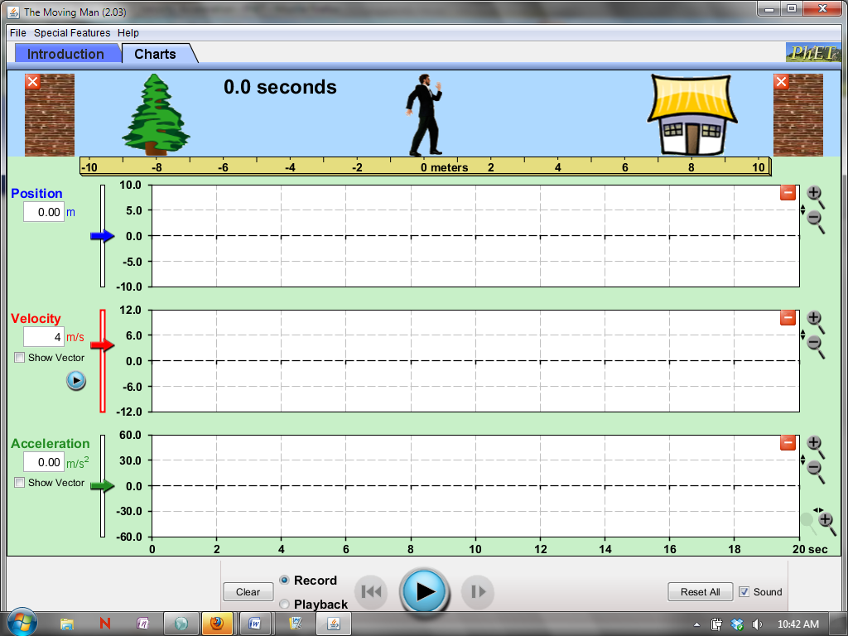

Click on the Charts tab at the top of the screen.
This works better if you type numbers into the box instead of moving the man with your mouse.
For each question, answer with both a sentence and a graph.

1. HDYK from the graphs if you have constant velocity?
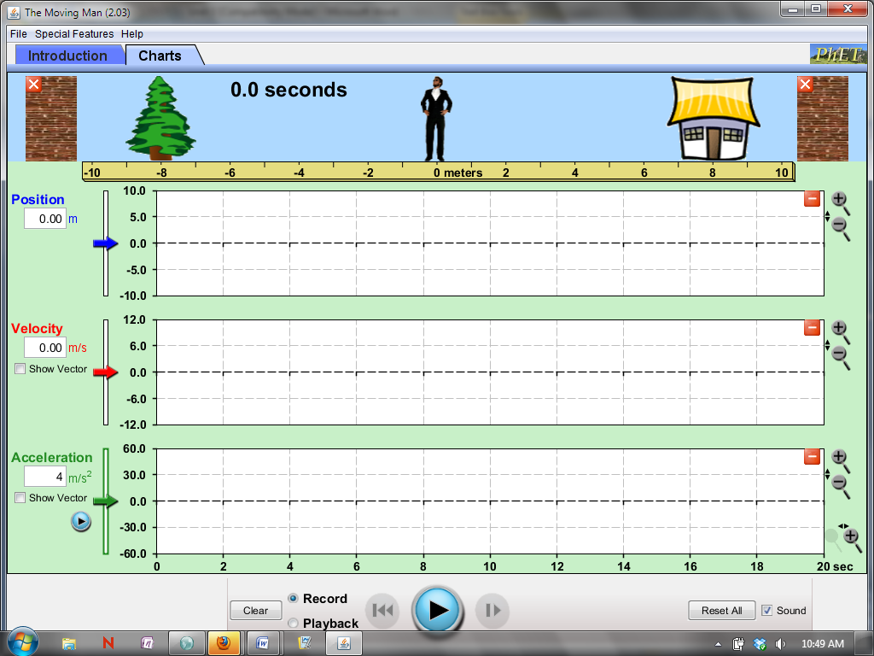

2. HDYK if the moving man is moving forward or backward?

3. HDYK on a velocity vs. time graph if the acceleration is positive or negative?

4. HDYK which way the position vs. time graph will curve?

5. What happens when you have a positive velocity and a negative acceleration?

6. What happens when you have a negative velocity and a positive acceleration?

7. There are two ways to get positive acceleration. What are they? (how must he move?)

8. There are two ways to get negative acceleration. What are they? (how must he move?)

