
UTeach Outreach The University of Texas at Austin

Gravity and Orbits – Scripted Version

Lesson created by: UTeach Outreach
Description of the class: 6th Grade
Length of lesson: 60 - 75 minutes
Resources Used:
http://www.gravityforthemasses.com/Page2.html
http://starchild.gsfc.nasa.gov/docs/StarChild/teachers/orbiting.html
http://www.msnbc.msn.com/id/45317181/ns/technology_and_science-space/t/nasa-budget-plan-saves-telescope-cuts-space-taxis/#.TzFltkqy0za
GRAIL Spacecraft: http://www.nasa.gov/mission_pages/grail/launch/grail_gravity.html

TEKS Addressed:
Skills TEKS: 6.3A-D
6.3: Scientific investigation and reasoning. The student uses critical thinking, scientific reasoning, and problem solving to make informed decisions and knows the contributions of relevant scientists.
(A) in all fields of science, analyze, evaluate, and critique scientific explanations by using empirical evidence, logical reasoning, and experimental and observational testing, including examining all sides of scientific evidence of those scientific explanations, so as to encourage critical thinking by the student. DC
(B) use models to represent aspects of the natural world such as a model of Earth’s layers.
(C) identify advantages and limitations of models such as size, scale, properties and materials.
(D) relate the impact of research on scientific thought and society, including the history of science and contributions of scientists as related to the content. DC
Knowledge TEKS: 6.11B-C
6.11 Earth and space. The student understands the organization of our solar system and the relationships among the various bodies that comprise it. The student is expected to:
(B) understand that gravity is the force that governs the motion of our solar system; and
(C) describe the history and future of space exploration, including the types of equipment and transportation needed for space travel.
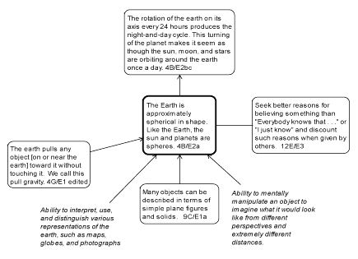
National Science Standards and Project 2061

I. Overview
The lesson begins with the teacher leading a demonstration of spinning two washers attached to a string to show how planets that are closer to the sun revolve faster around the sun. The students are introduced to the Question of the Day: “How does gravity affect the motion of the planets?” The teacher leads a discussion on the contributions of Galileo and Newton to the study of gravity. Using the Gravity and Orbits PhET simulation, students work in pairs to study how gravity affects the motion of planets. By the end of the lesson, students will understand how the gravitational force between two objects increases as the amount of mass involved increases and/or the planet moves closer to the sun. In addition, the students will understand that certain limitations are involved with this simulation. For example, the simulation is not in 3D, the planets are not shown to scale, and the simulation is exhibiting a perfect system with no outside complexities affecting the orbits. As an extension, students will calculate the weight of an object on different planets to demonstrate an understanding of how the gravitational force on a planet contributes to an object’s weight. The lesson concludes with the students discussing possible careers related to space exploration and the future of our space programs.

II. Objectives:
- Students will identify advantages and limitations of models of the solar system.
- Students will learn about the role of gravity in the solar system and how it affects the way planetary objects move in relation to each other.
- Students will examine and judge scientific evidence and explanations using logical reasoning, experimental and observational testing.
- Students will give accounts of the impact of scientists’ contribution on current scientific thought and society.

III. Resources, materials and supplies (per bin/student or teaching pair)

Engage:
- 2 washers of equal size
- 1 m of string
- 1 piece of plastic pipe (with hole large enough to put string through)

Explore:
- 1 computer per pair

Elaborate:
- 1 calculator per pair

IV. Advanced Preparation

Engage:
- Attach one washer to a string. Pass string through a piece of pipe. Attach second washer to end of string. See set up below.
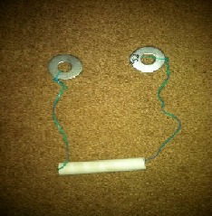

Explore:
- Bookmark PhET simulation link for Gravity and Orbits (http://phet.colorado.edu/en/simulation/gravity-and-orbits) on student computers or visit http://phet.colorado.edu/en/get-phet to see other ways to load the simulation on student computers.

V. Supplementary worksheets, materials and handouts
- See attached

VI. Background information
College Level:
In everyday life, it may be sufficient to describe gravity as the force which causes objects to fall towards the Earth. However, of all fundamental forces in physics, gravity is presently the least understood. Compared to another fundamental force, for instance electromagnetism, gravity seems much weaker. A tiny refrigerator magnet can pull more on a paperclip than the entire gravitational pull of the Earth. Research is ongoing to discover the relationship between gravity and the other natural forces, but at present it must be treated separately.
Measurements of the effects of gravity date back to Galileo Galilei's (1564 - 1642) measurements of gravitational acceleration on Earth. Galileo found that the rate at which objects accelerate towards Earth when dropped seems to be independent of their mass, barring effects such as air resistance. This measurement spurred a revolution in the theory of gravity, ousting the concept that more massive objects accelerate faster. The current model of gravity builds on this observation, indicating that gravity is an effect of the presence of matter in our universe.
Isaac Newton's Universal Gravitation proposed in 1686 generalized the force of gravity beyond the Earth. The orbits of planets and moons in our solar system had been described mathematically, but there was no theory explaining what caused this motion. Based upon orbit data of Jupiter's moons, Newton argued that there was an attractive force between the planet and orbiting bodies. He stated that the force was proportional to the inverse square of the distance between each object, and that the force was gravity.

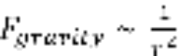,
where r is the distance between the centers of mass of the two objects. Newton proposed that the complete equation for this force was

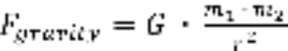,
where m₁ and m₂ are the masses of the objects attracting each other and G is a constant, called the universal gravitation constant.
The value of G has been empirically measured after Newton proposed the theory, but remains difficult to measure precisely. Nevertheless, this equation satisfies the observations of Galileo and contemporary scientists. The distance between the center of mass of an object and the center of mass of the Earth is nearly constant throughout a falling path if the object is dropped near the surface of the Earth. The distance between the centers of mass very closely approximates the radius of the Earth.
Since the force of gravity is just a special case of Newton's Second Law of Motion (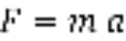), the mass of the object can be factored out and the remaining terms represent its acceleration.

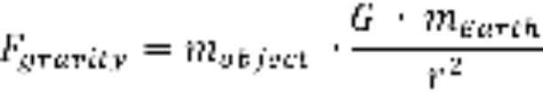
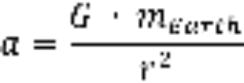

Since the mass of the Earth is constant, G is constant, and the distance r is very nearly constant, the acceleration is very nearly constant. This acceleration is also independent of the mass of the object being dropped. As a result, the acceleration observed for objects with different mass when dropped near the Earth are approximately the same constant acceleration, provided forces such as air resistance are minimal. It should be noted that the value of the gravitational acceleration shown above is not 9.81 meters per second squared. Since everyone rotates along with the Earth, we feel the rotational acceleration as a centripetal force. The component of centripetal force which opposes the gravitational acceleration changes the strength of the downward pull we call gravity.
When applied to the orbits of a planet around a star or a moon around a planet, the force of gravity is similar to a string when twirling an object tied to the other end.

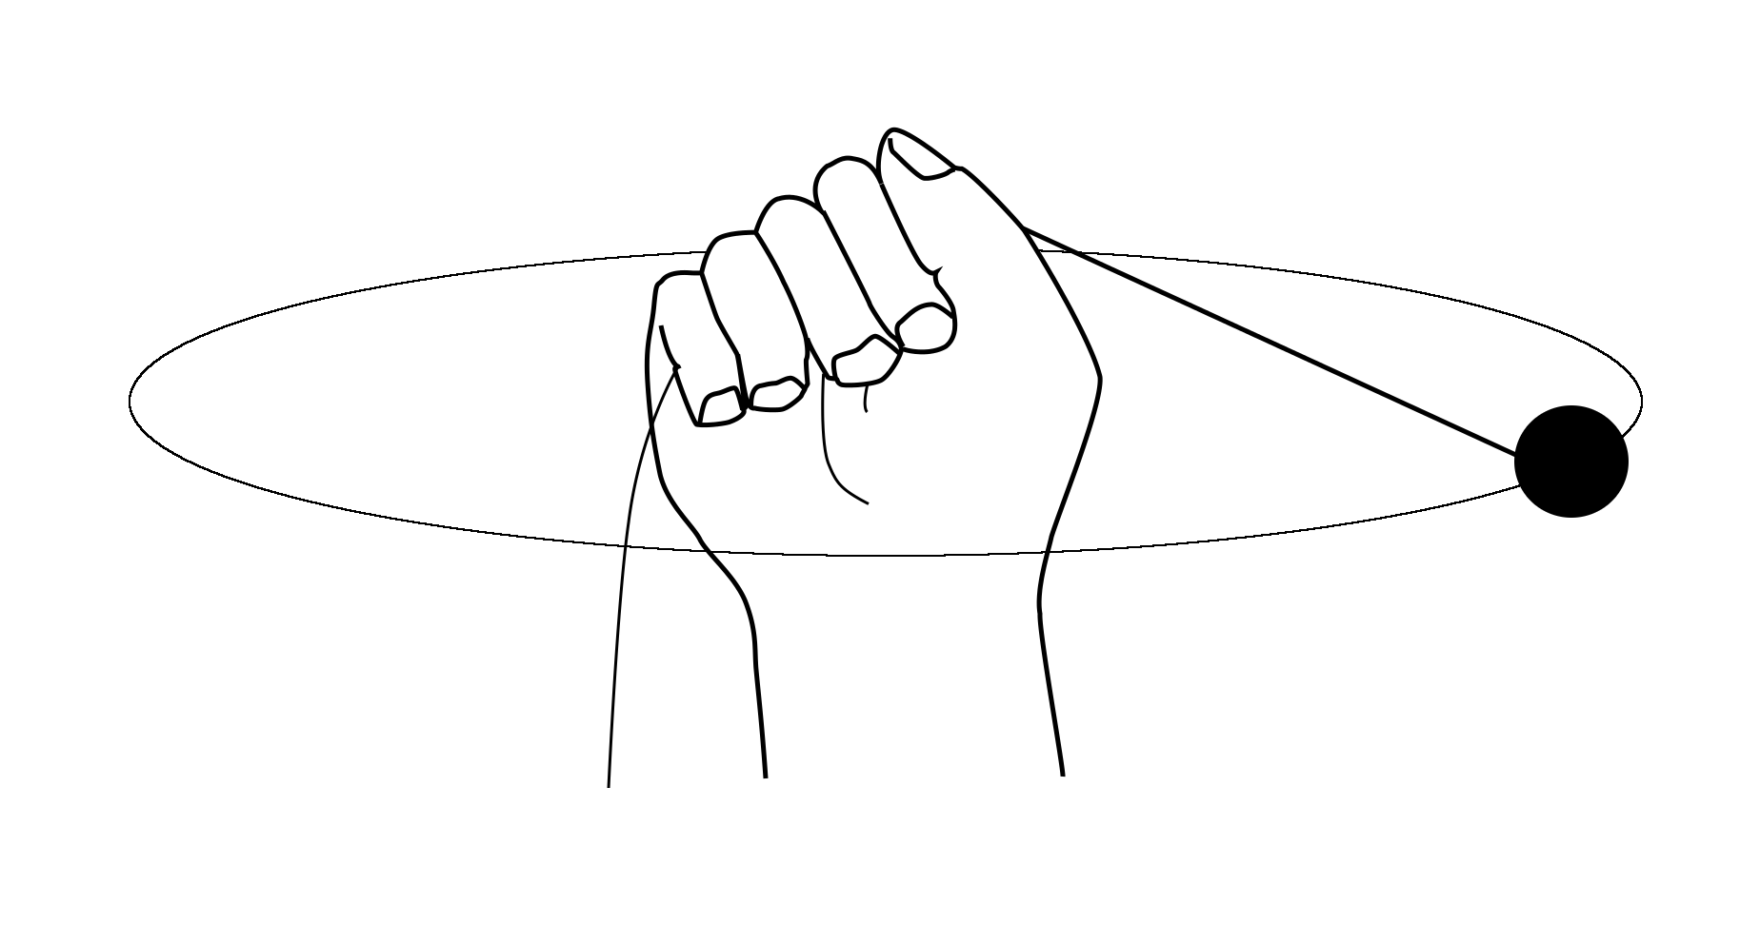
Planetary orbit modeled by mass on a string
The hand applies a force to the mass by pulling on the string.
Changing the direction of pull causes the mass to move in a
curved path, which may form the circular orbit shown.
The string keeps the hand and object relatively close. However, if the velocity of the object is great enough, the person will not be able to hold onto the string and the string will start to slip through their hand. Likewise, if the velocity of a satellite is great enough and pointed at an angle greater than ninety degrees to the force of gravity, the distance between the central object and the satellite will increase. If the velocity is too great, the acceleration due to gravity will be too small to keep a stable orbit and the object will go off into space. Otherwise, gravity will eventually pull the two objects back together and create an orbit. The shape of the orbit depends on the velocity of the satellite. In this way, orbits due to gravity are elliptical rather than being strictly circular.

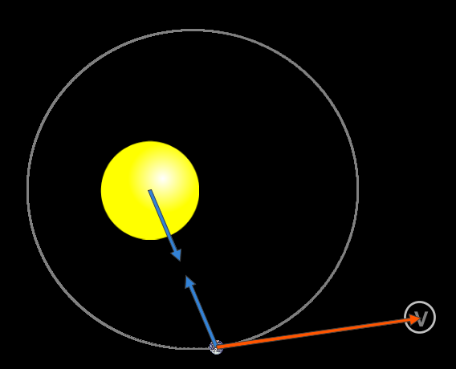
Elliptical orbit due to angle between velocity vector (red) and gravity vector (blue)
Image from Gravity and Orbits PhET simulation
Following Newton's third law of motion, the force of gravity will pull both objects towards each other. If one of the objects is much larger than the other, the larger object will accelerate less. This is the case with the sun and the Earth. If the motions of both objects are plotted, the point about which they both orbit is the center of mass between the two objects. In the case of the sun and the Earth, the center of mass is located inside the sun, but not at the center of the sun. Orbits are often plotted with the center of mass at the origin since any shared motion of the two objects can be simplified and applied at the point. For instance, the Earth and sun also revolve about the Milky Way.
Elementary Level:
Gravity is a force everyone on Earth experiences constantly. It is easy to accept being pulled down to the Earth and not pay any more attention to what causes this pull. However, gravity is what makes many common technologies possible. For instance, satellites that provide communication, television, and Global Positioning System (GPS) services would not exist without gravity. Perhaps more importantly, the Earth would not orbit the sun, which provides the energy for life as we know it.

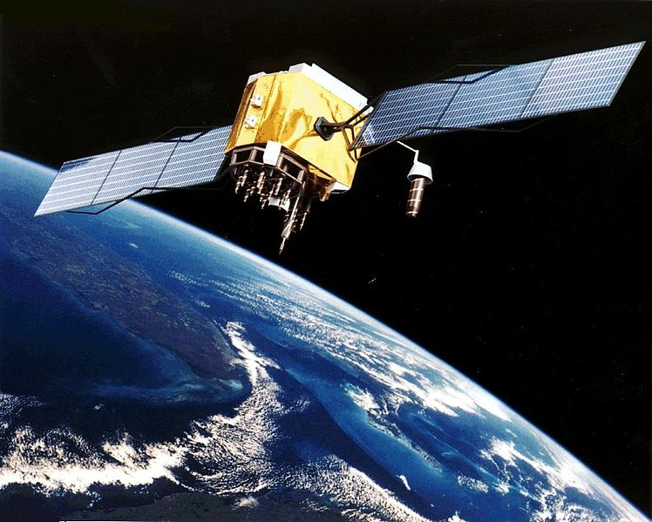
Artist’s interpretation of a GPS satellite, courtesy of NASA
http://en.wikipedia.org/wiki/File:GPS_Satellite_NASA_art-iif.jpg

Gravity has been studied for over two thousand years, and scientists have improved the explanation of how gravity works many times. The first measurement which supported the current description of gravity came from Galileo Galilei (1564 – 1642), who noticed that objects accelerate downward at the same rate regardless of their mass. What causes a difference in acceleration is other forces like air resistance? Isaac Newton thought that the force of gravity could be described beyond Earth. Using data from the movement of moons around Jupiter, Newton proposed an equation to calculate the force of Gravity anywhere. He used this to explain the orbits of the planets around the sun and moons around the planets. His work was published in 1687 and revolutionized physics.

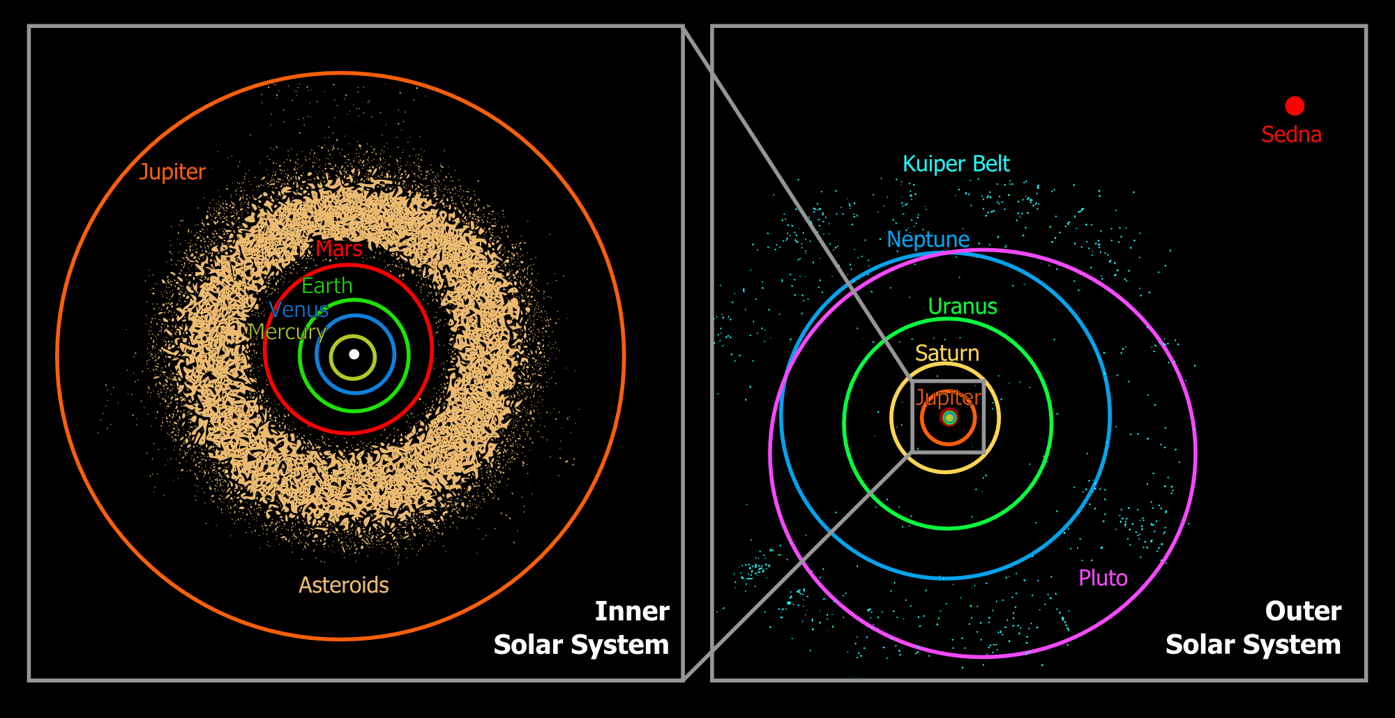
Diagram of planetary orbits and objects in the solar system, original courtesy NASA
http://en.wikipedia.org/wiki/File:Oort_cloud_Sedna_orbit.svg
Gravity causes all objects with mass to be attracted to one another. The force increases as the amount of mass involved increases, and decreases as the distance between objects increases. More precisely, the force decreases as the distance between the centers of mass increases. Using the centers of mass of objects to calculate the force of gravity is an approximation. It is a very good approximation if the force of gravity is not likely to break the objects apart. Since gravity is much weaker than the other fundamental forces, this is true for many situations.

VII. Possible Misconceptions (in bold) (correct science non-bold): Also denoted by “MC” within lesson.
- Gravity exists only on Earth so there is no gravity in space. Gravity exists everywhere in the universe. Students often think that there is no gravity in space because they have seen astronauts appear weightless in movies and in pictures. The astronauts are not really weightless. They only appear so because the space shuttle and the astronauts inside of it are in a constant state of free fall around the Earth.
- Gravity is selective and acts differently on some matter. Gravity is not selective; it doesn’t have “feelings.” Gravity acts the same on everything. The strength of gravity varies (see College Background).
- Planets far from the Sun have less gravity. This is not true. Gravity depends on the distance between two objects AND the objects’ masses.
- Gravity can push and pull. Students are commonly taught that a force is a push or a pull. Gravity is an attractive force only; it pulls objects together.
- Size and mass are the same. A planet’s size is how big it is in 3 dimensions. An object’ mass is the amount of matter an object contains.

VIII. Vocabulary and Definitions:

College Level:
- Gravitational acceleration: the acceleration of a massive body due to gravity
- Gravity: a force that two objects exert on one another, proportional to the product of their masses divided by the square of the distance between their centers of mass
- Gravitational constant: the constant of proportionality which arises from the calculation of the gravitational force
- Center of mass: the average position of all the mass of an object or system of objects used to approximate the position where a force is applied

Elementary Level:
- Matter (asunto): anything that has mass and takes up space
- Mass (masa): the amount of matter an object contains
- Gravity (gravedad): the force that pulls two objects towards each other
- Force (fuerza): something that causes an object to change its motion
- Orbit (órbita): the path by which an object revolves around another object due to gravity
- Satellite (satélite): any object that orbits another object

IX. Safety Considerations
- Be careful when spinning objects.
- Monitor students on computers to ensure they are not visiting inappropriate websites.

X. Question of the Day:
- How does gravity affect the motion of the planets?

Five-E Organization

Engagement |  | Time: 3 minutes
What the Teacher Will Do | Probing Questions | Student Responses  Potential Misconceptions
Good afternoon class! I hold in my hand a model of a planet.  Show the model of the washers attached by a string.  Hold the system at one arm’s length away from your body.  The washer attached to the string represents a planet.  Keep the handle vertical while rotating it in a circular motion. Rotate it fast enough so that the washer attached to the string starts to revolve in a circle.  Exactly! The string represents a force, which pulls on the planet. Refrain from discussing gravity at this point. Focus on the fact that the string represents a force.  Pull one of the washers towards you. The other washer should begin to revolve in a faster smaller circle.  That’s right. The washer, or planet, was pulled closer toward the center as the force increased. When the force was larger, the planet’s radius of orbit decreased and the speed increased. The radius is the distance from the center of a circle to the edge. If needed, draw picture of a circle and mark the radius on the board. In this case, it is the length of exposed string from the pipe to the washer. Today we will be exploring how planets orbit the Sun and the force that controls this motion. | - Based on what I told you, what is the planet doing?  - What could the string represent? Why?  - What happened to the revolution path of the planet?  - What happened to the planet’s revolving speed? | - Revolving! [MC: rotating]  - A Force because it is pulling on the planet (washer).  - It revolved in a smaller circle.  - It sped up.

Exploration |  | Time: 40 minutes
What the Teacher Will Say or Do | Probing Questions | Expected Student Responses /  Potential Misconceptions
To begin our lesson on forces and motion, let’s briefly discuss some history.  Galileo Galilei was a philosopher in the late 1500s and early 1600s that discovered the idea that objects fall at the same rate with little air resistance and found that objects have a constant acceleration due to gravity on earth. Show image of Galileo Gailei. However, scientists thought that our gravity was something unique to earth.  Show demonstration again. Exactly right! It is important to remember that while a force is a push or a pull, the force of gravity is only a pull. It is an attraction between two objects.  Yes! Another scientist that has played an important role in the study of gravity is Sir Isaac Newton.  Sir Issac Newton was a philosopher in the 1600s. He developed an equation that determined the force of gravity everywhere in the universe. He implied that gravity is a force that behaves in similar ways throughout the universe. Show image of Sir Isaac Newton. In order to describe gravity, he realized he needed to describe what forces are and how they relate to the motion of objects.  Let’s see if we can use a simulation to make observations about how gravity affects the motion of planets.  Our question for investigation today is, “How does gravity affect the motion of the planets?” Post Question of the Day on the board.  Pass out the Gravity and Orbits PhET Sheet and Job Cards.  Today, we will be using a simulator to explore gravity and orbits. You will be working in pairs. One student will be the Driver and the other will be the Navigator.  Just like a driver operates the car, today our Drivers will control the computers.  Today, the Navigator will assist the driver by providing instructions. Also, your job card have these instructions on the back!  Right, today we will be focusing only on the PhET simulation. If you are off-task you will receive one warning. If you continue to be off-task your computer will be taken away. Enforce this rule!  Pass out computers. Instruct students on how to get to the simulation.  Take 5 minutes to explore the simulator and figure out what everything does. Then, as a class, we will discuss what we have found.  Walk around the room and make sure students are not having problems opening and exploring the simulation.  After five minutes, have several students share what they have found.  I need everyone to put their computers at half-mast or acute angles as we discuss what we have discovered. Do not continue until all student computers are at half-mast.  Those are all excellent observations!  You are going to have about 30 minutes to complete your activity sheet. You may begin!  The following questions can be used to guide students either as a group or individually. | - Where have you heard of Galileo before?  - If gravity was unique to earth, what would that tell you about the gravity on other planets?  - In our demonstration, what could have represented gravity? Why?  - According to Galileo, if the washer represented a different planet, what would have to be different about our model?  - Where have you heard of Sir Isaac Newton before? What is he famous for?  - What does the driver of a car do?  - What does a navigator do?  - When using the computers what should we NOT do?  - What have you discovered about the simulation?  - What do you notice about the path of the orbit?  - What do you notice when you change the sizes of the objects?  - Pause the simulation and move the earth from its normal position. What do you observe? What shape is the orbit?  - Why do things crash?  - What do you notice when you change the distances of the objects?  - Is it possible to change the time it takes for one object to orbit another? How?  - If a force can’t be felt, how do we know that it is there? | - He’s a scientist. He’s old. His study of the planets.  - Gravity would be different.  - The string! Because it was pulling on the planet. [MC: the washer]  - The string. [MC: the washer]  - Newton’s laws! The unit “Newton.”  - Drive the car!  - Give directions!  - Go to other websites, play with the camera.  - It has different controls, you can change the size of the Earth (planet), Sun, etc.  - It is elliptical [MC: Paths are circular.]  - Force of gravity changes; the orbit changes; other various answers.  - The path changed. An ellipse.  - The gravitational force is so large that objects are pulled together so they touch.  - Force of gravity changes; the orbit changes.  - Yes, change the size and/or distances of the objects.  - We can observe the change in motion.

Explanation |  | Time: 15 minutes
What the Teacher Will Do | Probing Questions | Student Responses  Potential Misconceptions
Let’s discuss our observations from our simulation.  The Earth orbits the Sun in an ellipse and the Moon orbits the Earth in an ellipse. If students struggle with this concept, select the show grid function on the simulation and have the students make observations.  Give students two minutes to discuss and then call on students to share.  Scientists define the orbit of a planet as the path that an object takes around another.  Now, really the orbits of the planets and moons are not as perfect as we’re stating here – we’re approximating. For instance, the Moon is actually very slowly drifting away from the Earth at a rate of 3.8 centimeters per year. The force of gravity between the Earth and Moon is in balance, but it’s not enough to keep the Moon in orbit. From our perspective, it doesn’t seem to be moving away from the Earth since it’s moving so slowly.  Gravity is responsible for keeping all planets in orbit. It governs the motion of our solar system. Without gravity, life as we know it would not exist.  Excellent! There is actually a gravitational force between all objects. Use two classroom objects as an example, explaining that the force between them is very small because they do not have much mass. Without the force of gravity, objects would not remain in orbit. This is what you saw in your simulation.  For both the Earth orbiting the Sun and the Moon orbiting the Earth, the size of the arrows were equal to one another. There exists a balanced force, because the force from the Earth on the Sun and the force from the Sun on the Earth are equal.  The arrows point towards each other. This shows us that gravity is an attractive, pulling force.  Give students two minutes to discuss then call on a few students to share.  Scientists define gravity as the force that pulls two objects towards each other.  Yes, the size of a planet or the Sun and the distance between the Sun and the planet affect the time it takes for the planet to orbit the Sun.  The size of the planet and its distance from the Sun affect the gravitational force between the two planets. This was seen as an increase or decrease in the size of the gravity arrows on the screen. Gravity is universal, meaning that it behaves the same everywhere. This is what Sir Isaac Newton described. The strength of gravity may change but its properties remain the same.  Let’s go back to our Question of the Day: How does gravity affect the motion of the planets? Turn to your neighbor and discuss!  Allow students five minutes to discuss the question. If students struggle, tell them they can use their PhET worksheet as evidence.  Excellent! We saw using the Gravity and Orbits PhET simulation that gravity keeps all of the planets in orbit. It also varies in strength based on how far away the planet is from the Sun and its mass.  Let’s discuss the advantages and limitations of using the PhET simulation.  The simulation allowed us to explore how planets orbit the Sun and how gravity changes based on different variables, such as, the mass of the Sun and/or planet and the planet’s distance from the Sun.  There are many different experiments that scientists can do to explore gravity. Many of the current missions involve sending probes into space to orbit different celestial bodies, such as, the Gravity Recovery and Interior Laboratory mission (GRAIL) which is mapping the moon’s gravity. Show picture of GRAIL mission. The GRAIL mission measures the differences in gravity across the moon’s surface. Scientists hope that this information will help them understand how other planets might have formed.  Having preset conditions to select would be helpful to study the different planets. | - What observations did you make about the path the Earth takes around the Sun? Moon around the Earth?  - Talk among your group and decide how would you define the word “orbit”?  - What does the Moon orbit around?  - What does the Earth orbit around?  - What did you notice when you turned gravity off in the simulation?  - What does that tell you about gravity?  - Why is gravity important to learn about?  - What do you think the gravity force arrows represented?  - What did you notice about the size of the “Gravity Force” arrows?  - Which direction did the arrows point? What did that tell you?  - Talk among your groups and decide how would you define gravity based on your observations.  - How could you change the time it took the Earth to orbit the Sun?  - Besides changing the time it took for the planet to complete one revolution, what else did you notice?  - If the mass of either object involved increases, what happens to the force of gravity?  - What would happen if we decreased the mass of the planet or the Sun?  - What happens to the force of gravity if the distance increases?  - How does gravity affect the motion of the planets?  - What were some limitations of our simulation?  - What were some advantages?  - Besides using a computer simulation, what else could you use to detect if gravity is present?  - What changes would you make to the simulation to make it a better representation of our solar system? | - It looked like an ellipse. [MC: a circle]  - A path, something moving around something.  - The Earth.  - The Sun.  - The Earth went off the screen. The Moon went off the screen.  - It keeps Moon/Earth in orbit.  - It controls the motion of everything!  - The force of gravity!  - They were the same size!  - The arrows pointed towards each other. This shows a pull. [MC: a push]  - It’s a force between things. [MC: a push]  - Change its size, distance from the Sun.  - The gravity arrows changed size!  - The force of gravity increases.  - The force of gravity would decrease.  - The force of gravity decreases.  - Gravity keeps the planets in orbit. It varies in strength based on the size of the planet and its distance from the Sun.  - You couldn’t select different planets. In the scaled mode, you couldn’t see the objects easily (sometimes they went behind the controls).  - You could see the path, gravity force and change the different systems.  - Many different experiments, sending satellites into space, etc.  - Have more planets. Show multiple planets at a time.

Elaboration |  | Time: 5-10 minutes
What the Teacher Will Do | Probing Questions | Student Responses  Potential Misconceptions
Alright! Now that we’ve learned about gravity and the difference in gravity on each of the planets. We’re going to do a small exercise with weight.  Pose Question:  You’re right! We don’t weigh the same on Mars or any of the planets as we do on Earth.  Now before we start this exercise we must distinguish between weight and mass.  Ask students question and help them answer it.  Hand out worksheet.  I am passing out a worksheet that has the conversion factors for your weight on different planets. You can use the conversion factors to find out how much we would weigh on the different planets! Keep in mind that this exercise assumes that you could actually stand on the surface of all these planets. We’re only going to do conversions for two of the planets but you can work on the others if you have time later on your own.  Have the students choose two planets they’d like to know their weight for and fill out the table and answer the questions if they get done early.  As an example, let’s discuss what would happen to your weight on Jupiter.  Because Jupiter is mainly a gas, you couldn’t stand on its surface. In fact, Jupiter’s gravity at the surface would only cause you to fall into the gas.  That’s right! Jupiter has much more mass than the Earth, but it is also much larger in size. This is the reason why the gravitational force at the surface is only about 2.5 times the gravity here on Earth.  Although scientists have discovered many properties about the planets and the solar system, there is still a lot to learn about the solar system. Who knows, you could be the person to discover whether or not there is life on Mars!  These are all really good answers. If you’re interested in space and the solar system, you could go work for NASA or other private companies and become a chemical, mechanical, electrical, or other type of engineer. Remember the types of engineers we told you about when we were testing balloon rockets? Well, if you’re interested in space, you could become one of those things.  Unfortunately, NASA has experienced sharp budget cuts in the past few years. In fact, after the end of the space shuttle program in 2011, NASA depends on Russia to fly astronauts into space at the cost of over $50 million per person.  Try to get students to say more than “because it’s cool.”. | - What does the fact that different planets have different gravitational pulls tell you about our weights on different planets?  - What is the difference between weight and mass?  - If you were on the surface of Jupiter, what would cause your weight to increase?  - What state of matter is Jupiter mainly composed of?  - How does Jupiter’s size (mass and diameter) compare with the Earth’s size?  - What kinds of jobs do you think people interested in the solar system can do?  - If you were in charge of NASA’s spending, what would you focus on: traveling to other planets, studying the stars and different galaxies or traveling to the moon? Why? | - Your weights vary depending upon what planet we’re on.  - Mass is how heavy something is without gravity and weight is the force created when a mass is acted upon by a gravitational field  - The larger mass of Jupiter.  - Gas.  - It’s much larger.  - Astronaut! Engineer! Scientist!  - Traveling to other planets to see how life would survive on those planets, etc.

EVALUATION |  | Time: 5 minutes
What the Teacher Will Say or Do | Probing Questions | Student Responses /  Potential Misconceptions
Alright, now we are going to answer some questions to showoff what you learned today.
Pass out “Show Off What You Know” worksheets.

Question of the Day

How does gravity affect the motion of the planets?

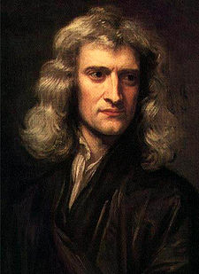
Photo of Sir Isaac Newton. Source: http://www.newton.ac.uk/art/portrait.html

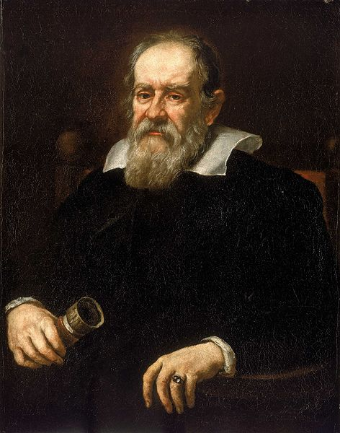
Photo of Galileo Source: http://www.nmm.ac.uk/mag/pages/mnuExplore/PaintingDetail.cfm?ID=BHC2700

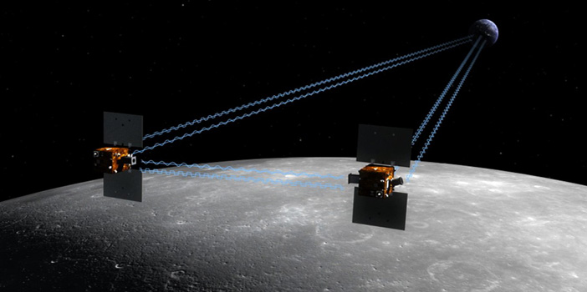
Photo of Gravity Interior and Interior Laboratory Source:
http://solarsystem.nasa.gov/grail/missionoverview.cfm
Name: _____________________________

Gravity and Orbits PhET

Part I: Orbits
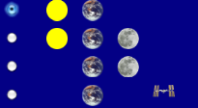
a) Draw the path of the Earth orbiting the Sun.

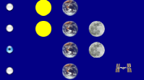
b) Draw the path of the Moon orbiting the Earth.

c) Based on your observations, what similarities and differences can you observe about the motion of the Earth (a) and the motion of the Moon (b)?

d) Based on your observations, how would you define the word “orbit”? Use (a) and (b) as your evidence.

Part II: What holds the Earth in orbit around the Sun and the Moon in orbit around the Earth? Explore the simulation to determine what keeps the Earth in orbit around the Sun and the Moon in orbit around the Earth.
a) What do you think the gravity force arrows represent?

b) What do you notice about the size of the “Gravity Force” arrows?

d) In what direction do the arrows point? What do you think this means?

e) Based on your observations, how would you define the word “gravity”?

Part III: Gravitational Force between the Earth and the Sun
a) It takes 365 days for the Earth to complete one revolution around the Sun. Find three different ways to change the number of days it takes for the Earth to complete one revolution around the Sun.
Method | How many days did it take to complete one revolution? | What did you do? | What happened to the gravitational force arrows? | Observations
1
2
3

b) In a few sentences, what can you conclude about how the size of a planet and its distance from the Sun affects its orbit?

Part IV: Gravitational Force between Different Planets and the Sun
a) Venus is called Earth’s “sister planet” because it is almost the same size (mass and diameter) as Earth. Venus is closer to the Sun, what can you say about the following? (Circle the word you think is correct)

- The Sun has a stronger/weaker gravitational pull on Venus than it does on Earth.
- Venus has a longer/shorter period of revolution around the Sun when compared to Earth’s period of revolution around the Sun.

b) Jupiter is has a much larger mass than the Earth and is farther away from the Sun. What can you say about the following?

- Jupiter has a longer/shorter period of revolution around the Sun when compared to Earth’s period of revolution around the Sun.
Name: _____________________
SHOW OFF WHAT YOU KNOW!

1. Gravity is a(n) _______ force that acts between two or more objects. Gravity exists ______ in the universe
a. repulsive, everywhere
b. attractive, in some places
c. repulsive, in some places
d. attractive, everywhere

2. As the distance between two masses decreases, the gravity force between them:
a. increases
b. decreases
c. remains constant

3. How did Galileo and Sir Isaac Newton differ in their views of gravity?
a. Galileo thought that gravity was unique to Earth, while Newton saw it as universal.
b. Galileo thought that gravity was a push, while Newton thought it was pull.
c. Galileo found that gravity affects objects with the same force, while Newton saw that gravity depends on the mass of an object.
d. Galileo and Newton’s views did not differ.

4. Astronaut Luke Starkiller wants to travel to the far away galaxy. He weighs 250N (Newtons) on earth. The table to the right shows the weight conversions for earth and two planets in that galaxy. In which planet will astronaut Starkiller feel the heaviest?
Planet | Conversion factor
Earth | × 1.00
Yavin IV | ×0.85
Yavin II | ×0.20
a. Yavin IV
b. Yavin II
c. Both Yavin IV and Yavin II
d. Earth
Name: _______________________

What’s your weight on other planets?
Due to the different gravitational pulls each planet has, you would weigh differently based on what planet’s surface you are on. Assume you weigh 300 Newtons. A Newton is a unit for measuring weight.
Planet | Conversion
Mercury | x 0.378
Venus | x 0.905
Earth | x 1
Mars | x 0.379
Jupiter | x 2.529
Saturn | x 1.066
Uranus | x 0.903
Neptune | x 1.096
Formula:
300 Newtons x conversion factor (see table above) = your weight on another planet

1) Planet 1: ___________________
a) Do you think you will weigh more or less on this planet? Why?

b) Calculate your weight on this planet.

Your weight =

2) Planet 2: ________________
a) Do you think you will weigh more or less on this planet? Why?

b) Calculate your weight on this planet.

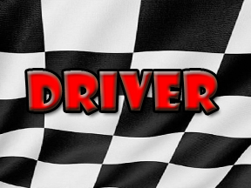
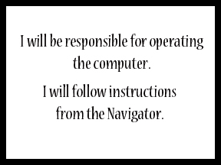
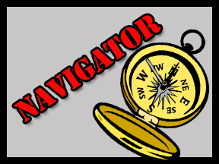
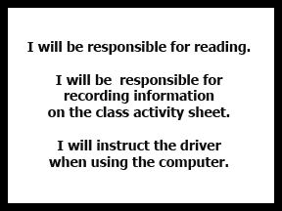

Name: ________KEY______________

Gravity and Orbits PhET
Part I: Orbits
a) Draw the path of the Earth orbiting the Sun.

It should be elliptical in shape, the simulation shows it a bit more circular than in reality

b) Draw the path of the Moon orbiting the Earth.

Although in principle it should be elliptical, a circular path of the moon around the earth is a sufficient first approximation

c) Based on your observations, what similarities and differences can you observe about the motion of the Earth (a) and the motion of the Moon (b)?
Similar: Both revolve around bigger object, elliptical, shorter the distance the shorter the speed, gravity force
Different: Moon's path is more circular and shorter radius of revolution, greater speed

d) Based on your observations, how would you define the word “orbit”? Use (a) and (b) as your evidence.
It is the path followed by an object revolving around another. It can be elliptical or circular.

Part II: What holds the Earth in orbit around the Sun and the Moon in orbit around the Earth? Explore the simulation to determine what keeps the Earth in orbit around the Sun and the Moon in orbit around the Earth.
a) What do you think the gravity force arrows represent? The direction where the arrows point is the direction of the pull and the length is the strength (i.e. longer arrow, greater force)

b) What do you notice about the size of the “Gravity Force” arrows relative to each other? As the objects come to a closer distance, the arrows get longer

c) In what direction do the arrows point? What do you think this means? The direction of the gravity force. That there is gravity force between two objects

d) Based on your observations, how would you define the word “gravity”?
It is a pull or force between two objects. It depends on the distance between the objects

Part III: Gravitational Force between the Earth and the Sun
a) It takes 365 days for the Earth to complete one revolution around the Sun. Find three different ways to change the number of days it takes for the Earth to complete one revolution around the Sun.
Method | How many days did it take to complete one revolution? | What did you do? | What happened to the gravitational force arrows? | Observations
1 | It took less time | Place the Earth closer from the Sun | Got longer | The time it took for one revolution went down
2 | It took more time | Make the velocity arrow longer | Started getting shorter | The path changed (different orbit). Took more time
3 | It took less time | Increase the size of the sun | Got longer | Took less time for one revolution
(For opposite actions the effect on revolution time is also opposite)

b) In a few sentences, what can you conclude about how the size of a planet and its distance from the Sun affects its orbit?
The shorter distance, means there is a smaller orbit. The larger the planet, the greater the gravity force (longer arrow) but the orbit remains the same.
Part IV: Gravitational Force between Different Planets and the Sun
a) Venus is called Earth’s “sister planet” because it is almost the same size (mass and diameter) as Earth. Venus is closer to the Sun, what can you say about the following? (Circle the word you think is correct)

- The Sun has a stronger/weaker gravitational pull on Venus than it does on Earth.
- Venus has a longer/shorter period of revolution around the Sun when compared to Earth’s period of revolution around the Sun.

b) Jupiter is has a much larger mass than the Earth and is farther away from the Sun. What can you say about the following?

- Jupiter has a longer/shorter period of revolution around the Sun when compared to Earth’s period of revolution around the Sun.

Answer Key for “What’s your weight on other planets?”

Planet | Will you weigh more or less? | Why? (Samples answers) | Your calculated weight.
Mercury | Less | Mercury is much smaller than the Earth. | (300)(0.378) = 113.4
Venus | Less | Venus is smaller than the Earth. | (300)(0.905) = 271.5
Earth | Same | This is our control factor. | (300)(1.0) = 300.0
Mars | Less | Mars is smaller than the Earth. | (300)(0.379) = 113.7
Jupiter | More | Jupiter is much larger than the Earth and thus has a larger gravitational force. | (300)(2.529) = 758.7
Saturn | More | Saturn is larger than the Earth. | (300)(1.066) = 319.8
Uranus | Less | Uranus is less dense and much farther from the Sun. | (300)(0.903) = 270.9
Neptune | More | It is larger than the Earth. | (300)(1.096) = 328.8

SHOW OFF WHAT YOU KNOW Answer Key:
- D- attractive, everywhere
- A- decreases
- A - Galileo thought that gravity was unique to Earth, while Newton saw it as universal.
- D- Earth

