Blissfield Physics Name_______________________
PhET Wave On A String 2012
http://phet.colorado.edu/sims/wave-on-a-string/wave-on-a-string_en.html

Set the controls to the following:
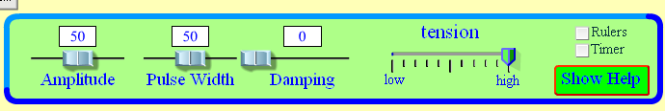

Reflection on a fixed end.
1. Click on pulse mode. Click on fixed end. Send a single pulse down the string. What does the pulse do when it hits the fixed end? Does it reflect upright or inverted?

Click on loose end. Send a single pulse down the string. What does the pulse do when it hits the loose end? Does it reflect upright or inverted?

Amplitude
2. Do you think amplitude will affect wave speed?____________________________

Click reset. Click on fixed end. Set amplitude to 100. Click on Timer (reset if needed). Click the pause button.
You will be timing the wave down and back two times. Record your time here___________.
Click reset. Set amplitude to 50. Click on Timer (reset if needed). Click the pause button.
You will be timing the wave down and back two times. Record your time here___________.
How did the times compare?__________________________________________________

Does amplitude affect wave speed? ___________

Wave Interference
3. Click reset. Click on fixed end. Set amplitude to 50. Unclick timer.
Send a pulse and then send another one as the first one reaches the fixed end. Click pause as soon as possible. Step the waves and observe what happens as they pass through each other.
This is called destructive interference.

Click reset. Click on fixed end. Set amplitude to 50. Click ruler. Click loose end.
Send a pulse and then send another one as the first one reaches the loose end. Click pause as soon as possible. Step the waves and use the ruler to record the height of an individual pulse (record here___________) record the height as the two waves interfere completely (record here___________). This is called constructive interference.

