Blissfield Physics 2012 Name____________________
Parallel Circuits
PhET http://phet.colorado.edu/en/simulation/circuit-construction-kit-dc

Draw a schematic diagram of a parallel circuit. Let R1 = 20 ohms, let R2 = 60 ohms, and let the battery V(Source) = 30 volts.

Calculate the effective resistance of the circuit. Show your work.

Calculate the current in the circuit. Show your work.

What is the voltage on R1? __________

What is the voltage on R2? __________

Calculate the current in each branch of the circuit. Show your work.

I1 = _______ I2 = ________

Now, lets check your work. Construct the above circuit (see diagram below) and record your results below.
Use a voltmeter to check the voltages and a non-contact ammeter to check the current in the circuit. Good luck!

V1 = _______ V2 = _______ I = _______ I1 = _______ I2 = _______

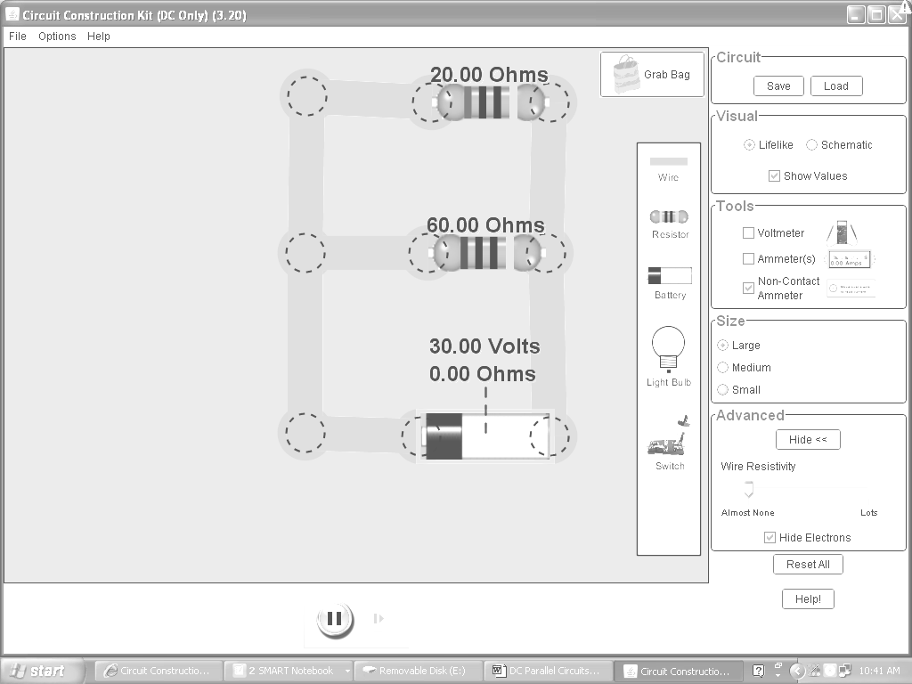

Follow up questions.

1. What do you notice about the values for V1 and V2?

2. How does the sum of I1 and I2 compare to I ?

3. Now, create your own parallel circuit with 3 resistors. Let two of the resistors be the same resistance R1=R2=40 ohms, R3=20 ohms, and let the voltage equal 30 volts.

- Draw your schematic below.
- Show your work.
- Calculate the effective resistance. (Reff)
- Calculate the current in the circuit. (I )
- Calculate the voltage across each resistor. (V1, V2, V3)
- Calculate the current in each branch. (I1, I2, I3)
- Finally, check your work by making the circuit on the applet.
- Let your instructor check your work and applet before you end the program.

