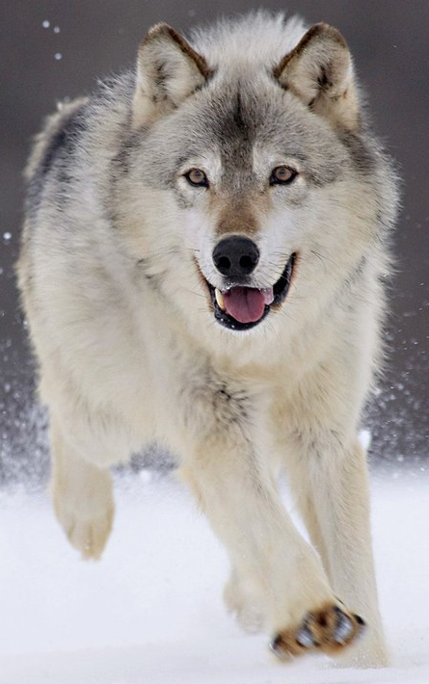
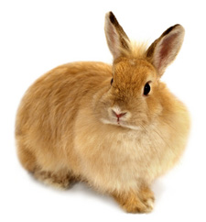
Name:_________________________________________________________________Hour:______
Natural Selection Bunny Simulation
http://phet.colorado.edu/en/simulation/natural-selection
Created by the HHS Biology Team Feb, 2012.

Background Information:

In the mid 1800’s a scientist named Charles Darwin discovered and developed a mechanism for evolution that he called natural selection. Natural selection simply stated that within any population with variation there would be a struggle for existence that would ultimately lead to the survival of the fittest. Darwin then went on to say that those traits that were the most fit would be passed on to the next generation more frequently. This continual selection for certain traits and against others over billions of years led to what Darwin called descent with modification. Descent with modification says that different environments selecting for certain traits over long periods of time could have caused an ancient ancestor of all life to be modified over and over again until it had evolved from a single species into all of the species that have lived on Earth since.
While Darwin defined the mechanism of evolution fairly accurately, there were two major components he was missing. Darwin had little to no idea what caused the variation he saw in nature and he could not explain how the variations he saw were passed from parent to offspring. It was not until the Hershey-Chase experiment in 1952, which showed DNA to be the hereditary molecule, and the discovery of the structure of DNA by Watson and Crick in 1953 that these questions could be answered. This discovery would change the way science studied evolution. Now that science knew it was DNA that caused the variation seen in nature and DNA that caused those traits to be passed from parent to offspring, they could focus on it as the root of evolution by natural selection. This meant that instead of approaching evolution by looking at how an organism’s phenotype (physical features) changed over time, scientists could study the evolution of an organism’s genotype (allele combinations). This leads to our modern definition of evolution: The increase or decrease in the frequency of an allele over time.
In today’s simulation you will be studying how mutations in the DNA of an organism can lead directly to the evolution of the population it is a part of. This will be done by tracking how allele frequency is dependent upon the core principles of natural selection.

Pre simulation: Do this before you log on and start the simulation.

1. Define the following terms—

Mutation:

Allele:

Allele frequency:

2. In your own words explain how you think that DNA, mutation, genotype, phenotype, and natural
selection interconnect to cause evolution.
The simulation: Today you will be using the simulation software to run three experiments. Follow the directions below to collect the required data then use that data to answer the discussion questions that follow.

Experiment 1: In this experiment you will be examining the effect of a recessive mutation that changes the color of the organism and alters how it avoids predators.

Before you start: Read through the experiment. Then in the space below hypothesize how this change in DNA will affect the evolution of this population over the next 10 generations. (Remember… if, then, because)
_______________________________________________________________________________________________________________________________________________________________________________________________________________________________________________________________

1. Log onto your computer and go to the website listed on the first page. Once this page loads
click on the “run now” button under the picture of the simulation.

2. Take a few minutes to familiarize yourself with how the simulation software works. Be sure
to notice the following:

The population graph under the environment. This is where you will get the number of each type of rabbit. You can zoom in or out to get a more accurate reading of population size.

The generation bar, play, and pause buttons. These give you a time before each breeding period. The pause button allows you to stop the simulation so you can read the graph and take your data.

3. When you are ready to start your first experiment make sure the environment is set to “equator” then click on the “add a friend” button in the lower left hand corner of the environment. This will start the simulation. Watch the generation bar and let it run twice,
then hit pause. Record the data from the graph for generation two in data table 1.

4. Once you’ve recorded the data, click on “Brown fur” in the add mutation section of the simulator. Using the edit genes section of the simulator change brown fur to a recessive trait.

5. Start the simulation and let it run for two more generations. At this point pause the simulation and use the graph to fill in generation 4 data in data table 1.

6. Now add wolves as a selection factor and start the simulation. Let the simulation run
for three more generations. Hit pause and collect the data for generation 7 on data table 1.

7. Click play and let the simulation run for three more generations. Pause the simulation and
record the data for generation 10 in data table 1.

Experiment 2: In this experiment you will be examining the effect of a dominant mutation that changes how the organism obtains food.

Before you start: Read through the experiment. Then in the space below hypothesize how this change in DNA will affect the evolution of this population over the next 10 generations. (Remember… if, then, because)
_______________________________________________________________________________________________________________________________________________________________________________________________________________________________________________________________

1. Click the reset all button in the lower right hand corner of the simulator

2. When you are ready to start your second experiment click on the “add a friend” button in the lower left hand corner of the environment. This will start the simulation. Watch the generation bar, let it run twice, then hit pause. Record the data from the graph for generation two in data table 2.

3. Once you’ve recorded the data click on “long teeth” in the add mutation section of the simulator. This mutation should already be designated as the dominant trait but check the edit genes section of the simulator to be sure.

4. Start the simulation and let it run for two more generations. At this point pause the simulation and use the graph to fill in generation 4 data in data table 2.

5. Now add food as a selection factor and start the simulation. Let the simulation run
for three more generations. Hit pause and collect the data for generation 7 on data table 2.

6. Click play and let the simulation run for three more generations. Pause the simulation and
record the data for generation 10 in data table 2.

Experiment 3: In this experiment you will be examining the effect of a dominant mutation that changes the length of the rabbit’s tail. Your job in this simulation is to determine whether or not having a longer tail gives the rabbits an advantage when trying to escape predators.

Before you start: Read through the experiment. Then in the space below hypothesize how this change in DNA will affect the evolution of this population over the next 10 generations. (Remember… if, then, because)
_______________________________________________________________________________________________________________________________________________________________________________________________________________________________________________________________

1. Click the reset all button in the lower right hand corner of the simulator.

2. When you are ready to start your third experiment click on the “add a friend” button in the lower left hand corner of the environment. This will start the simulation. Watch the generation bar, let it run twice, then hit pause. Record the data from the graph for generation two in data table 3.

3. Once you’ve recorded the data click on “long tail” in the add mutation section of the simulator. This mutation should already be designated as the dominant trait but check the edit genes section of the simulator to be sure.

4. Start the simulation and let it run for two more generations. At this point pause the simulation and use the graph to fill in generation 4 data in data table 3.

5. Now add wolves as a selection factor and start the simulation. Let the simulation run
for three more generations. Hit pause and collect the data for generation 7 on data table 3.

6. Click play and let the simulation run for three more generations. Pause the simulation and
record the data for generation 10 in data table 3.

Data and Analysis:

Data table 1 | Graphical Data |  |  | Percentage calculations
Generation number | Number of Brown | Number of White | Total | % Brown Rabbits | % White Rabbits
2

4

7

10

Analysis:

1. Calculate the percentage of each color of rabbit using the following method:

% Brown rabbit = (Brown rabbits / Total rabbits) X 100
% White rabbit = 100% - % brown rabbits.

2. Briefly explain how this change in DNA affected the allele frequency of the population. Be sure to use your data in this explanation.

3. Does the data in the table above support the hypothesis for this experiment? Be sure to use your data in an explanation of why the data does or does not support your hypothesis.

Data table 2 | Graphical Data |  |  | Percentage calculations
Generation number | Number of Normal teeth | Number of Long teeth | Total | % Normal Tooth Rabbits | % Long Tooth Rabbits
2

4

7

10

Analysis:

1. Calculate the percentage of each tooth type using the following method:

% Long tooth rabbit = (Long tooth rabbits / Total rabbits) X 100
% Normal tooth rabbit = 100% - % Long tooth rabbits.

2. Briefly explain how this change in DNA affected the allele frequency of the population. Be sure to use your data in this explanation.

3. Does the data in the table above support the hypothesis for this experiment? Be sure to use your data in an explanation of why the data does or does not support your hypothesis.

Data table 3 | Graphical Data |  |  | Percentage calculations
Generation number | Number of Short Tail | Number of Long Tail | Total | % Short Tail Rabbits | % Long tail Rabbits
2

4

7

10

Analysis:

1. Calculate the percentage of each tail type using the following method:

% Short tail rabbit = (Short tail rabbits / Total rabbits) X 100
% Long tail rabbit = 100% - % brown rabbits.

2. Briefly explain how this change in DNA affected the allele frequency of the population. Be sure to use your data in this explanation.

3. Does the data in the table above support the hypothesis for this experiment? Be sure to use your data in an explanation of why the data does or does not support your hypothesis.

Discussion Questions: Use your data, your knowledge of evolution, and genetics to answer the questions that follow.

1. Given the current definition of evolution being a change in allele frequency over time, did any of the mutations above fail to cause the population to evolve? If so which one? Use your data to explain how you know.

2. Predict what would have happened in simulation 1 if you had switched the environment from equator to arctic. Do you think the brown rabbits could have been completely bred out of the population like the white ones may have been in simulation 1? Why or Why not?

3. In simulation three there should have been very little change in the percentage of each type of rabbit. Why did the allele frequencies not change as drastically in this simulation as they did in the other two?

4. Compare your data from simulation 1 and simulation 2. In simulation 1 the mutation was recessive; in simulation 2 the mutation was dominant. What was different about how these two populations evolved after the mutation? Did being the dominant form of the trait insure that it would be selected for?

5. The mutations you made were in reality small changes in the DNA. Briefly explain how a small change in DNA can cause such a huge evolutionary shift within a population.

