Student guide: Name:____________________
Discuss the words in the box.
  - review we have already covered and new you will learn today
Review: New: (check-off at the end)
crest amplitude
trough frequency
line of origin oscillate vs. pulse

Guiding Question:
How do the properties of amplitude and frequency affect wavelength?
Start:
Phet Waves on a string
- Click on the first link
- For this activity you will be collecting data to explore three properties of a wave.
-  Explore the simulation with your partner. Be sure to click on all the buttons.
- For the first set of investigations, we will look at amplitude.
  - you need to be on
  - The rest of your screen should be set up like this:
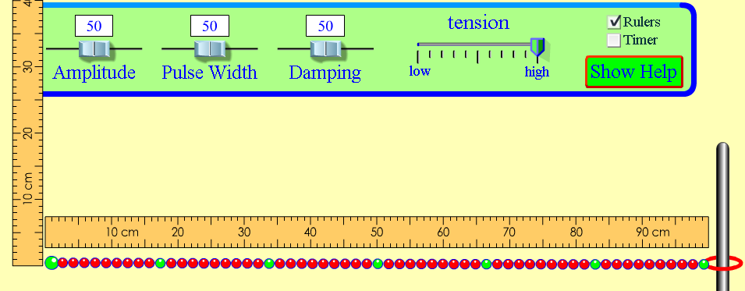
Look over the data table, on the back, and discuss how get the data you need.
 moves the wave.

Amplitude setting | Height of wave at the start  (be sure your ruler is lined up correctly) | Distance ring moves on pole (end)
100
50
5
Discuss what happened to the energy at the end of the wave when we changed the amplitude. Be prepared to share your thoughts on this with the class
- Repeat number 4 – using and then
 Why didn’t we use these options for the experiment with the amplitude button?
__________________________________________________________________ Teacher
Check- point
- For this next part we will investigate wavelength.
  - You need to be on
  - The rest of your screen should be set up like we did for number 4.
  - Try out the  button after you hit pause. This may be useful for collecting data.
Data:
wavelength = _______ cm

Wavelength = _____ cm
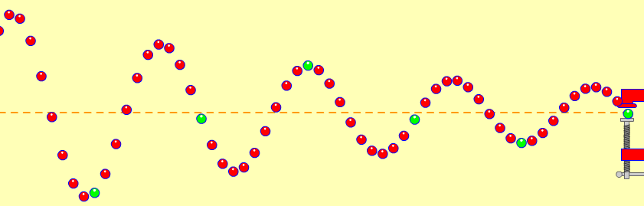
7. Talk about the wavelength of the two waves you measured.
- Discuss how they were similar and how they were different.
- Be prepared to share your thoughts with the class.

Teacher check-off
Day 2: For the third set of investigations, we will look at frequency.
Name __________
  - you need to be on
  - open both the ruler and timer
  - controlled variables: Amplitude and damping should be left on 50 and tension stays on “high”
  - Remember, to stop or slow the wave use pause/play and .
- Look over the data table and discuss how you will collect the data you need.
- Before you begin… try a little practice using the timer:
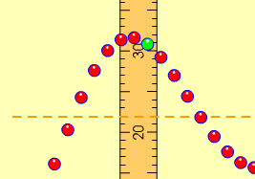
- Turn the timer on, off and reset the timer while waves are moving.
- Practice counting waves passing a given point:
- Move the vertical ruler so that it is along the wave’s path. This will be the point where you watch waves pass and count them. Count 5 waves passing the ruler. Change the frequency and count again.
- Fill in the table by working together counting the waves and using the timer.
Data:
frequency | Time interval | Number of waves: |  |  | Average number of waves counted in 10 second period | Number of waves in 1 second  _{frequency**}
frequency | Time interval | Trial #1 | Trial #2 | Trial #3 | Average number of waves counted in 10 second period | Number of waves in 1 second  _{frequency**}
50 | 10 seconds
10 | 10 seconds
100 | 10 seconds
*To find frequency, divide the average number of waves counted by the time interval.
5. Talk about the data.
- Decide on a way your group can explain wave frequency to the class.
- Write your idea(s) on the lines.
___________________________________________________________________
___________________________________________________________________
___________________________________________________________________

Frame: Our data show that the higher the number chosen for the frequency on the slider, the _________________ the number of waves passing ____________________ in a certain amount of ________________________.

6. Use arrows, or draw on the wave, to show what will happen when the amplitude is increased:
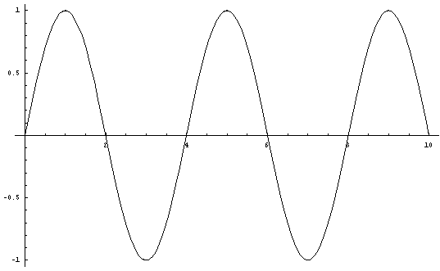
Line of --origin------
- Use arrows, or draw on the wave, to show what will happen when the frequency is increased:

Line of --origin------

