Anatomy of a Wave – partner activity (introduce periodic motion of waves (2-D), crest and trough, wavelength – length of one wave)
Materials:
Laminated copy of a simple transverse wave picture Lab notebooks-new page- with page dated pencil
Part I:
- Have students break into groups of 2 or 3.
  - One is the “reporter” and will get the laminated sheet (does not look at until told to by teacher and doesn’t at anytime show others)
  - Partners are the “artists” –they will try to draw what the reporter describes

- Tell students that the sheets the “reporter” will get are top secret – no peeking!
  - Rules while describing the picture to artists:
    - Reporters cannot comment on artists work! They can answer questions, but cannot look at a picture and clarify by “showing” them.
- Hand out laminated copies of a basic wave shape (see next sheet)
- Allow reporters to look at their sheet – tell other students to close their eyes because they will look at other students’ pictures. Remind students this is FUN!!! NO CHEATING!!!
- Give a quick instruction about how the “reporter” will be telling them about the picture they will draw.
- Walk around listening as the students instruct the “artists” on how to draw the picture of the wave.
- I give them 5 minutes but if they start trying to look around and lose focus…I wrap it up.

Part II:
- I collect the laminated copies and ask the students to turn their picture over. (turn the page in their lab notebooks) – the reporters find a fresh page, too.
- I go through the activity again giving instructions for all to draw.
- After we all finish- we look at both drawings and I put the picture on the document camera/computer/overhead
- We make touch ups and talk about difficulties with listening and creating images.
The goal is to draw and label a basic wave – in a fun, interactive way
****Be sure to put describe a wavelength and have them add it to the drawing. (I go from crest to crest to give them the easiest view)

crest crest crest
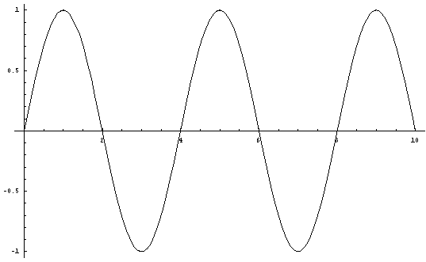
Line of --origin------
trough trough

