Student guide: Name:____________________
Start:
Phet Energy Skate Park
- Click on the first link
- Click on the button.
-  Explore the simulation with your partner and complete the following checklist: 
    - Move the blue dots on the track and run the skater. 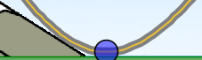
- Try out different locations.
- Try different skaters.
- Try the different energy graphs. 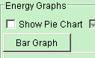

- Add friction to a track. 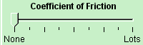
 Time to explore potential energy, kinetic energy and conservation of energy.
- Reset the simulation. Then make your screen look like the picture by
- clicking to open the bar graph
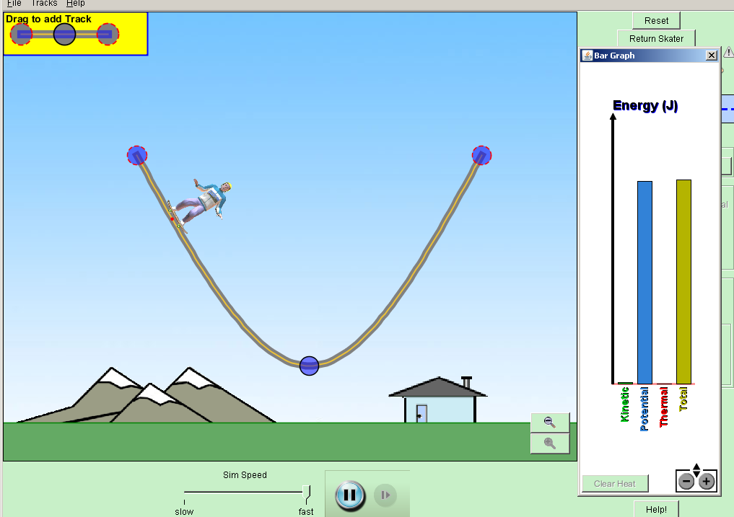
- dragging the graph closer to the track.
- ask if you need help

  -  Discuss the changes in the bar graph as the skater moves on the track

  - Use the symbols to fill in the data table:
(↑ increases, ↓ decreases, S for stays the same)
Skater’s movement |  | Potential energy  ( ↑ ↓ S ) | Kinetic energy  ( ↓ ↑ S ) | Total energy  ( ↑ ↓ S )
Down the hill | 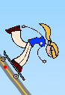
Up the hill | 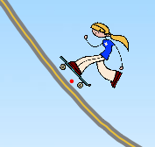
 Discuss any patterns you see for the energy data table.
- Change the skater and repeat #4. 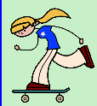   
- Add symbols ( ↓ ↑ S ) to complete the observation statements:
As an object moves down the track, the kinetic energy _________ and the potential energy ____________. When the object moves up the track the kinetic energy ________ and the potential energy _______.

- Look at your data table and focus on the Total energy column. Write a statement or two about the “total energy” of the object moving up and down the track.

Name______________________________
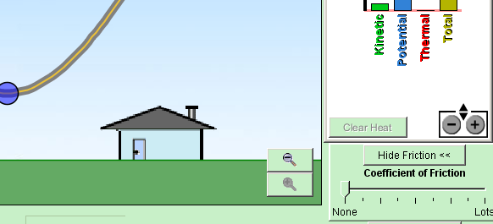
Time to explore friction!
- Reset the simulation.
  - Open the bar graph again
  - Click .
  - Move the slider to change the friction
Discuss the changes in the bar graph as the skater moves up and down on the track.
- Use the symbols to fill in the data table.
(↑ increases, ↓ decreases, S stays the same)
Skater’s movement | Potential energy  ( ↑ ↓ S ) | Kinetic energy  ( ↓ ↑ S ) | Total energy  ( ↑ ↓ S ) | ________  ( ↑ ↓ S )
Down hill
Up the hill
Discuss any patterns you see in the data table.
- Change the skater and repeat this part of the activity.
Add arrows the complete the following observations. ( ↑ ↓ S )
- As an object moves down the track, the kinetic energy _________ and the potential energy ____________. The total energy __________________.
- After watching the bar graph while the object is moving, especially with “lots” of friction, write a title for the last column. Use the symbols to fill in the last column.
-complete the observation statement:
As the skater moves with friction, the kinetic energy and potential energy both ___, the thermal energy________ and the total energy ________.
Write a possible explanation for this. ______________________________________________
______________________________________________________________________________________
- Discuss what changed and what stayed the same when friction added to the skate park .
____________________________________________________________________
____________________________________________________________________
____________________________________________________________________
- Which situation, with friction or without friction, is more similar to your everyday experience on a skateboard or bicycle? Write at least 2 sentences to explain your answer.

____________________________________________________________________
____________________________________________________________________
____________________________________________________________________

