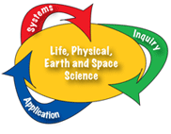
Boulder Valley School District: Essential Learnings /Alignment with Colorado State Standards:

Standard 2: Students know and understand common properties, forms and changes in matter and energy
*PYS7: Applies an understanding of the conservation of mass to physical and chemical
changes within a system

c. Applies the law of conservation of mass to chemical changes (for example: determine the mass of products given the reactants)

e. Defines chemical change as a change in which existing substances react to form new substances with different properties

PYS10: Describes the similarities and differences among elements, molecules,
compounds and mixtures

f. Identifies whether or not a simple chemical equation is balanced

Technology Integration Expectations: (Technology Integration and Information Literacy)
Students will use technology:
- responsibly for communication and transfer of ideas
- to gather, organize, analyze and communicate about data
- to collaborate with others to identify information problems and seek their solutions

*PYS stands for Physical Science

