Learning Goals: Students will be able to:
- Draw pictures that show the difference in the arrangement of molecules for the solid state, the liquid state and the gas state as seen under a microscope.

- Discuss the affects of adding or removing heat to matter

- Answer the following question: When heat is added to a solid, liquid or gas in a closed system, how would the particles be moving if we could see them under a microscope?

- Determine some variables that bring about changes in speed and arrangement of atoms or molecules.

Background:
Prior to the simulation, a brief lesson concerning the four states of matter would be helpful to familiarize students with the vocabulary- solid, liquid, gas/vapor, plasma. Remind students that, although we cannot see molecular motion with just our eyes, molecules and atoms are always moving.
 indicates students write a response 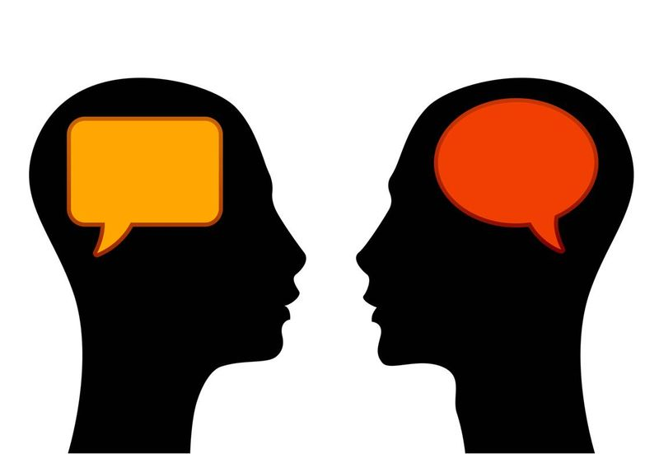 indicates students will discuss with partner

Indicates students need to check-in with the teacher
Teacher notes:
- I only use the first two tabs with my middle school students. This activity works well as a demo, but I prefer to have students work in pairs in the computer lab. The third tab is beyond the scope of my lesson, but as a teacher, it is worth checking out.
- Keep students focused on the learning goals. Writing the question from the third objective on the board and referring back to the goals frequently may also be useful. This lesson is intended to explore the states of matter based on speed and arrangement of the particles involved. The last page is an enrichment activity for students who learn quickly and are likely to finish early. It is also intended to allow for further exploration of the simulation outside the context of the lesson.
- Check boxes are used for students to check-in with the teacher.
- “Frames” are added to help students frame an answer to the question. I use them because I have a large range of learners including many English Language Learners, and in the first half of the year they are hesitant to put their thoughts in writing for me.
- I finish this part of the unit with a physical lab called Boiling Ice – using a thermometer, stop watch, tin can, ice cubes or snow, hot plate and safety goggles. The goal is to generate a change in state (solid water to water vapor) as temperature increases/time goes by. I have them chart the temperature every 2 minutes and note when they see changes in state. We graph their results and compare them to better research data to see how accurate they were and what might be some sources of error. We wrap up by discussing that all solids have a melting point and boiling point/plateau with changes in state- ice is just really easy for us to work with. Lastly, I check their understanding by asking them about boiling gold- or any other substance (like rock –magma!) and what the curve might look like.
- Possible Extension –Gas Properties simulation. The gas laws fit well here. Students can see that pushing down on the finger in the Phase change tab will reduce the volume and the pressure will quickly build until the lid blows off. They can try to come up with an explanation for why the lid blew off. To go deeper, however, use the Gas Properties simulation where they can move the container walls or add heat etc. It is a good illustration that gases behave according to the variables at work in the gas laws.
- I assess this unit with student interviews. If you would like more information about this time consuming, but very worthwhile process, please feel free to e-mail me.

