Pre-Lab for Density Simulation: Name: ___________________
B
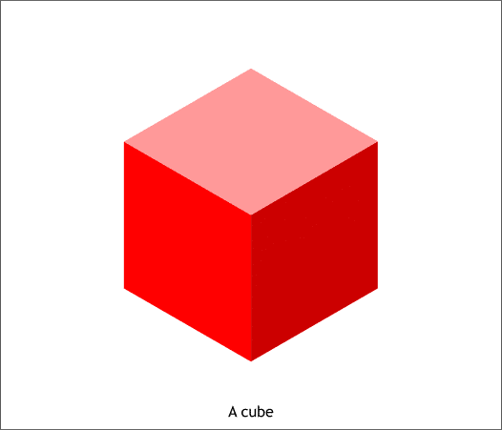
A
1. Will cube (A) sink or float in water? I think it will _______________ because _____________________
____________________________________________________________________________________
2. Will cube (B) sink or float in water? I think it will ______________ because ______________________
____________________________________________________________________________________
C. D.
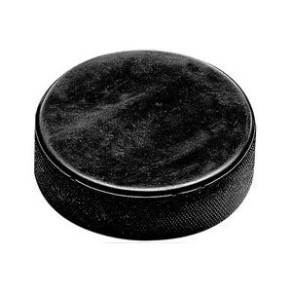material: plastic hockey puck
Mass: 11.5 grams
Volume: 38 cm³
Density: 0.3 g/cm³
material: “metal” hockey puck
Mass: 40.1 grams
Volume: 38 cm³
Density: 1.1 g/cm³

3. Will (C) sink or float in water? Explain your answer. ________________________________________
4. Will (D) sink or float in water? Explain your answer. ________________________________________
5. You are given two solid gold bricks (Au)! Which
1. 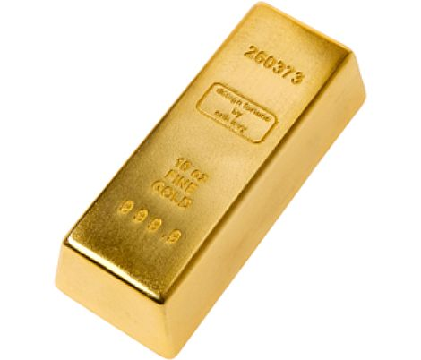 2.
properties change from brick number 1 to brick number 2?
Choose the answer(s) that apply.
A. the mass of the gold will change
B. the volume of the gold will change
C. the density of the gold will change
6. I love silver (Ag)! I won a contest and the prize was a life-sized statue of my dog!
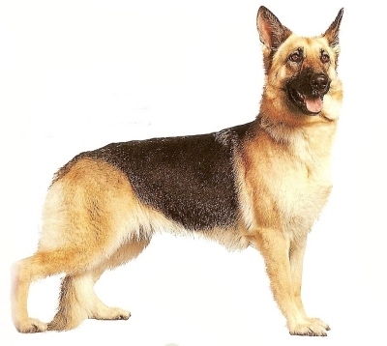 I pick up my prize worth $6,000.00! On the way out, I start thinking that it isn’t very heavy for an object of this size made of solid silver. I know it is only a “prize” that I won, but I think it might be made of something other than valuable silver.
How could I find out for sure if this statue is made of solid silver?
(Please write out your answer on the back-tell me everything!)

