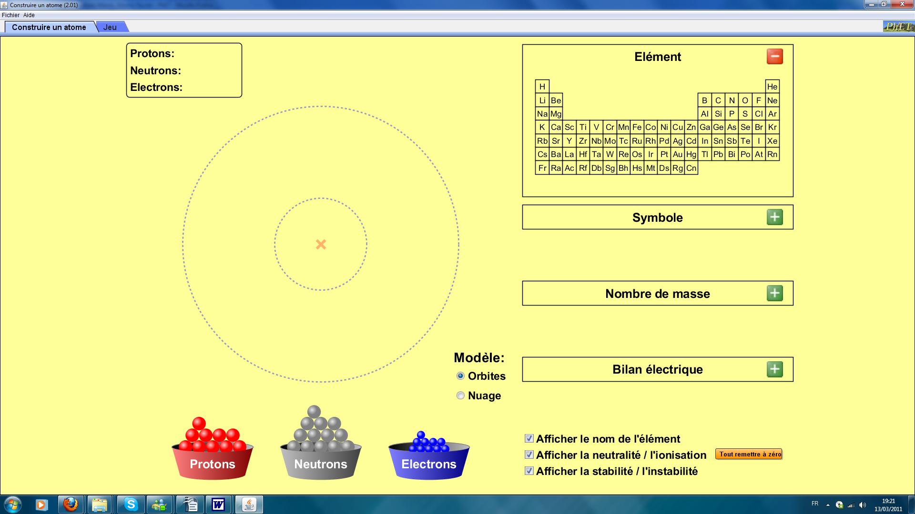


Welcome to T.C.A. (Technical Center for Atoms).
(Translation supervisor : J.L. Houville)

Connect to PhET è Chemistry è « Build an Atom »

I Atoms

To build an atom you need very few "materials" : protons, electrons and neutrons (nothing more) !...
You just have to comply with two obligations:
- The atom has to be neutral.
- The atom has to be stable.

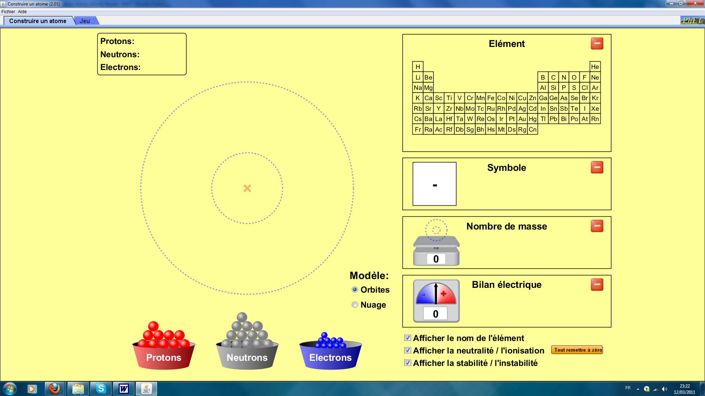
Open
the 3
windows
Check the 3 cases

1) Build a carbon atom (neutral and stable, of course ! )
- How many protons do you need ? .........
- How many electrons do you need ? .........
- How many neutrons do you need ? ......... or .........

Draw your carbon atom (the one with mass number = 12)

Orbits model:

Cloud model:

2) Fill up the following table:

 | Protons  number | Neutrons  number | Mass  number | Electrons  number | Symbol
Hydrogen

Helium

Nitrogen

Oxygen

Conclusions:
- Can you define an equality between the mass number, the protons number and the neutrons number ?
....................................................................................

- In which condition is the atom neutral ? .............................................................
₇ ₀
3) Hence the symbol: Li .Build the corresponding atom, draw it and
³ ^{here}
name it:
(here) : ...............................

II Ions

If the net charge differs from zero, the corresponding structure is called an « ion ».
If the net charge is negative, it is called a negative ion (ion-).
If the net charge is positive, it is called a positive ion (ion+).

₁₇ ₂₋
1) Hence the symbol: O
⁸
Build the corresponding ion-, draw it
here

and name it:

here ......................................................

What is its mass number ? ............................
How many protons does it have? .........................
How many neutrons does it have ? ...........................
How many electrons does it have ? ...........................

₉ ₊
2) Hence the symbol: Be
⁴

Build the corresponding ion+, draw it
here

and name it:

here ......................................................

What is its mass number ? ............................
How many protons does it have ? .........................
How many neutrons does it have ? ...........................
How many electrons does it have ? ...........................

III Isotops

We have seen (page 2) that the oxygen atom has 3 stable structures:
₁₆ ₀ ₁₇ ₀ ₁₈ ₀
O O O
⁸ ⁸ ⁸
generally written:
₁₆ ₁₇ ₁₈
O O O
⁸ ⁸ ⁸
without zero due to the null net charge.

But, in the following table, which is the "periodic table of the éléments", only one oxygen structure appears (the first one) !

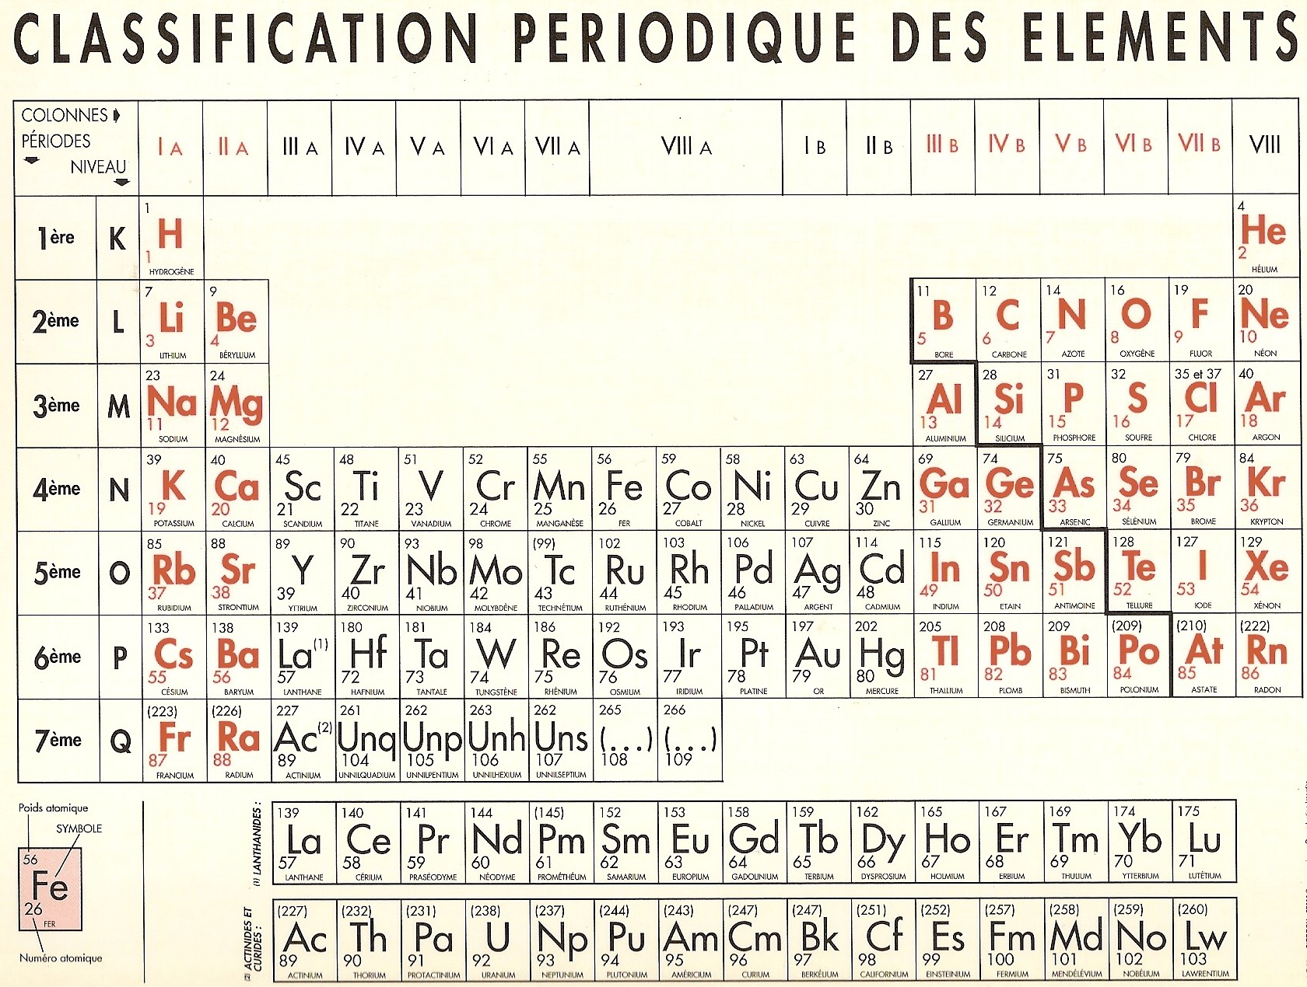
^{Mass number}
^{Atomic number}
^{Mass number}
So what ? Did the T.C.A. (Technical Center for Atoms) ^{[remember]} get a bad stuff ??!!

Be quiet, the PhET simulation is perfect.

In fact, the three oxygen structures coexist in nature, but oxygen 16 represents 99,762 % of all. (Oxygen 17 : 0,038 % , and oxygen 18 : 0,2 %.)

These three atom structures are called "isotops" and in the periodic table of the elements the isotop with the most natural abondancy appears.

Remark. Exception made for the chlorine atom for which two isotops are mentionned:
- chlorine isotop 35 : 75.8 %
- chlorine isotop 37 : 24.2%

IV Game

Before evaluation, you can test and train yourself by clicking on the thumb index :"game" .

Insert your performances. (5 questions per level.)

Level 1

Level 2

Level 3

Level 4

Name: ...........................................................
First name:...................................................

Assessment
1) Using the simulation, build and then draw the fluor isotop 19 atom.
Drawing (orbits model):

What is the mass number ? .......................
What is the protons’ number ? ....................
What is the neutrons’ number ? ...................
What is the electrons’ number? ...................

Write its symbol :

2) What would happen by adding one electron to this atom?

₆₄ ₂₊
3) Hence the symbol: Zn
³⁰
- What is the significance of Zn ?........................................
- What is the mass number ? ..............................................
- What is the protons’ number ? ...........................................
- What is the neutrons’ number ? ..........................................
- What is the electrons’ number ? .........................................
- Is it an atom or an ion ? ..............................................

4) Using the the periodic table of the elements, can you define the atomic number of an atom ?

