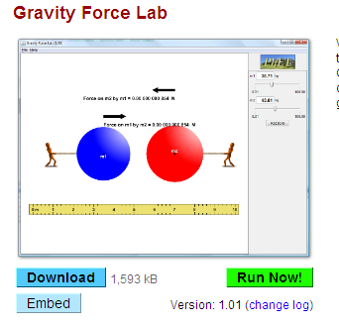
Gravity Lab Introduction

Name

Go to http://phet.colorado.edu/en/simulation/gravity-force-lab
And select RUN

Qualitative Observations.

- Move the masses closer. When they move closer the force between them becomes (Greater/Less/the same)
- Move the masses further apart. When the masses move away the force between them becomes (Greater/Less/the same)
- Double Mass 1. When mass 1 is doubled the force between them becomes (Greater/Less/the same)
- Cut Mass 2 in half. When the mass is reduced the force between them becomes (Greater/Less/the same)
- In any of the situations did the forces ever differ in magnitude?
- In any of the situations did the forces ever not point in opposing directions?
- What physics LAW explains questions 5 and 6 (either give name or definition)

Quantitative.

MASS

It is now time to build a model. First, let us examine the relationship between masses.

-Separate Mass 1 and Mass 2 so that their centers of mass (black dots) are 6 meters apart.

-Set Mass 2 to 30.0 kg.

-Start Mass 1 at zero kg. Collect 10 data points with the gravitational force being your dependent variable and your Mass 1 being independent.

-Sketch a graph.

-Redo the experiment but set Mass 1 to 30.0 kg and collect data on Mass 2’s relationship to force.

- Does it matter which mass increases?

- What type of relationship is there between Mass and force?
DISTANCE

-Set both masses to 30.0 kg.

-Collect 10 data points of different distances between the masses. Take note you can move the ruler and the masses to maximize your range.

-Sketch a graph of Force vs. Distance (F vs. r)

- What is the relationship between distance and the force of gravity?

-Linearize the graph. Be careful!

- What is the actual relationship between distance and the force of gravity?

See if you can write out the proportions between Mass 1 (m₁), Mass 2 (m₂) distance (r) to the Force of gravity (F_{g}).

F_{g}

Check with your instructor to make sure your proportionality is correct. If you are correct, you should notice entering lab data for m₁, m₂, and r does not equal F_{g}. Also work out your units, do they equal a Newton? This means there is also a constant (G) that we need to multiply to our proportionality to complete our formula.

Make a graph of Force vs. your proportionality; this will help determine your constant (G)

Determine the gravitational constant (G) that will multiply to your units. Give k its proper unit too. Hint, all your units combined need to = a Newton.

G=

Write your full formula and check with your instructor. Congratulations!

