Lab Activity – Momentum Name:_________________________
Physics Date: _________________________

Part 1: Center of Mass (From the Dick and Rae Physics Demo Notebook)

Procedure A:  - Stand next to a wall so your toes and nose are touching the wall. Put your hands behind your back.  - Try to stand on your tip toes without falling. What happens? _________________________ ______________________________________ Why? ________________________________ ____________________________________________________________________________  - Stand in a doorway so your toes and nose are against the doorway.  - Grab a weight in each hand and hold your arms out from your body on either side of the wall. | 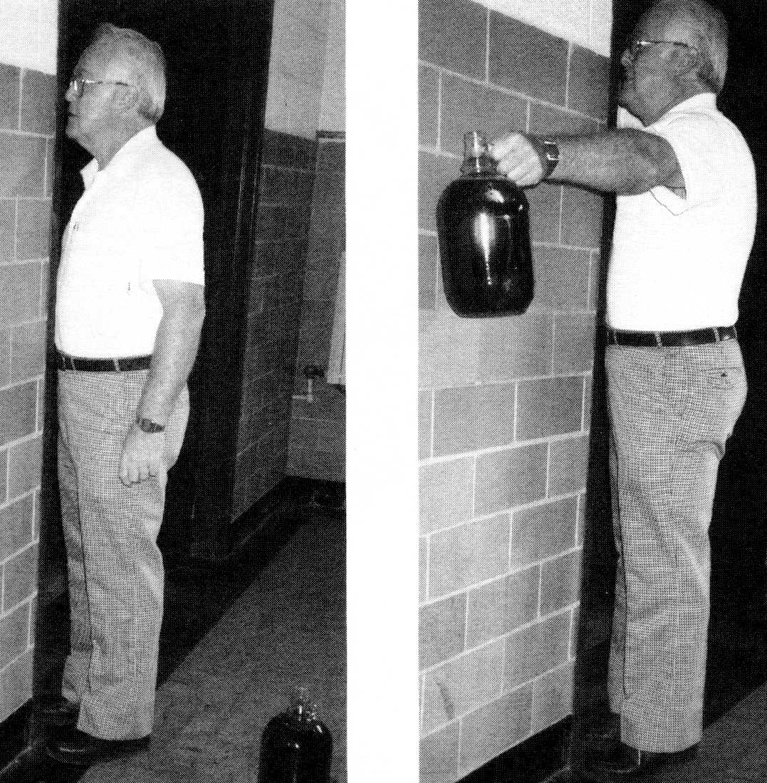
- Try to stand on your tip toes. What happens? _____________________________ Why? ____________________________________________________________ __________________________________________________________________ Should the same amount of weight help people of all heights / weights? Why / why not? _________________________________________________________ __________________________________________________________________

Procedure B:
- Obtain 10 meter sticks
- Lay one flat on a table so the 100 cm end is flush with the end of the table.
- Consider the zero end of this meter stick to be the origin.
- Set the second meter stick on top of the first 4.6 cm from the origin.
- Continue stacking the sticks according to the chart below:
Meter Stick | Distance from Origin
1 | 0 cm
2 | 4.6 cm
3 | 9.9 cm
4 | 16.0 cm
5 | 23.3 cm
6 | 32.3 cm
7 | 43.8 cm
8 | 59.5 cm
9 | 83.5 cm
10 | 132.0 cm
Questions:
Consider the mass of each meter stick to be 1. Relative to the origin:
1. What is the center of mass of one meter stick?
2. What is the center of mass of the first two meter sticks? (Show work)

3. What is the center of mass of all ten meter sticks? (Show work)

4. Explain why the sticks don’t fall.

Part 2: Momentum Web Quest

Procedure C:
- Open the Physics Animations folder, then open the “Collision Lab”
- Click “1 Dimension” at the top.
- Drag the green ball all the way to the right. Observe the “X”
- What does the X represent? ___________________________________________
- Which ball must be more massive? _________ How do you know (other than the fact that it tells you at the bottom) ___________________________________
- Hit Play and Observe the X, Pause it when the X changes direction.
- What happened that made the X change direction? ________________________
- If the velocity of X is supposed to be constant for any system, then why does speed and direction change? __________________________________________
- Reset the animation. Click 1 Dimensional again. Click the button that says “More Data”
- Drag the red ball all the way to the left, and the green ball all the way to the right.
- Hit Play, but Hit Pause before the balls collide.
- If you were an observer on the red ball, what would the velocity of green ball be relative to you (include a direction)? __________________________
- If you were an observer on the green ball, what would the velocity of red ball be relative to you (include a direction)? __________________________
For all Calculations, Show Your Work. Used the data to check yourself.
- Calculate:
The initial momentum of mass 1: ______________________________________
The initial momentum of mass 2: ______________________________________
Total initial momentum: _____________________________________________
The initial kinetic energy of mass 1: ____________________________________
The initial kinetic energy of mass 2: ____________________________________
Total initial kinetic energy ___________________________________________
- Hit play again, but hit pause immediately after the collision (don’t allow a ball to hit a wall)
- Calculate:
The final momentum of mass 1: _______________________________________
The final momentum of mass 2: _______________________________________
Total final momentum: ______________________________________________
The final kinetic energy of mass 1: _____________________________________
The final kinetic energy of mass 2: _____________________________________
Total final kinetic energy: ____________________________________________
- What can you conclude about the momentums and kinetic energies of the system? __________________________________________________________________
- What type of collision is this (look up in chapter 10): _______________________
- Reset, select 1 Dimension again, and set the elasticity = .50
- Hit play and pause before and immediately after the collision (don’t allow a ball to hit a wall)
- Calculate:
The initial momentum of mass 1: ______________________________________
The initial momentum of mass 2: ______________________________________
Total initial momentum: _____________________________________________
The initial kinetic energy of mass 1: ____________________________________
The initial kinetic energy of mass 2: ____________________________________
Total initial kinetic energy: ___________________________________________

The final momentum of mass 1: _______________________________________
The final momentum of mass 2: _______________________________________
Total final momentum: ______________________________________________
The final kinetic energy of mass 1: _____________________________________
The final kinetic energy of mass 2: _____________________________________
Total final kinetic energy: ____________________________________________
- What can you conclude about the momentums and kinetic energies of the system? __________________________________________________________________
- What type of collision is this (look up in chapter 10): _______________________
- Reset, select 1 Dimension, and set the elasticity = .50
- Hit play and pause before and immediately after the collision (don’t allow a ball to hit a wall)
- Calculate:
The initial momentum of mass 1: ______________________________________
The initial momentum of mass 2: ______________________________________
Total initial momentum: _____________________________________________
The initial kinetic energy of mass 1: ____________________________________
The initial kinetic energy of mass 2: ____________________________________
Total initial kinetic energy: ___________________________________________

The final momentum of mass 1 and 2 together: ___________________________
The final kinetic energy of mass 1 and 2 together: _________________________
- What can you conclude about the momentums and kinetic energies of the system? __________________________________________________________________
- What type of collision is this (look up in chapter 10): _______________________

Procedure D:
- Reset the Collision WebQuest, but leave 2 Dimensions checked.
- Hit Play, but pause before the collision.
For all Calculations, Show Your Work. Used the data to check yourself.
- Calculate:
The initial x momentum of mass 1: ________________________________________
The initial x momentum of mass 2: ________________________________________
The initial y momentum of mass 1: ________________________________________
The initial y momentum of mass 2: ________________________________________
The total initial momentum in unit vector notation is: _________________________
- Predict what the velocity of mass 1 will be after the collision with mass 2 relative to the velocity of mass 2. (smaller, larger, or same?) _______________________
- Hit Play and pause immediately after the collision
- Calculate:
The final x momentum of mass 1: _________________________________________
The final x momentum of mass 2: _________________________________________
The final y momentum of mass 1: _________________________________________
The final y momentum of mass 2: _________________________________________
The total final momentum in unit vector notation is: __________________________
The final magnitude of the velocity of mass 1: _______________________________
The final magnitude of the velocity of mass 2: _______________________________
- Compare the final and initial momenta. _______________________________
- Compare the final velocities of mass 1 and mass 2. Explain why they are what they are. ____________________________________________________________________________________________________________________________________

