Physics Web Search: Projectile Motion Name_________________________
Period ________________________

Go to: http://phet.colorado.edu/get_phet/simlauncher.php

Part 1: Projectile Motion
    - At the top right click “tank shell”
    - Set the angle to 60° and the speed to 16m/s. Leave the mass and diameter as they are.
    - Calculate the maximum height, the range, and the time in the air for this projectile. Show your work.

    - Set the measuring tape at the origin and measure out the distance for your range. Place the bull’s-eye here so it is even with the x – axis.
    - Fire the projectile. If you miss the bull’s-eye, check your work, erase the current trajectory, and fire again.
    - What does height at the top of the screen read? h = ________
    - What does this mean? _____________________________________________________
    - Why are your answers close but not exact? _____________________________________ ________________________________________________________________________
    - Calculate the time necessary for the projectile to fall 1.2 m below the height from which it was fired. Show your work and be wary of negative signs. You will ultimately have to use the quadratic equation:
$$x=\frac{−b±\sqrt{b^{2}−4\text{ac}}}{2a}$$

    - The quadratic equation will help you solve for two times. Why does only one make sense? __________________________________________________________________
    - Add this time to the time you originally calculated in step 3. t_{tot}= __________
    - This time should match the time at the top of the screen. If it doesn’t, check your work.
    - Without erasing this trajectory change only the angle to 30°.

    - Explain why the range is exactly the same. Refer to the range equation and what you know about the sine function.

$R=\frac{v_{0}^{2}\text{sin}2θ}{g}$ 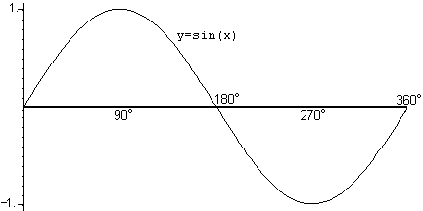

    - Give an example of two other angles that have the same range. ________ & ________
    - Check through the simulation that you are correct.
    - Which angle will always give the maximum range? __________ Why? ______________ ________________________________________________________________________
    - Check through the simulation that this angle has the greatest range.
    - What would be the range of a projectile shot straight up in the air? __________ Show that the range equation proves this.

    - Check air resistance, and then click through all of the other objects at the top.
    - Which objects have the greatest drag coefficient? ________________________________
    - What is your guess as to why these objects are the greatest? _______________________ ________________________________________________________________________

