Wave on String
Activity for Trigonometry Students

Purpose

In this computer based activity you will apply the properties of sinusoidal function to model the movement of energy on the sting. While working on this activity, you will practice the applications of the following trigonometric concepts:

- Amplitude of sinusoidal function
- Period of sinusoidal function and its relation to frequency
- Wavelength
- Vertical transformation

Getting Familiar with the Simulation

- Open the simulation Wave on a String http://phet.colorado.edu/new/simulations/sims.php?sim=Wave_on_a_String

- On the left upper corner press on Rulers and Time and Show Help

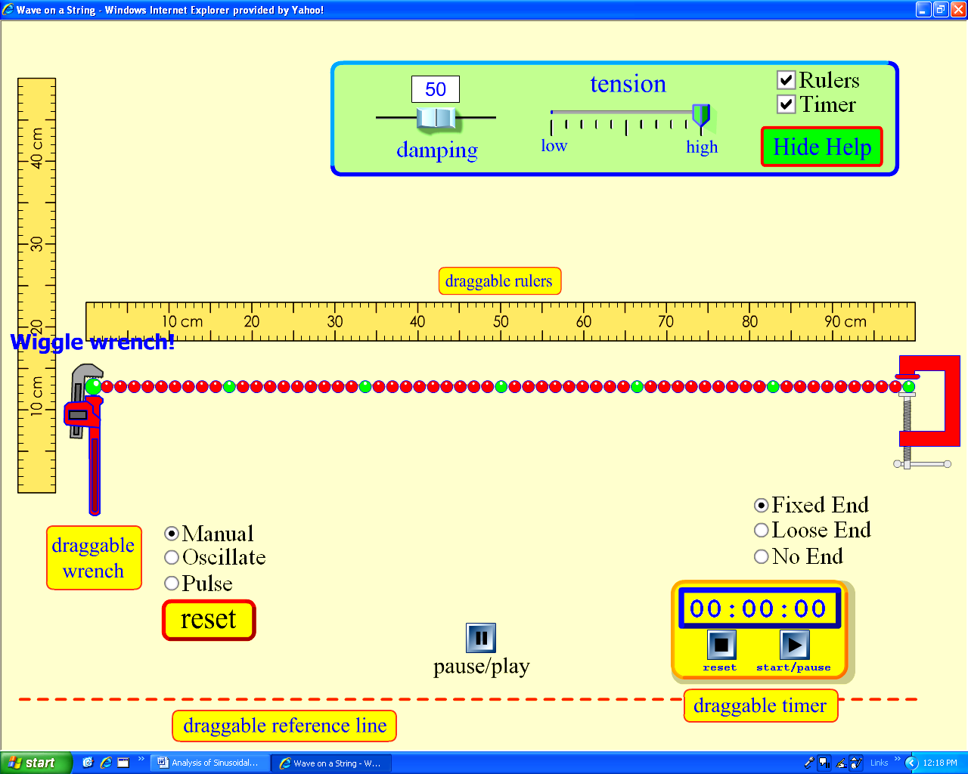

- There are two rulers shown on the screen; one horizontal, one vertical. Using respective ruler measure the distance between two consecutive green sections of the string ______
- Align the draggable reference line with the string.
- Adjust the vertical ruler so that its zero is aligned with initial section of the string.
- Wiggle the wrench so that the initial amplitude of the wave is 25 cm.
- Does the amplitude of the wave remain constant and the energy is moving along the string? _________________________________________________

Part 1. Purpose: Finding the equation of vertical position of the wave with prearranged components.

Set up the controlled variables of the experiment as follow:

- Mode of generating the wave to Oscillate
- Amplitude of the wave to 15 cm. Note 15cm is equivalent to about 81 units on the screen scale
- Damping factor that determines the loss of transmitted energy per wave to 0
- Tension that represents the properties of the medium in which the wave moves to high
- The medium at the end of the right side of the string; No End. This factor assures no change in medium at the end of the string.
- Adjust the frequency factor so that only one wave is shown on the string.
- Using the timer provided on the screen or a stopwatch, measure the time for the oscillator to make one full revolution. Repeat the measurements 5 times and find the average value.

Trial | 1 | 2 | 3 | 4
Time (in sec)

Average time t =______________________

- What quantity, from the listed below, is represented by the measured time?

A. Frequency B. Wavelength C. Period D. Circumference

A general form of a sinusoidal function is following
, where:

A is the amplitude of the function, expressed in the units of length,
T is the period of oscillation, expressed in the units of time
f is the frequency of wave production, expressed in the units of hertz
t represents a general independent variable (time) of the function

Substitute indicated quantities to the general form and write the function equation for the vertical position of the energy on the string.

_____________________________________________________________

Part 2. Analysis of the wavelength and the speed of the wave.

- Using the settings from the part 1, measure the wavelength of the wave.

___________________________________________________________________

- Using a general equation for speed of the front of the wave that is calculate the speed of the wave on the string:

____________________________________________________________________
_
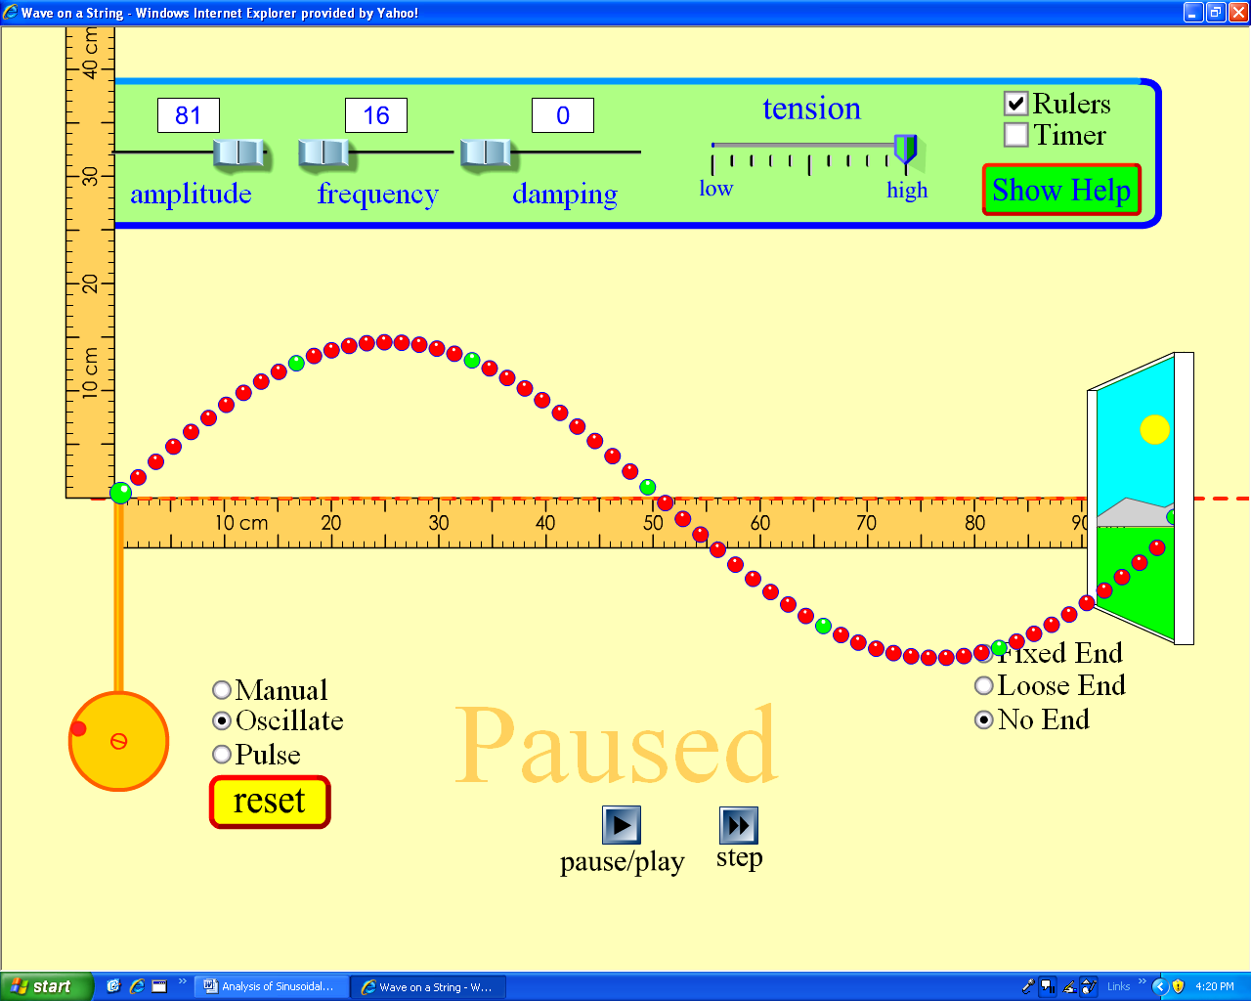

- Will the speed of the wave change if the amplitude changes?

- Will the speed of the wave change if the frequency changes?

Part 3. Modifying controlled variables

For each scenario given below construct respective sinusoidal function, and then verify it, using the simulations.
As the reference equation, refer to form constructed in Part 1.

1. Suppose that the x-axis; the draggable reference line, is moved 30 cm below the string. Identify the parameter that changes from the listed below and then construct the function.
A. Vertical Transformation B. Wavelength C. Period D. Horizontal Compression

______________________________________________________________________

2. Suppose that the period of the wave decreased by 50%.

_____________________________________________________________________

3. Suppose that the amplitude of the wave increased by 4 cm.

____________________________________________________________________

Part 4. In this part, you will investigate the influence of the tension factor on the wave components

1. Change the tension of the string to 7/10 of the high value. What parameters of the wave changed? Circle the one(s) that apply.

A. Speed B. Horizontal Compression C. Period D. Wavelength

2. Calculate the speed the speed of the new wave?

_____________________________________________________________________

3. Will increase of frequency of the oscillator produce more waves? Write the answer and then check your predictions using the simulation.

______________________________________________________________________

4. Does the wavelength of the wave depend on the frequency or on the medium represented here by the tension?

______________________________________________________________________

Conclusion; Write below your suggestions to improve the activity.

