Understanding Voltage, Potential Difference and Potential /Voltage Drop
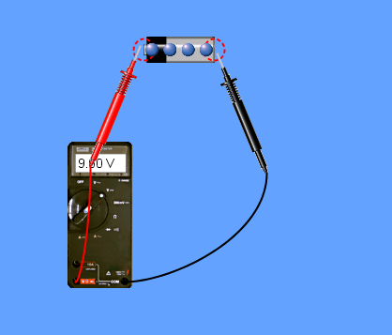Pic Entree | In pic Entrée  What does the voltmeter read?_____________-  What does a voltmeter measure?___________  Voltage is defined as energy expended per unit charge. $V=\frac{W}{Q}$  How much work will this battery do with the voltage that it shows?
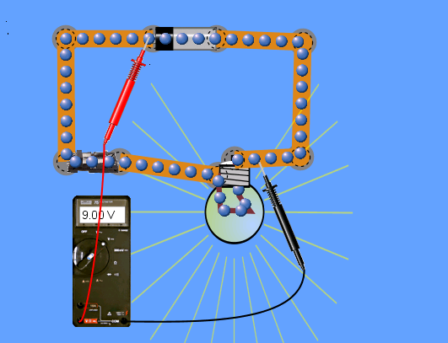Pic Crazy  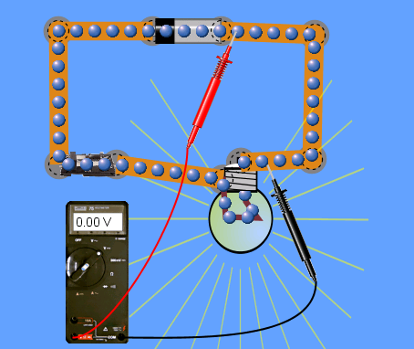  Pic Weird | In Pic Crazy  The black lead of the voltmeter is made to slide across the wire. What does the voltage in the voltmeter read? ________  This means that there is no voltage drop in the wire. A voltage drop is a decrease in voltage  (or energy/charge) along a conductor through which current is flowing. In real circuits, there is a small voltage drop. What does this mean?  __________________________________________  __________________________________________  In pic Weird  Why does the voltmeter show 0V? Explain using energy concept?  __________________________________________-  ________________________________________________________________________________________________________________________________________________________________________
  Pic Strange | In pic Strange  What does the voltmeter read?____________  So the ‘voltage drop’ across the bulb is __V.  This means that the entire energy from the cell got used up across the bulb.

  Pic ultimate | In pic ultimate  What does the voltmeter read? Explain using energy concept.  ___________________________________  ____________________________________  ____________________________________
Voltage, Potential difference and Voltage drop-  Potential difference= voltage at each point  Voltage= sum of potential differences  Voltage/Potential drop-=a decrease in voltage along a conductor through which current is flowing  Voltage drop and potential difference can be swapped as their meaning is similar. | Voltage, Potential Difference and Potential drop are used in different sentences.  State if these have been correctly used or not.  A wire has 20 V voltage across it due to a 20 V battery connected at its end points( also called terminal).  ___T/F_______  A Wire has a potential difference of 20 V due to a 20 V battery connected across it’s terminals.  ___T/F______  A voltmeter measure voltage across a battery._  ____T/F______  A voltmeter measures Potential difference across a battery  _____T/F__________  When a voltmeter is connected across any two points in a wire it measures Voltage.  _____T/F__________  When a voltmeter is connected across any two points in a wire it measures Potential difference between these two points.  _____T/F__________

Write a paragraph summing up the concepts learnt from the above table. The paragraph must explain the concept of energy change when the current flows in the circuit. Take your time; explain as if you are giving details to someone who is relying on you for a better understanding of the Voltage, Potential Difference, and Voltage Drop concept.

