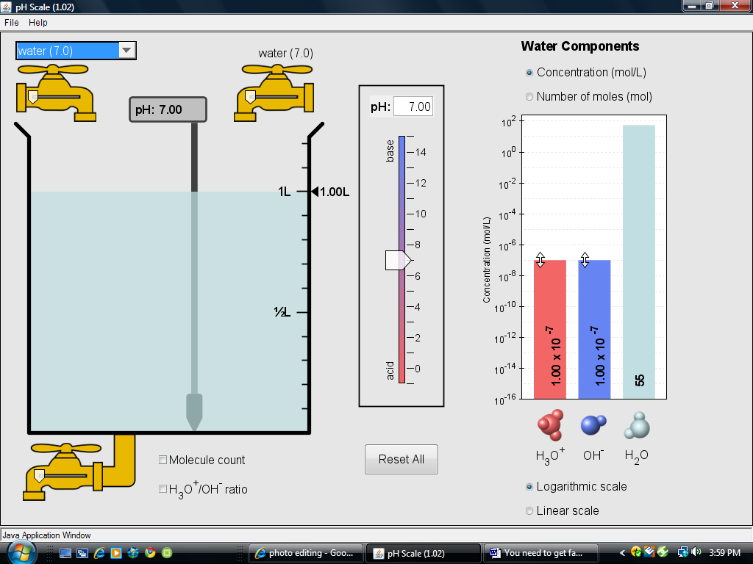
pH Scale Simulation

Go to my website and click
on the link to get to this
Simulation. Click Run, and
follow the procedure below.

1) You need to get familiar with adjusting the amount of liquid in the beaker. Choose water from the pull down menu. Fill and drain the water using the faucet knobs above and below the beaker. Try to get 0.5 L of water in the beaker. Using the slide arrow, adjust the flow. Play for a bit! Be sure to click the box shown.

2) Using the pull-down menu, change the contents of the beaker to “water”.
What is the pH? ________
Record and compare (concentration mol/L) H₃O⁺/OH⁻ ratio.

3) Fill the beaker with drain cleaner.
What is the pH? ________
Record and compare (concentration mol/L) H₃O⁺/OH⁻ ratio.

4) Fill the beaker with soda.
What is the pH? ________
Record and compare (concentration mol/L) H₃O⁺/OH⁻ ratio.

5) Using “custom liquid”, adjust the pH level to 6.00. How does the H₃O⁺/OH⁻ ratio differ from a pH of 7?
Record and compare (concentration mol/L) H₃O⁺/OH⁻ ratio.

6) Again, using “custom liquid, adjust the pH level to 8.00. How does the H₃O⁺/OH⁻ ratio differ from a pH of 7?
Record and compare (concentration mol/L) H₃O⁺/OH⁻ ratio.

7) Alright…let’s mix some acid items with water to see what happens to the H₃O⁺/OH⁻ ratio!

8) Fill the beaker with coffee (pH 5.0). Drain out half, and replace that amount with water. What is the new pH? ________
Record (concentration mol/L) H₃O⁺/OH⁻ ratio.

9) OK, feeling nauseous? Fill er’ up with Barf!(pH 2.0) Drain out half, and replace it with H₂O!
What is the new pH?________
Record (concentration mol/L) H₃O⁺/OH⁻ ratio.

10) Let’s get back to “basics”. LOL. Fill up with hand soap, drain half, and replace with water.
What is the new pH? ________
Record (concentration mol/L) H₃O⁺/OH⁻ ratio.

11) What do you notice about the H₃O⁺/OH⁻ ratio when you add water to either an acid or a base? Hmmm….refer to how the mol/L changes.
________________________________________________________________________________________________________________________________________________________________________________________________________________________

12) Calculate: Add anything to the beaker. Using your scientific calculator, find the negative logarithm (-log) of H₃O⁺ mol/L. This should match the pH value given.

13) Calculate: Add anything to the beaker. Using your scientific calculator, find the negative logarithm (-log) of OH⁻ mol/L. This should match the pOH value given.

14) What is the pH of the solution to the left?

