Series and Parallel Circuits
Objective
Students will discover the difference between series and parallel circuits
Pre-Questions
- What is an electric circuit?
- What items are necessary to create an electric circuit?
Procedure
- Log on to your computer
- Go to the following website: http://phet.colorado.edu/index.php
- Click the button that says “Play with sims…”
- Click on the application that says Circuit Construction Kit (DC only). It should be the first box.
- Click “Run now.”

Assignment #1 – One Light Bulb in SERIES CIRCUIT

- Build this circuit:

What do the blue dots represent?

From which end of the batteries are they flowing?

- Select the “Voltmeter” tool from the right side and connect it to your circuit as shown below.
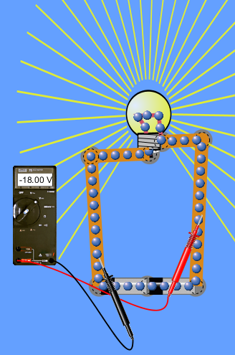
What does the voltmeter read? (Use proper units)

Take one of the batteries away. What happens to the light
bulb? What happens to the voltmeter reading?

Assignment #2 – Two Light Bulbs in SERIES CIRCUIT
- Build this circuit:
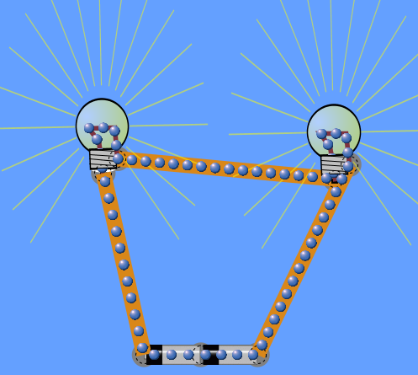
What happened to the brightness of the bulbs?

Why do you think this happened?

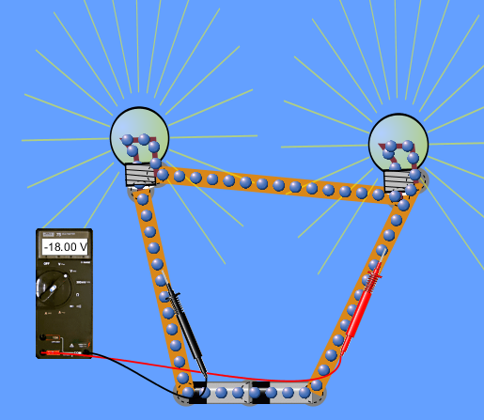
- Test your circuit with the voltmeter as shown below.

What does the voltmeter read?

Move the right prong so it is on the wire in
between the 2bulbs. What happened to the
voltmeter reading? Why do you suppose this
happened?

Assignment #3 – Adding a Switch in a Two Light Bulb SERIES CIRCUIT
- Insert a “switch” between the negative end of the batteries and the first light bulb. What happens to the two light bulbs when the switch is open? What happens to them when the switch is closed?

- Move the switch so that it is in between the two bulbs. What happens to the bulbs when the switch is open? What happens to them when it is closed?

Assignment # 4 – Two Light Bulbs in PARALLEL CIRCUIT
- Construct this circuit:
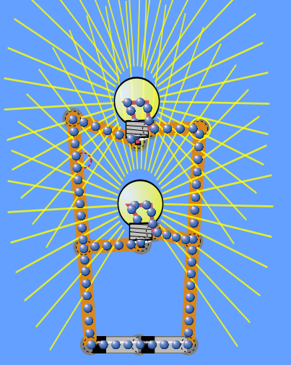
Compare the brightness of these two bulbs to the brightness of the two bulbs in series circuit.

Why do you think the brightness is different? It’s still 2 bulbs and 2 batteries, right?!?!

- Test your circuit with the voltmeter as shown below.
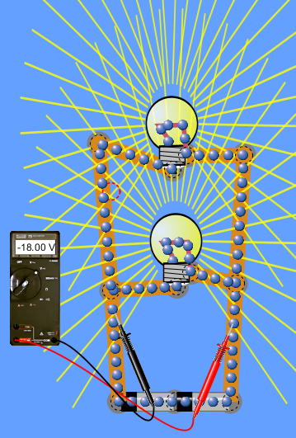
What does the voltmeter read?

Move the right prong so that it, again, is on the wire in between the 2 bulbs. What does the voltmeter read?

Explain why you think both readings are the same.

Assignment #5 – Adding a Switch to Two Light Bulbs in a PARALLEL CIRCUIT
- Insert a switch in between the negative end of the batteries and the first light bulb. What happens to the light bulbs when the switch is open? When it is closed?

- Move the switch so that it is in between the two light bulbs. What happens to the light bulbs when the switch is open? When it is closed?

Assignment #6 – Reflection Questions:
- Draw a series circuit with two light bulbs. Using “light ray lines” indicate light brightness of the two bulbs.

- Draw a series circuit with two light bulbs and an OPEN switch (where ever you want to put it). Indicate light brightness of both lights.

- Draw a parallel circuit with two light bulbs. Indicate light brightness.

- Draw a parallel circuit using two light bulbs and a switch (where ever you want to put it). Indicate light brightness of both lights.

- How does the type of circuit affect the brightness of two light bulbs?

- When is a series circuit beneficial? Give an example of a series circuit that you are familiar with.

- When is a parallel circuit beneficial? Give an example of a parallel circuit that you are familiar with.

Assignment #7 – Experiment!
Try changing around the position of the bulbs. Add bulbs. Add batteries. Change the positions of the batteries in the circuits. EXPLORE!!!

