PROJECTILE MOTION AND PARAMETRIC EQUATIONS

Purpose: In this lab you will construct and analyze projectile motion using parametric equations

Part 1
1. Referring to the conditions for the projectile shown, write parametric equations for the horizontal and vertical positions of the object in the function of time.  2. Using one of the derived functions, find the time when the object reaches the maximum height.  3. Find the vector of instantaneous velocity and acceleration at the maximum height. | 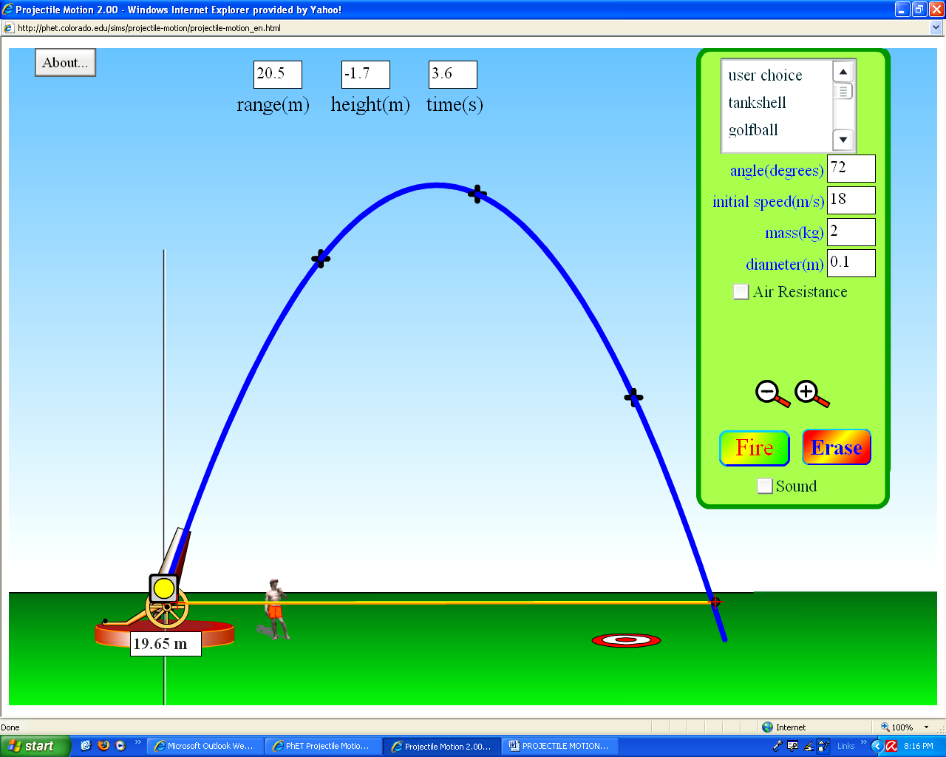

4. Determine the vector representing the position of the object at the maximum height. Use vector notation:  r = ai + bj  5. Find  6. Find the equation for the path of the object considering it to be a parabolic curve; y= f(x).  7. Find using form #6  8. Evaluate (using #5 and using #6) for t = 1s)  9. Find at t =1 s from the graph. | 10. Do all three values of at t = 1 correspond?  11. Find the vector of the final velocity and final position.  - Sketch the graph of position, velocity and acceleration separately for horizontal and vertical motion of the object.  Horizontal  Vertical  13. Find the total distance traveled by the object using equation for arc length for y=f(x) and using parametric form of the function for x=x(t) and y = y(t).

Part 2

Suppose that the object is projected from a height 6m and suppose that all remaining initial quantities are unchanged.

Which components of the motion will change and how (the frame of reference is on the ground)  1. Maximum height__________________________  2. Time to reach the maximum height______________  3. Position vector of the maximum height _______  4. The total distance of the object and the total time ___  5. Horizontal velocity of the object_______________ | 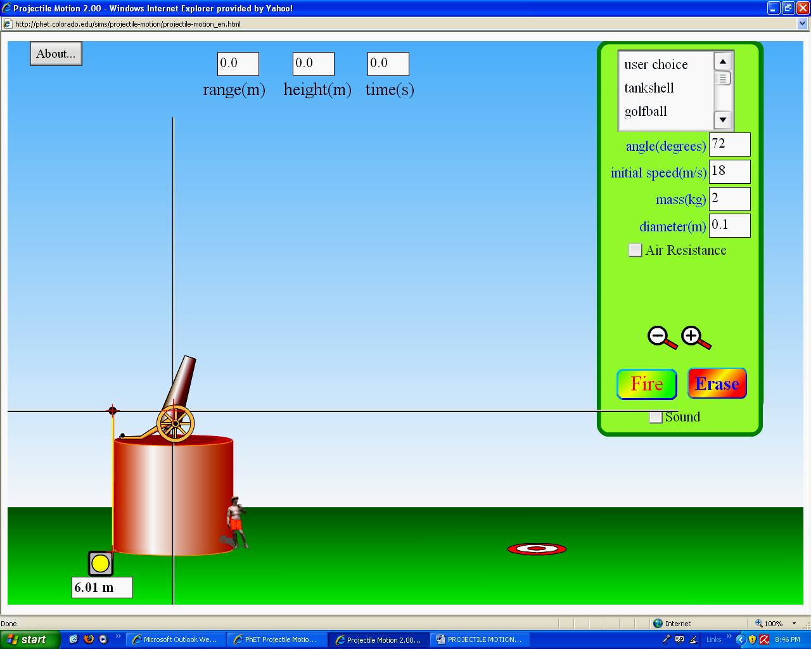

6. Write parametric equations for the position of the object motion.

7. Find parametric equations for the velocity and acceleration of the object.

8. Find the vector of the final position.

9. Find the average vertical velocity

10. Find the equation of a tangent line to the path of the motion at t= 2s.

