Station #1 Mr. Vendome
Eating and exercise East Brunswick High School

Open the java animation by either using the desktop animation or http://phet.colorado.edu/simulations/sims.php?sim=Eating_and_Exercise
Once started, you should see this:
Calories/day

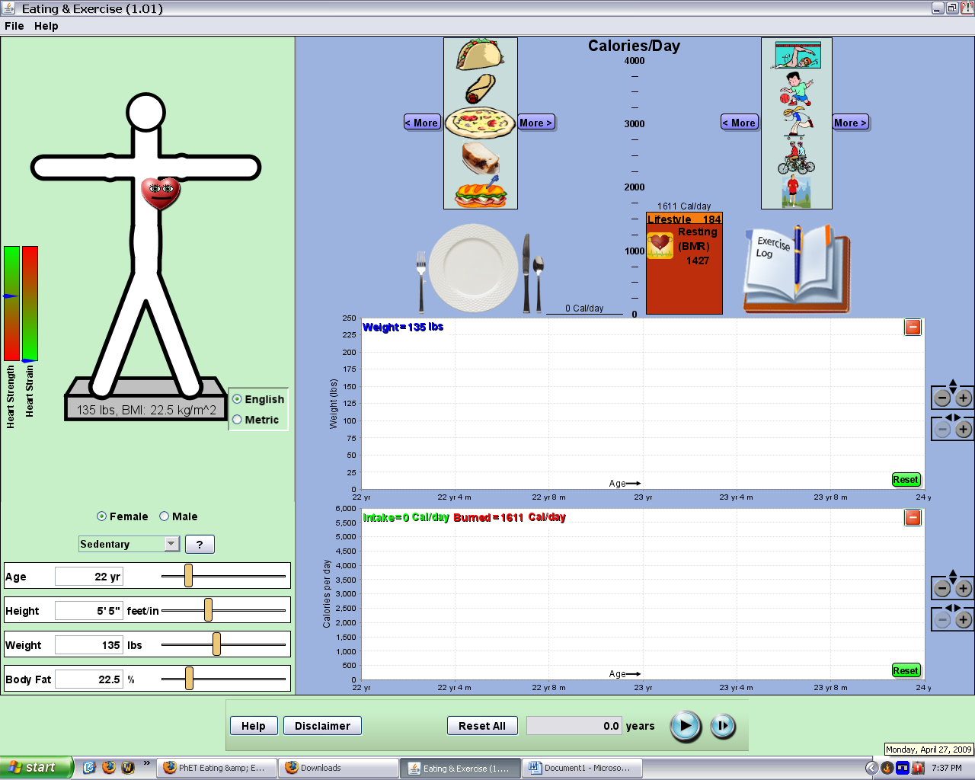
Lifestyle

Person traits
Records

Play Button

IMPORTANT!
This activity will ask a group member to input their personal measurements at times.
If nobody volunteers, make up a setting.
IF AT ANY TIME I HEAR PEER PRESSURE OR RIDICULE, THAT PERSON WILL BE SENT TO THEIR ADMINISTRATOR WITH NO SECOND CHANCE!

Use notes, the internet, and the interactive demo to answer the following

BMR:
- What is BMR? What does it stand for and mean? ____________________________
________________________________________________________________________________________________________________________________________________
- Adjust the person traits. Which traits are linked to each other? ________________
_______________________________________________________________________
Which are independent? (Can be changed without causing another to change)
________________________________________________________________________
Why are the independent traits like that? Remember that this can represent any person at any point in their life._________________________________________________________________
______________________________________________________________________________________________________________________________________________________________
- Adjust the body fat % and look at the BMR. What happens to the BMR as body fat increases? _____________________________________________________________________________
Give a reason for the change in BMR. What is it linked to? _______________________________
______________________________________________________________________________________________________________________________________________________________

- The 2 main body components that can be changed over time are muscle and fat. One of these is metabolically active, one is not. Based on what you saw in the previous question, which part, muscle or fat, is metabolically active? Why? ____________________________________________________________________________________________________________________________________________________________________________________________________________________________________________________________________________________________________________________________

- Change the gender of the person and observe. Which gender has a higher BMR? ___________
Why would 2 identical people of a different gender have different BMR? Consider the previous 2 questions. ______________________________________________________________________ ____________________________________________________________________________________________________________________________________________________________________________________________________________________________________________________________________________________________________________________________

Practice: What is the BMR for the following?

  - A very sedentary 17 year old female that is 5’8,” 124lbs and has 17.5% body fat ___________
  - A very active 16.5 year old male that is 6’1,” 188lbs, and has 24.2% body fat ___________
Lifestyle:
The way person lives their days has a general impact on the Cal/day that their body requires.
Set the person settings for a 20y/o male that is 6’, 175lbs, 15% body fat, and is very sedentary.

- Click the “?” symbol and read about the different lifestyle types.
- As a very sedentary person, how many Calories/day are burned in total? _________
How many Cal/day are from the lifestyle type? (do the math if you can’t see) _________
How might this person have an even lower number of Cal/day from their lifestyle? ______________________________________________________________________________________________________________________________________________________________
- Change the lifestyle to very active. How many total Calories per day are burned? _____. How many Cal/day are from his lifestyle? __________________
- Why does a more active lifestyle require more Cal/day, even when no exercise is being performed that day? ______________________________________________________________ _____________________________________________________________________________________________________________________________________________________________________________________________________________________________________________

Diet and Exercise:
Set the person parameters to any group member’s settings of gender, lifestyle, height, weight. If nobody volunteers, make one up. The % fat slider will move automatically.

- The % fat slider automatically moves with changes in height and weight. Is this an accurate measurement? __________ Why or why not? _________________________________________ ______________________________________________________________________________________________________________________________________________________________
Give a specific example where this readout will knowingly be wrong. Explain. _____________________________________________________________________________________________________________________________________________________________________________________________________________________________________________
- Scan through the food catalog above the plate. Note the amounts each icon represents.
1 serving of syrup is ______________ and has ____________ Calories
1 serving of mixed nuts is ____________ and has ___________ Calories
1 Serving of “Oreos” is _________________ and has ___________ Calories
- Drag a typical day’s food to the plate. Try to be as complete as possible and check the amounts. If you can’t find something, get the closest possible one. When you are done, look at the Calories/day bars next to the plate.
How many total Calories/day are eaten for this person? ______________
How many total Calories/day are used (right bar graph) _____________
Based on these numbers, what would you expect to happen over time if this is how the person lived every day? Why? ___________________________________________________________ _______________________________________________________________________________
- Read the bar graphs and copy the Cals/day of each source. Based on the day’s diet, determine the % of Calories from proteins, carbs, and fats:
Fat Cals: ________ Protein Cals: ________ Carb Cals: ________
% Calories from fat % Cals from protein % Cals from Carbs
(Show work for all)
- Choose any one activity from the list. For how long would you need to perform this activity to burn off all of the Calories/day in the left bar graph? Keep dragging and dropping the activity icons into the book until the Cal/day are equal or just greater than the Cal/day eaten:
Activity: ______________________________________ Calories burned per icon: __________
Duration (total time)needed to burn off the food Cal/day :________________________________
Does this seem like a reasonable thing to do? Why/why not? ____________________________ _____________________________________________________________________________________________________________________________________________________________________________________________________________________________________________
- Scan through the exercises on the right side and check types and durations. Drag and drop the typical activities for a day. Don’t forget the physical education period, traveling between classes, and after school sports. Again compare the Cal/day eaten vs Cal/day used. Which is higher now? ___________________
If this person continued on this diet/exercise routine, what would you expect to happen over time? ___________________________________________________________________ ________________________________________________________________________
- Look back at questions 4-5. If you said the person would gain weight, would they gain muscle or fat? Why? _____________________________________________________________________ _____________________________________________________________________________________________________________________________________________________________________________________________________________________________________________
If you said they would lose weight, calculate how much weight they would expect to lose each day. Remember that 3500 Cal is equal to 1.0 lb of fat. Show work:
How many lbs would they lose over a month (30days)?
- Consider what you wrote for question 6. If a person eats 100 extra Cal/day every day, will they indefinitely gain weight? Explain ___________________________________________________ ____________________________________________________________________________________________________________________________________________________________________________________________________________________________________________

- Play the demo and see what happens over the course of time. You can manually click the forward button to advance time faster. Were you correct? Describe what happens after:
6 months_________________________________________________________________
1 yr_____________________________________________________________________
5 yrs____________________________________________________________________

- Describe what causes each of the following in the demo:
Starvation:_______________________________________________________________ ________________________________________________________________________
Increased Risk of Heart attack: ______________________________________________ ________________________________________________________________________
High heart strength: _______________________________________________________ ________________________________________________________________________
If time allows, have each person input their own data and try the animation

