Lesson Plan for States of Matter Simulation
Approximate Length: 55 min
Learning Goal:
Students will be able to demonstrate their knowledge of the states of matter through illustrations and descriptions. These illustrations and descriptions should include:
- How varying the temperature changes the behavior of the molecules.
- How the molecules in a solid, liquid and gas compare to each other.

Background
This lesson is used on the first day of the unit to explore states of matter. Students have previously been introduced to the concept of kinetic energy and basic properties of solids, liquids and gases.

Lesson Plan with Simulation:
As a class, we will review properties of solids, liquids and gases. Students are given the Student Handout and will explore the States of Matter Simulation, which should take approximately 30 minutes.
After the simulation, I will place the students in groups of about three or four. In their small groups, students will compare their observations from the simulation and share their thoughts about kinetic energy and states of matter. Students will then further their knowledge of states of matter by discussing the following questions:
- Determine how a change in temperature affects the pressure inside a container.
- Explain this phase diagram by relating what you know about temperature, states of matter and pressure.

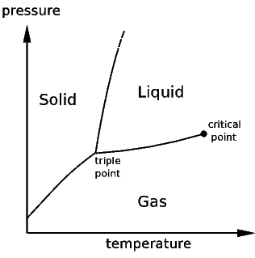

After the Lesson:
I teach States of Matter prior to Gas Laws. The next day, I have various stations set up, so students can test how variables such as volume, temperature, number of moles and pressure affect the behavior of gases. Some examples of the stations include:
- A marshmallow or balloon in a vacuum chamber
- A balloon covering the opening of an Erlenmeyer flask in hot and cold water
- Online video clip of liquid nitrogen poured over a balloon
- Small marshmallow in a syringe with a fixed volume of gas

