Sound SIM Homework II

In this homework, we will be using the Sound Simulation that we used in class is available at http://phet.colorado.edu/simulations/sims.php?sim=Sound
Begin by visiting the sound applet and exploring the various controls you have. You can
- change amplitude and frequency of the sound wave.
- move the listener toward or away from the speaker.
- turn the audio on or off, and you can listen to either the sound at the speaker or the sound heard by the listener.
- switch between the Listen Screen and the Measure Screen. In the Measure Screen you have a ruler and timer which you can use to make measurements. There are also blue lines which you can move around to help you measure.
- stop, run, or clear the sound waves.
- add another tone, an octave above the primary frequency, and observe the change in the wave form and the sound out of your speaker.
1) In class, we discussed how our ears detect sound.
a) (1.5 pts) The Listen Screen of the sound simulation lets you adjust the frequency and amplitude sliders and move the listener. The solid gray of the background represents the pressure of the air when no sound wave is present. Use the adjustments available to closely examine the relationship between the movement of the speaker cone and the sound waves produced and traveling away from the cone.
True False When the speaker is producing sound waves, the motion of the speaker produces a slight decrease in the pressure in front of the speaker during the forward motion of the speaker head and a slight increase in pressure during the backward motion of the speaker head.
True False In this simulation, a darker shade of gray indicates an increase in pressure compared to the undisturbed air pressure.
True False To increase the volume of a tone at 400 Hz heard by the listener, the speaker must oscillate back and forth more times each second than it does to produce the tone with lower volume.
True False If the speaker produces larger fluctuations in pressure, the volume of the tone heard by the listener increases.
True False To produce a lower pitch tone, the speaker must oscillate back and forth fewer times each second.

b) In the following graph we have plotted the pressure measured at the listener’s ear as a function of time for a 200 Hz tone generated by the speaker.
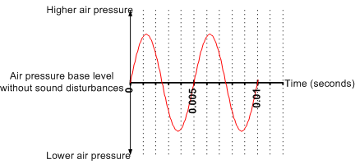
In the graphs of pressure versus time below, the dashed red line indicates the original 200 Hz tone.
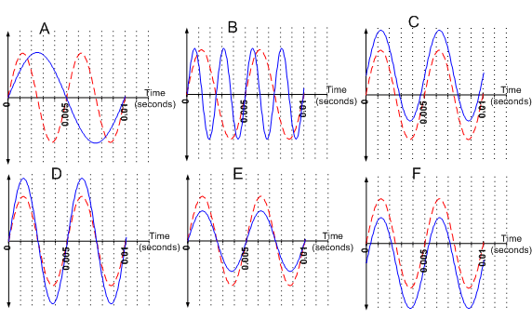
Which of the blue solid curves represents the variation in the pressure at the eardrum versus time when:
The speaker is producing a lower pitch tone:
The volume of the speaker is turned up:
The speaker sound is unchanged, but the listener has moved to be further from the speaker:
The speaker is oscillating back and forth, completing this cycle 400 times per second:
c) You hear a Concert A tone from the speaker. Describe the motion of the speaker and how this motion leads to our ears detecting Concert A tone, that is include the chain of cause-and-effect logic that results in your hearing Concert A tone from the speaker.

