Teacher Notes:
This lesson was adapted for elementary school students (grades 4-6?) from a high school lesson originally posted by Karen King. This lesson is meant to be a guided-inquiry. Teachers may adapt the level they guide their students depending on the students’ ability and background. Notes are embedded in the lesson.

Learning Goals:
- Be able to describe movement by looking at a motion graph

Set-up, materials:
2-3 students with access to a computer or laptop computer.
Teacher materials: laptop and projector or smartboard, board for sharing student ideas.

Directions:
Open up the simulation “Moving Man.”
- Either type in: http://www.colorado.edu/physics/phet or Google “phet” to get to the website.
- Click on Play with Sims, then click on Motion on the left side. Click on Moving Man.

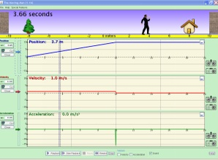

- Close the velocity and acceleration graphs by clicking on the minus sign on the right hand side of each graph.
Be sure to close out the two bottom graphs.

- Play with the Moving Man by dragging him back and forth. Graphing will not start until the student drags the man. There is also a slider on the left side of the page that will move the man, however it will not graph his movement until the man is dragged first. Click on the playback button at the bottom of the page to look at the graphs when you are done. Button at the bottom left hand of the simulation. Notice what is happening to the graphs as he moves. Tell your neighbor what you’ve noticed, and why you think it happened.

“Look, _____________, I noticed that…. | “Well, I think this happened because…”

Be sure to click the “clear” button on the left side of the screen to reset your graph.
Allow students the opportunity to share with their lab partners first, then the rest of the class. Record students’ ideas on a board for all students to see

- Look at the graph and the numbers underneath the man. Tell your neighbor what you noticed, and write or draw what you noticed.

Students might notice a number line, numbers that indicate position, and time.

- Write down what the graph looks like when you drag the man towards the house. Tell your neighbor what you noticed, and why you think it happened.
GRAPH | Explanation
 | Why do you think it should look like this?

- Do you think the line will always look this way when the man is moving? Test out your ideas on the simulation. Share your thoughts with your neighbor, then write or draw what you noticed.

This part of the lesson is set up for students to make conjectures about what they see. The line will start at zero and move upwards to the right when the man is moving towards the house. Students should be allowed time to play with the sim to see if the line will always move this way. Share and write down students’ observations after they have had time to explore.

- Write down what the graph looks like when the man is standing still. Tell your neighbor what you noticed, and why you think it happened.

GRAPH | Explanation
 | Why do you think it should look like this?

6. Do you think the line will always look this way when the man is standing still? Test out your ideas on the simulation. Share your thoughts with your neighbor, then write or draw what you noticed.

This part of the lesson is set up for students to make conjectures about what they see. The line will remain flat when the man is standing still. Some students might notice that they can tell where he is standing from the graph, as well as how long he has been standing there. Students should be allowed time to play with the sim to see if the line will always move this way. Share and write down students’ observations after they have had time to explore.
- What do you think will happen to the line if the man moves away from the house? Draw your prediction in the space below, then test out your idea. Share what you found out with your neighbor and write it in the space marked “explanation.”
GRAPH (Prediction) | Explanation
 | Why do you think it should look like this?
GRAPH (Actual) | Explanation
 | Why do you think it looked like this?

8. Do you think the line will always look this way when the man is moving away from the house? Test out your ideas on the simulation. Share your thoughts with your neighbor, then write or draw what you noticed.

This part of the lesson is set up for students to make conjectures about what they see. There is also the opportunity to make a prediction based on what they noticed in the 2 previous examples. The line will move downward and to the right when the man is walking away from the house. Students should be allowed time to play with the sim to see if the line will always move this way. Share and write down students’ observations after they have had time to explore.

- Summary
In the table below, summarize your findings.
Students should try to make generalizations from their previous observations
When the graph looks like this: | Describe the man’s movement
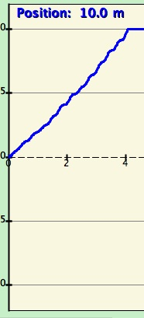
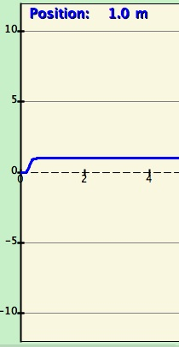
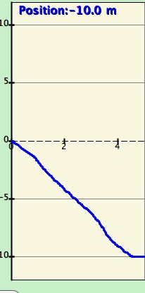

EXPLAIN and EXPLORE
This section allows students the opportunity to apply what they have observed in the previous section. Can be used as a formal or informal assessment on student understanding.

1. Without using Moving Man, draw what you think the line would look like for the following story.

A man is napping under the tree. He wakes up and walks toward the house. He stops because he is worried that he dropped his keys. He stands still as he searches his pockets for his keys. When he discovers he can’t find them, he runs towards the tree. He hits the tree and gets knocked out, so he can’t move.

Graph (prediction) | Graph (actual)

2. Now use Moving Man to see if your graph was correct. If not, go back, and draw the correct line on the 2nd graph.

3. In the space below, write your own story for the following graph.  

