Moving Man Elementary Lesson

Learning Goals:
- Be able to describe movement by looking at a motion graph

Set-up, materials:
2-3 students with access to a computer or laptop computer.

Directions:
Open up the simulation “Moving Man.”
- Either type in: http://www.colorado.edu/physics/phet or Google “phet” to get to the website.
- Click on Play with Sims, then click on Motion on the left side. Click on Moving Man.

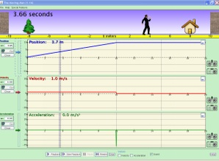

- Close the velocity and acceleration graphs by clicking on the minus sign on the right hand side of each graph.

- Play with the Moving Man by dragging him back and forth. Click on the playback button at the bottom of the page to look at the graphs when you are done. Notice what is happening to the graphs as he moves. Tell your neighbor what you’ve noticed, and why you think it happened.

“Look, _____________, I noticed that…. | “Well, I think this happened because…”
Be sure to click the “clear” button on the left side of the screen to reset your graph.
- Look at the graph and the numbers underneath the man. Tell your neighbor what you noticed, and write or draw what you noticed.

- Write down what the graph looks like when you drag the man towards the house. Tell your neighbor what you noticed, and why you think it happened.

GRAPH | Explanation
 | Why do you think it should look like this?

- Do you think the line will always look this way when the man is moving? Test out your ideas on the simulation. Share your thoughts with your neighbor, then write or draw what you noticed.

- Write down what the graph looks like when the man is standing still. Tell your neighbor what you noticed, and why you think it happened.

GRAPH | Explanation
 | Why do you think it should look like this?

6. Do you think the line will always look this way when the man is standing still? Test out your ideas on the simulation. Share your thoughts with your neighbor, then write or draw what you noticed.

- What do you think will happen to the line if the man moves away from the house? Draw your prediction in the space below, then test out your idea. Share what you found out with your neighbor and write it in the space marked “explanation.”
GRAPH (Prediction) | Explanation
 | Why do you think it should look like this?
GRAPH (Actual) | Explanation
 | Why do you think it looked like this?

8. Do you think the line will always look this way when the man is moving away from the house? Test out your ideas on the simulation. Share your thoughts with your neighbor, then write or draw what you noticed.

9. Summary
Based on what you saw in the examples, summarize what you know.

When the graph looks like this: | Describe how the man is moving.
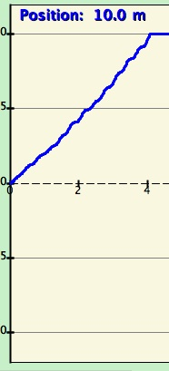
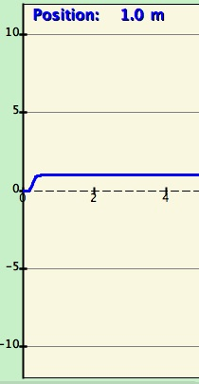
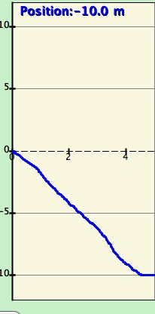

EXPLAIN and EXPLORE

1. Without using Moving Man, draw what you think the line would look like for the following story.

A man is napping under the tree. He wakes up and walks toward the house. He stops because he is worried that he dropped his keys. He stands still as he searches his pockets for his keys. When he discovers he can’t find them, he runs towards the tree. He hits the tree and gets knocked out, so he can’t move.

Graph (prediction) | Graph (actual)

2. Now use Moving Man to see if your graph was correct. If not, go back, and draw the correct line on the 2nd graph.

3. in the space below, write your own story for the following graph.  

