Resistance in Series Circuits
Name _______________
You are designing a Holiday light and Santa display at your house. You need to decide what you may want to place in series and what you may want to place in parallel (next activity). First you must discover the attributes of both. You will do this using a computer simulation.

Goals:
Correctly place voltmeters and ammeters in a series circuit.
Find the voltage and amperage in series circuits.
Determine which is constant in a series circuit, voltage or amperage.

- Open the phet website and go to the Circuit Construction Kit simulation.
- Make a series circuit using three resistors. Remember the series circuit is circular with only one path for electricity.
- Add an ammeter between each resistor and the resistors and the source
- Measure voltage with a voltmeter over each of the lights.
- Turn on Show Values so you see the resistor values

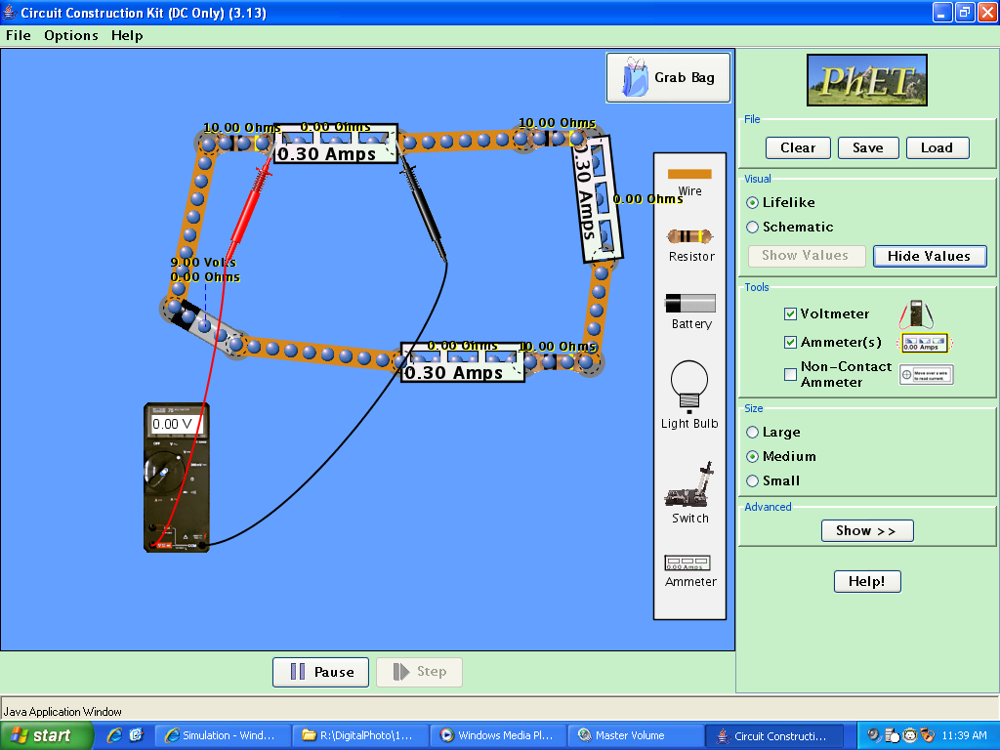
- Change the resistor values by right clicking the resistor. Make the resistors at least 10 Ohms different!
- Record both the resistor value, voltage and the amperage in the table below.
- Unhook one of the resistors from the circuit. What happens?
- Discuss with another student, what conclusions can be drawn from this data?

 | Resistor size (R) in Ohms | Voltage (V) | Amperage (I)  In amps | V/I in Ohms

Resistor 1
Resistor 2
Resistor 3
Source | R1+R2+R3=
Questions
1) How close were your resistor size and the V/I resistor calculation you found what Ohm’s Law?

2) When placing a voltmeter in a circuit, does it go in series or parallel?

3) When placing an ammeter in a circuit, does it go in series or parallel?

4) What conclusions can you draw from the readings on the voltmeters?

5) What conclusions can you draw from the readings on the ammeters?

6) Which best describes a series circuit? Circle all that apply:
a) V_{s} = V₁ + V₂ + V₃ d) V_{s} = V₁ = V₂ = V₃
b) I_{t} = I₁ + I₂ +I₃ e) I_{t} = I_{t} = I₁ = I₂ =I₃
c) R_{t} = R₁ + R₂ +R₃ f) R_{t} = R₁ = R₂ =R₃

7) When you unhooked a light, what happened? If a light burns out the same effect will be seen. How would this affect your holiday display?

8) In your holiday display when would you use series and when would you use parallel circuits?

