Phys1010 Homework 12 SIM
Top of Form
1) Using the EMF Simulation, adjust the transmitter so that it is in sinusoidal mode and the electrons are oscillating up and down at a regular frequency. This is how radio waves are broadcast. Set it so that both “display the curve” and the “radiated field” boxes are checked.
a) What does the curve represent?
The line of electrons being sprayed off of the antenna that then cause the receiver electron to move.
The path that an electron will follow due to the electromagnetic wave.
The evenly spaced electrons moving up and down between the two antennae.
The field of negative charges that are moving through space.
The strength and direction of the force that would be exerted by the electromagnetic wave on an electron.
b) With the frequency set at the mid-point of the slider and the amplitude set at the mid-point of the slider, approximately how many grid marks is the wavelength of the wave (use the pause button and step button as you need to in order to get a good measure, and round to the nearest whole grid mark)?
If the amplitude is increased, the wavelength
decreases increases stays the same
c) Use the simulation to evaluate the following statements.
True False If the oscillation frequency of the transmitting electron decreases, the oscillation frequency of the electron in the receiver is instantaneously affected.
True False The electron in the receiving antenna oscillates at a lower frequency than the electron in the transmitting antenna because of the distance between the antennas.
True False If the frequency of oscillation increases but the amplitude of the electron oscillation remains the same, then the electron in the transmitting antenna is experiencing larger accelerations (recall what you know about acceleration and motion).
True False If the amplitude increases but frequency remains the same, the electron at the receiving antenna experiences larger peak forces but oscillates at the same frequency as before.
True False If the frequency of the transmitting electron decreases by a factor of two, it will now take longer for the electromagnetic signal to reach the receiving antenna.
True False If the frequency decreases, the wavelength decreases.
True False The electromagnetic waves generated by the transmitting antenna produce currents in the receiving antenna.
True False When the electron in the transmitting antenna is at its peak height, the electron in the receiving antenna is always also at its peak height.
Explain your reasoning to your answer for the T/F If the frequency of oscillation increases but the amplitude of the electron oscillation remains the same, then the electron in the transmitting antenna is experiencing larger accelerations (recall what you know about acceleration and motion). Include in your explanation how this affects the strength of the transmitted electromagnetic signal (revisit the simulation if you did not notice what happened to the strength of the transmitted signal).
d) For the radio wave transmitter in the simulation, which of the following orientations of the receiver antenna will pick up the signal? (Select all that will)
an antenna oriented vertically
an antenna oriented horizontally (parallel to the ground) with one tip pointing towards the transmitting antenna (so it is oriented East-West)
an antenna oriented horizontally and perpendicular to the antenna in the previous answer (so it is oriented North-South)
e) Which one of the following sets of graphs of position vs. time, velocity vs. time, and acceleration vs. time corresponds with the motion of the electron in the receiving antenna? (It may help to remember the relationship between force and acceleration, and use the “Step” feature to step through the motion of the electron and have the vectors display the “force on an electron”.)
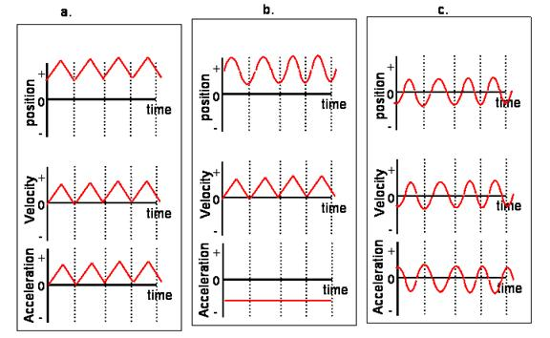
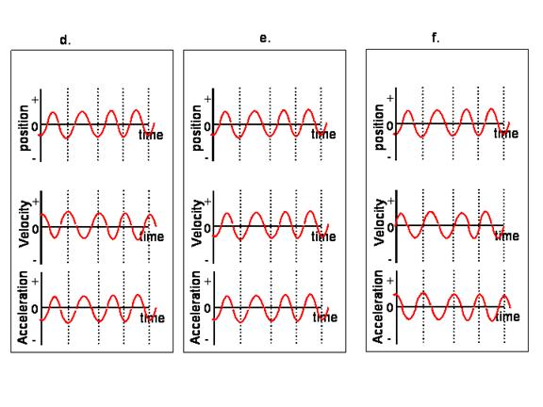
The correct graph is
2) Begin the microwave simulation, turn the microwave on, and observe how the electromagnetic waves influence water molecules in the microwave. Be sure to play with the frequency so you can clearly see the behavior.
a) Below is a water molecule (two hydrogens and an oxygen) pictured with arrows indicating that the field is aligned such that it would exert an upwards force on an electron placed in the region of the water molecule.
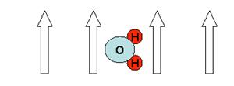

i) How would the water molecule be affected by this field?
It would rotate such that the hydrogens were pointed upwards and the oxygen downwards.
It would not be affected by this field.
It would rotate such that the hydrogens were pointed downwards and the oxygen was pointed upward.
It would feel a force upwards and move up.
It would feel a force downwards and move down.
ii) Why would the water molecule react as you indicated? Explain your reasoning being sure to refer to the physics principles that support your reasoning.
iii) Using the simulation to guide your description and understanding, explain how microwaves are able to heat foods that contain liquid water molecules and how that heat or thermal energy is represented in the simulation.
b) Most materials, such as hard plastic or glass plates, even when carefully dried have a very thin layer of water molecules that are rigidly stuck to them by a strong chemical bond. However, if you put a clean, dry plate in a microwave oven, the surface of the plate does not seem hot, and you do not see any steam coming off. As these observations suggest, in fact the water on the surface does not heat up. Which or the following are reasonable reasons for the water on the surface to not heat up? (Check all that are reasonable.)
If the layer of water molecules is thin enough, the microwave fields will go right on through without having any effect on the molecules.
The microwaves are reflected away by the plate, so they never get to the water molecules.
The molecules are held so tightly at the surface that they do not rotate back and forth very much.
The microwaves are all rapidly absorbed by the plate.
There are so few molecules that they seldom bump into each other as they rotate back and forth in the microwave field.
c) Assume the chemical structure of the three molecules CH4, NH3, and HCl are as pictured, with the hydrogen atoms all tending to be positively charged.
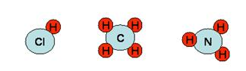
Rate the three molecules as good, fair, or poor (where water is good), with regard to how well a liquid of each of these molecules would heat up in a microwave oven. Remember that in a liquid there are many molecules oriented in many different directions relative to the electromagnetic field.
HCl, hydrogen chloride
NH3, ammonia
CH4, methane
d) If a layer of marshmallows was laid out across the bottom of a microwave oven and it had been badly designed so that nothing was done to interfere with standing waves, how far apart would be the positions of no heating of marshmallows?
Explain how a standing wave in a microwave is similar to an oscillating violin string?
e) If you decided to change the frequency of the microwaves used in the oven from the typical frequency of 2.45 GHz to 4.6 GHz, evaluate the following statements as true or false.
True False Food would no longer heat up in the oven.
True False The spacing between the peaks and valleys in the standing wave pattern would get closer.
True False The molecules would rotate back and forth more slowly.
True False The leakage through the door screen would increase.
True False The microwaves would travel faster in the oven.

