Radio Waves & Electromagnetic Fields SIM Homework
1) For this question, use the Radio Waves & Electromagnetic Fields simulation to guide your understanding of how Radio broadcasting and Radio receivers work. This simulation is available at the Physics 1010 Homepage.
a) How is the radiating electric field (or electromagnetic signal) produced when radio stations broadcast? Include a description of what is producing the signal as well as the reasoning behind how this could produce a signal.
b) How does your antenna work to detect this electromagnetic signal produced when radio stations broadcast? Include the physics principles that support your description of how this signal is detected.
2) Using the simulation, adjust the transmitter so that it is in sinusoidal mode and the electrons are oscillating up and down at a regular frequency. This is how radio waves are broadcast. Set it so that both “display the curve” and the “radiated field” boxes are checked.
a) What does the curve represent?
The line of electrons being sprayed off of the antenna that then cause the receiver electron to move.
The path that an electron will follow due to the electromagnetic wave.
The evenly spaced electrons moving up and down between the two antennae.
The field of negative charges that are moving through space.
The strength and direction of the force that would be exerted by the electromagnetic wave on an electron.
b) With the frequency set at the mid-point of the slider and the amplitude set at the mid-point of the slider, approximately how many grid marks is the wavelength of the wave (use the pause button and step button as you need to in order to get a good measure, and round to the nearest whole grid mark)?
If the amplitude is increased, the wavelength
decreases increases stays the same
c) Use the simulation to evaluate the following statements.
True False If the oscillation frequency of the transmitting electron decreases, the oscillation frequency of the electron in the receiver is instantaneously affected.
True False The electron in the receiving antenna oscillates at a lower frequency than the electron in the transmitting antenna because of the distance between the antennas.
True False If the frequency of oscillation increases but the amplitude of the electron oscillation remains the same, then the electron in the transmitting antenna is experiencing larger accelerations (recall what you know about acceleration and motion).
True False If the amplitude increases but frequency remains the same, the electron at the receiving antenna experiences larger peak forces but oscillates at the same frequency as before.
True False If the frequency of the transmitting electron decreases by a factor of two, it will now take longer for the electromagnetic signal to reach the receiving antenna.
True False If the frequency decreases, the wavelength decreases.
True False The electromagnetic waves generated by the transmitting antenna produce currents in the receiving antenna.
True False When the electron in the transmitting antenna is at its peak height, the electron in the receiving antenna is always also at its peak height.
Explain your reasoning to your answer for the T/F If the frequency of oscillation increases but the amplitude of the electron oscillation remains the same, then the electron in the transmitting antenna is experiencing larger accelerations (recall what you know about acceleration and motion). Include in your explanation how this affects the strength of the transmitted electromagnetic signal (revisit the simulation if you did not notice what happened to the strength of the transmitted signal).
d) For the radio wave transmitter in the simulation, which of the following orientations of the receiver antenna will pick up the signal? (Select all that will)
an antenna oriented vertically
an antenna oriented horizontally (parallel to the ground) with one tip pointing towards the transmitting antenna (so it is oriented East-West)
an antenna oriented horizontally and perpendicular to the antenna in the previous answer (so it is oriented North-South)
e) Which one of the following sets of graphs of position vs. time, velocity vs. time, and acceleration vs. time corresponds with the motion of the electron in the receiving antenna? (It may help to remember the relationship between force and acceleration, and use the “Step” feature to step through the motion of the electron and have the vectors display the “force on an electron”.)
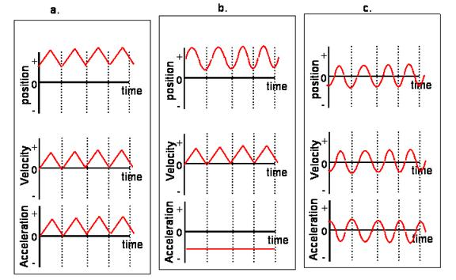
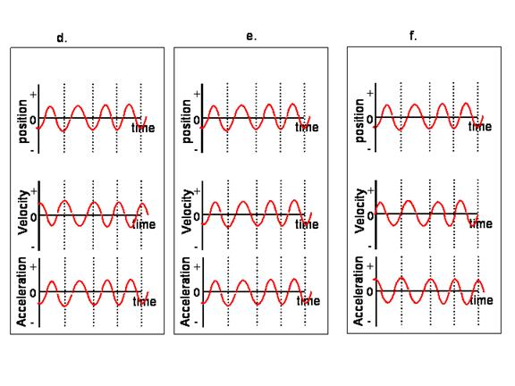
The correct graph is

