Wave on a String Simulation

1. Access the Physics Education Technology website at the University of Colorado - Boulder by typing in "http://phet.colorado.edu/new/simulations/index.php" or by googling "PhET Simulations".

2. Under Simulations, click on Sound and Waves. Click on Wave on a String. Click on Run Now! Set up the controls as shown below.
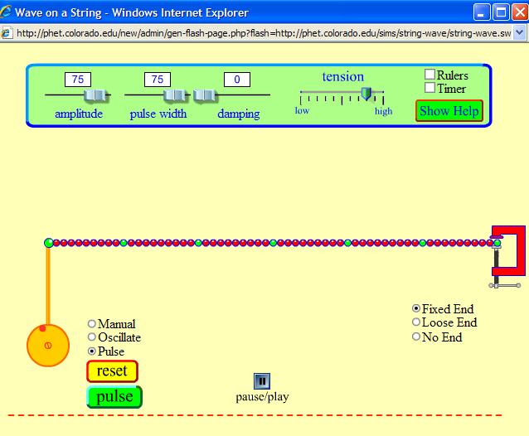

3. Fixed vs. Loose End: Click on the green pulse button. Observe the pulse through one cycle. Click on yellow reset button and change the Fixed End to Loose End. Observe the pulse through one cycle. Repeat these steps if necessary and describe the difference in the reflected waves.

4. Fixed vs. No End: Reset the controls to the original settings. Click on the green pulse button. Observe the pulse through one cycle. Click on yellow reset button and change the Fixed End to No End. Observe the pulse through one cycle. Repeat these steps if necessary and describe the difference in the reflected waves.

5. High vs. Low Tension: Reset the controls to the original settings. Click on the green pulse button. Observe the pulse through one cycle. Click on yellow reset button and reduce the tension to two clicks above low. Observe the pulse through one cycle. Repeat these steps if necessary and describe the difference in the reflected waves.

6. Damping vs. No Damping: Reset the controls to the original settings. Click on the green pulse button. Observe the pulse through one cycle. Click on yellow reset button and move the damping slider to 30. Observe the pulse through one cycle. Repeat these steps if necessary and describe the difference in the reflected waves.

As the amplitude of the wave decreases, the energy of the waves dissipates. Where does the energy go?

6. Two waves on a String: Reset the controls to the original settings, except click on the Loose End. Click on the green pulse button. When the pulse is about half way down the chain, click on the green pulse button a second time. Observe the two pulses through several cycles. When two "up" waves meet, what happens to center chain link when the pulses are completely overlapped?

When "up" and "down" waves meet, what happens to center chain link when the pulses are completely overlapped?

7. Explore: Take some time to explore the Manual and Oscillate options and the effects of varying the amplitude, pulse width, damping and tension controls.

