Virtual Circuits
http://phet.colorado.edu/simulations/cck/cck.jnlp
The Screen
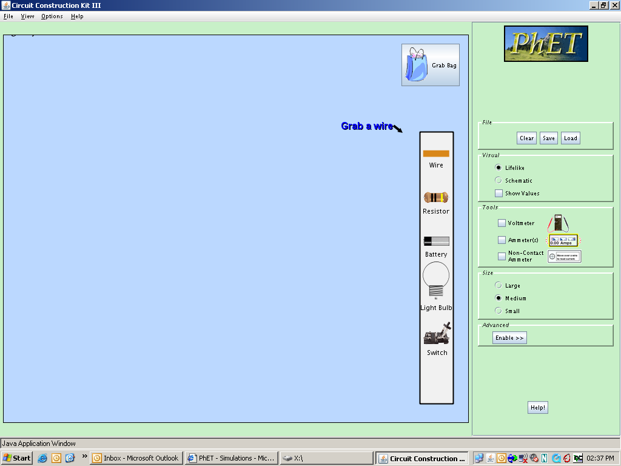
Switch this to “schematic” – note the U.S. resistor symbol is different to the international one
Toolbar of components available to use. Drag to construction area to start building
Construction area

Assignment 1 – Series Circuits

Build this circuit:

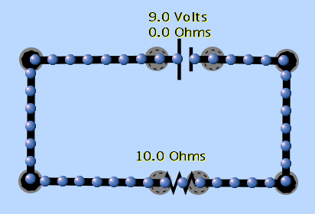
Note: you will need to right-click on the battery (yes I know it should be called a cell) and set its “internal resistance” to zero

Now, use the “Non-contact Ammeter” 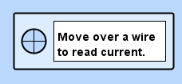 to measure the current at various points around the circuit. What do you notice?
Next, increase the resistance of the resistor (right-click) to 20 Ohms. What happens to a) the current and b) the moving electrons

Now, add a 2nd resistor (resistance 10 Ohms) to the circuit. Use the Voltmeter to measure the Potential Difference (Voltage) across each resistor:
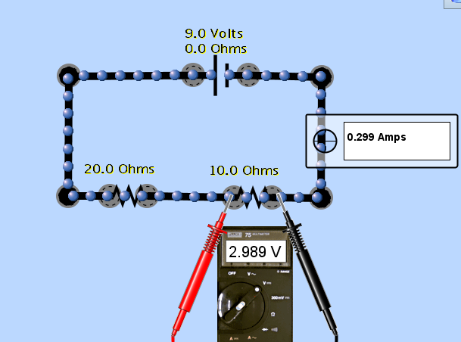

TASK
In your book, draw a circuit diagram of this final circuit, noting all values of current, resistance and p.d. Write down the rules governing a) current and b) p.d. in a Series circuit.
Place a screen shot of your circuit beneath

Assignment 2 – Parallel Circuits

Build this circuit:
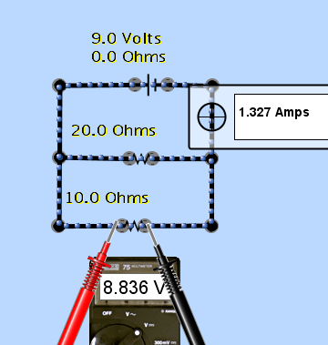
A
B
C
D
Use the ammeter to measure the currents at points A, B, C, D (shown). Measure the p.d. across each resistor
TASK
In your book, draw a circuit diagram of this final circuit, noting all values of current, resistance and p.d. Write down the rules governing a) current and b) p.d. in a Parallel circuit.
Place a screen shot of your circuit beneath

Assignment 3 – Circuit Problems

a) a series circuit contains two 1.5 Volt cells and two resistors (20 Ohms and 5 Ohms). Predict:
- The current in the circuit
- the p.d. across the 20 Ohm resistor
- the p.d. across the 5 Ohm resistor
Now make your circuit and test your predictions. Take a screen shot of your circuit showing the measurements

b) a parallel circuit contains 2 branches and is driven by a single 12V cell. The 1st branch contains a 30 Ohm resistor. The 2nd branch contains two identical lamps. The current leaving the cell is 1Amp. Predict:

- The current through the resistor
- The p.d. across the resistor
- The current through the lamps
- The resistance of 1 lamp

Now make your circuit and test your predictions. Take a screen shot of your circuit showing the measurements. Why is the current leaving the cell not quite 1 Amp as stated in the question?

