Wave Hello to Knowledge!
PART I: Go to http://phet.colorado.edu/simulations/sims.php?sim=Wave_on_a_String

From here, shake wrench, play with all the dials, and figure out what happens with each action.

Thinking questions
-When damping is set to 100 what happens to wave?
-When damping is set to 0 what happens?
1. What does Damping do to the energy in the wave?

-When tension is high what happens? When it is low?
2. What does Tension effect in the wave?

Lab Set up

On the bottom set up ‘PULSE’ and ‘NO END’. Press reset in case you still have a wave

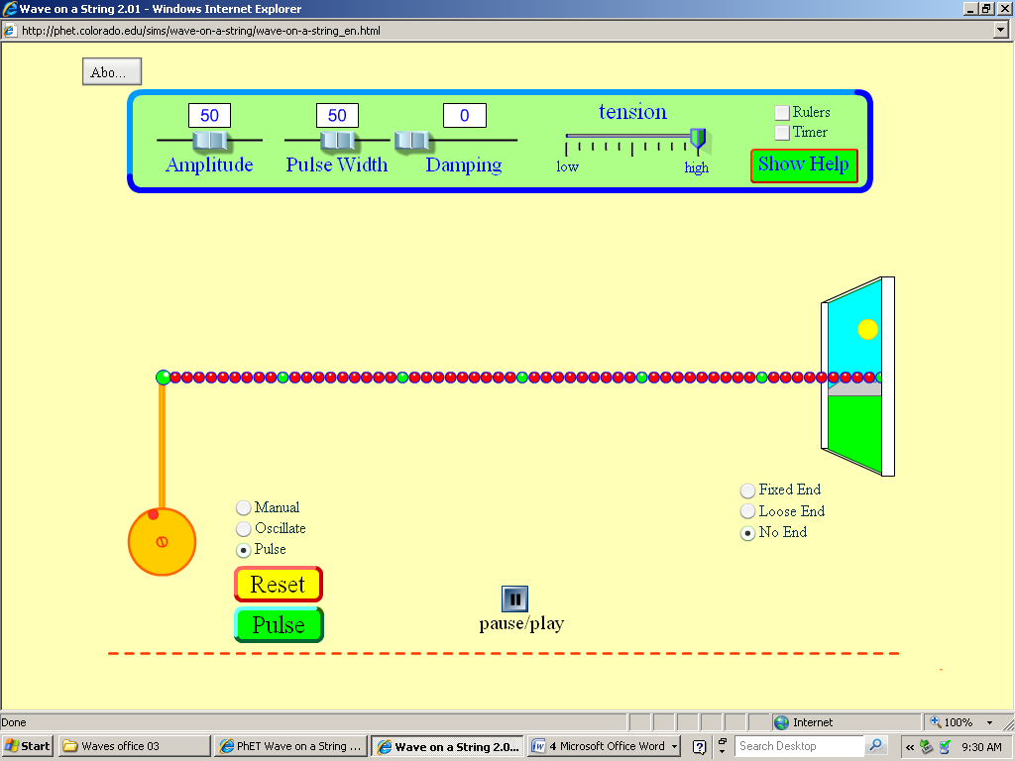

On the top there are two new sliders, play with them.

-When Pulse Width is set at 0, 50, and 100 what occurs when you set a pulse?
-When Amplitude is at 0, 50, and 100 what occurs when you set a pulse?
3. Define what Amplitude is in your own words

Set your settings so that Amplitude is set to 50, Pulse Width to 50, Damping to 0 and Tension to 1 click beyond half.

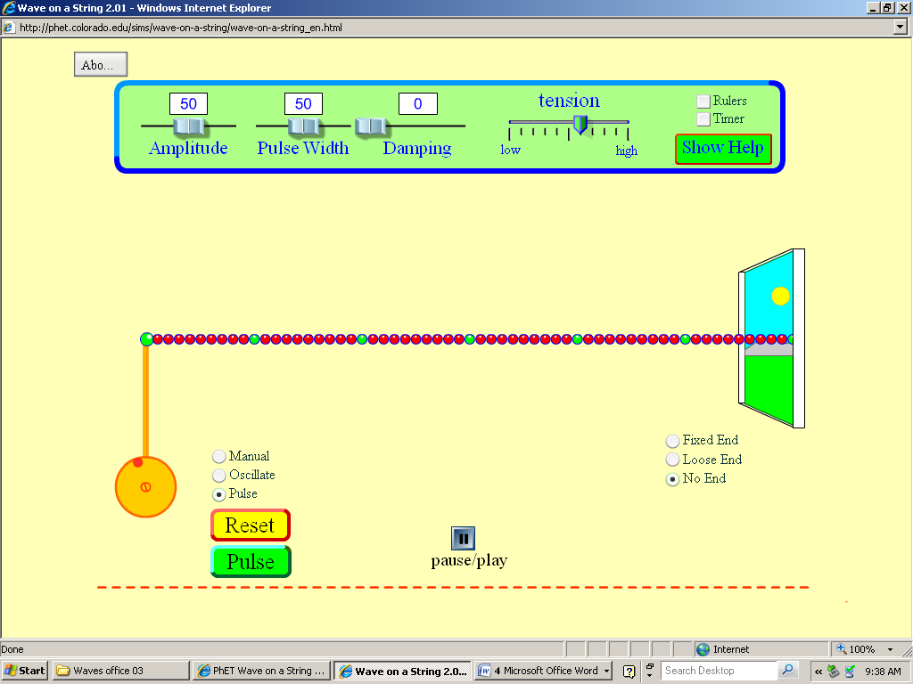

Our first mini-experiment is to observe what happens to ‘matter’ as a wave moves along. There are a few quick terms to interject here. The material the wave is passing through is called a medium, so for us the chain of purple and green dots is our medium.

4. Switch to ‘MANUAL’ and shake the wrench so a wave moves through the medium. Now, imagine you took the wrench off of the chain and shook it. Would a wave make it to the other end if the medium were to be removed?

-SWITCH back to ‘PULSE’ and hit the green pulse button several times. Watch the wave and pick one green dot to watch.
-Which way is the wave moving?
-Which way is the green dot moving?
5. Does the green dot move with the wave? Do any of the dots end up being displaced after the wave passes?

6. Does the green dot move parallel or perpendicular to the direction the wave went?

Here is another new term. When the particles of a wave move perpendicular to a wave it is called a transverse wave. Also at this point it is important to emphasis the difference between moving and displacing. The wave will shake or move a particle such as the green dot away from its starting position and back too it. Because it is moved back to the starting position it ends up with no net displacement.

7. This should be a free question…Do waves displace matter?

One last important lesson here, if waves don’t send matter from one end to the other what do they send? Think about this for a bit and think back to what we have learned already this year, we will have a discussion later.

8. Viewed from the side, a transverse wave moves through a pile of Jell-O in a rightward direction along the x-axis. The possible directions of motion for the Jell-O particles are...
a. x-axis (left-right)
b. y-axis (up-down)
c. z-axis (towards-away)
d. x and z axis
e. y and z axis
CLICK to review what the z-axis is

9. A basketball is floating in the center of the swimming pool. A student near the edge of the pool claims that she can get the ball to the other side of the pool by making waves at the edge of the pool. Suppose the student is successful in making transverse waves near the edge of the pool. Does the basketball make it to the edge of the pool? Describe the motion of the basketball as the waves reach the object.

10. Why would you not be able to hear someone scream in outer space?

PART II:
Time for you to take some experimental design and model some relationships.

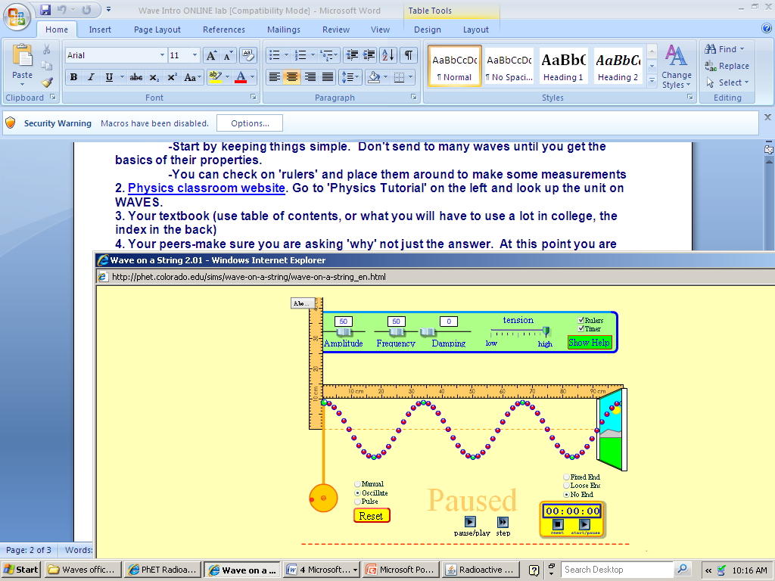
Click on ‘OSCILLATE’ make sure Amplitude is set to 50 and the new option of frequency is set to 50 undefended units. Click ‘Ruler’ and ‘Timer’ and set up your screen like the picture above. Note, damping is at 0 and tension is at high.

The term frequency is the number of occurrences of an oscillating or repeating event per second. As such the unit is a per second ( /s) which is also called Hertz (Hz). Unfortunately the ‘50’ we have set for frequency is not measured in Hz, so we will have to record our own measurement. But first…

Press the Pause/Play button on the bottom center of the screen so that you pause when the medium is starting at the highest point so your screen is paused and look like the picture above.

Wait, Ruler? Stop watch? That means we have things we can measure and collect data on!

Time for some new terms…Parts of a wave
Crest is the high point of the wave and trough is the low point.
Equilibrium is the middle point between the crest and trough of the wave. If the wave were to stop, it is the point the medium would come to rest at.
Amplitude is a measure of height (or depth) of a wave, going from equilibrium up to crest or down to trough.
Wavelength is the length of one full wave before it repeats. If you measure from one spot on a wave, you continue until that same point reappears, in the picture below I measured from one crest to another.
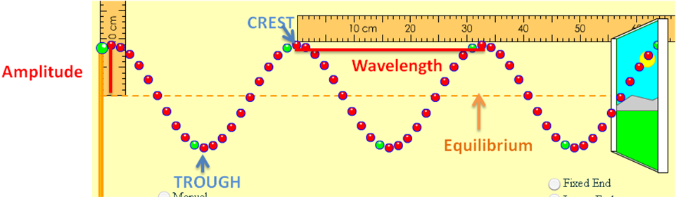

HOW TO MEASURE FREQUENCY
-Make sure screen is paused with the furthest left point on the medium is at a crest (like the picture above).
-On the stopwatch press ‘start/pause’. IT WON’T START…that’s ok, just wait.
-Read the following, AND THEN press start.
-Look only at the beginning of the wave (the orange pole on the left) and count 10 new crests being made.
-AS SOON AS the 10th crest occurs STOP the stopwatch. It may help to place the stop watch next to the beginning of the wave.

-Record this time, clear, and do this a MINIMUM of 3 times
-Average the times

Frequency is the number of occurrences of an oscillating or repeating event per second. We need to find out how many oscillations occur in one second so take our 10 oscillations we counted and divide it by our average time.

Did your frequency calculate out to be between 1.75 /s and 1.80 /s? If so, you are good to continue. If not, double check your set up, reread the steps above and continue.

Relationship 1

Let’s make a few quick observations.
-How does frequency affect amplitude?

-Set AMPLITUDE to 55. This will allow it to read ’10 cm’ on your vertical ruler
-Set up a data column with frequency as your x and amplitude as your y.
-Pick at LEAST 10 different frequency settings and record what happens to amplitude. FOR NOW, do not worry about calculating frequency.

- How does frequency affect amplitude?

Relationship 2

Maybe frequency is dependent on amplitude? Use your data gathering skills, gather enough data points, and determine if amplitude affects frequency.

- How does amplitude affect frequency?

Relationship 3

There is one more relationship we can easily measure today, and that is the relationship between frequency and wavelength. Since we change frequency to see what happens to wavelength frequency should be our independent variable in your set up.

Do a quick test, set frequency to 10 on the slider, then 100. Did the wavelength change?

- How did frequency affect wavelength?

Hmm..we have something here. Time to get GOOD data
-make sure for each frequency you calculate it like you did before (time 10 oscillations multiple times. Avg. the time data, then divide 10 by the avg. time). Do this for EACH frequency measurement.
-While still on a frequency, make sure you pause and measure the wavelength!
-Collect at least 10 different data points, and get a large range (some small frequencies, some large ones)!

When you have good data, go graph it! Don’t forget units; your ruler has units for wavelength, and frequency is in Hz, or /s. For our graph, use PER SECOND ( /s).

Graph questions
- What type of relationship is graphed?
- If there is a straight line linear relationship turn y=mx+b into an equation with our graph data. If not, turn your graph into a straight line first, then turn y=mx+b into our graph.
- Using your model, solve; if the frequency were 30 times per second, how large would the wavelength be?
- If the wavelength were 2 meters long, what would the frequency be?
- Look at the units for your slope. What does this slope represent about the wave?

CHECK WITH THE INSTRUCTOR AT THIS TIME FOR A QUICK DISCUSSION AND CHECK ON YOUR CONCLUSIONS.

END QUESTIONS

- The wavelength in the following picture is known to be 1.0 m long.
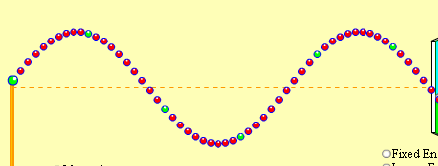
The length of the rope is...

- A wave is known to have a frequency of 20 Hz, wavelength of 0.5 m, and amplitude of 1.2 m. If the amplitude of the wave is doubled, the wave will have a frequency that is ______ as compared to the original wave.
a. double
b. larger
c. the same
d. smaller
e. one-half

- A wave is known to have a frequency of 20 Hz, wavelength of 0.5 m, and amplitude of 1.2 m. If the frequency of the wave is doubled, the wave will have an amplitude that is ______ as compared to the original wave.
a. double
b. larger
c. the same
d. smaller
e. one-half

- A wave is known to have a frequency of 20 Hz, wavelength of 0.5 m, and amplitude of 1.2 m. If the frequency of the wave is doubled, the wave will have a wavelength that is ______ as compared to the original wave.
a. double
b. larger
c. the same
d. smaller
e. one-half

- A wave is known to have a frequency of 20 Hz, wavelength of 0.5 m, and amplitude of 1.2 m. If the amplitude of the wave is doubled, the wave will have a speed that is ______ as compared to the original wave.
a. double
b. larger
c. the same
d. smaller
e. one-half

- A wave is known to have a frequency of 20 Hz and wavelength of 0.5 m. The speed of this wave is_________.

- A wave is traveling through a medium at 0.8 m/s with a wavelength of 0.4 meters. What is the frequency of the wave?

