Learning Goals: Students will be able to
- Calculate speed or height from information about a different position.
- Describe how different gravity fields effect the predictions.

Helpful hints: You can take measurements by using the Show Path button, then click on any purple dot to see the values. Make sure if you change any variables (like mass, location, character, etc) that you clear the path to get new purple points.
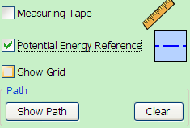
- Play with the features shown to the right and the purple dot data to understand what the data means. Then,
  - Explore how the values change when you move the PE reference line.

  - 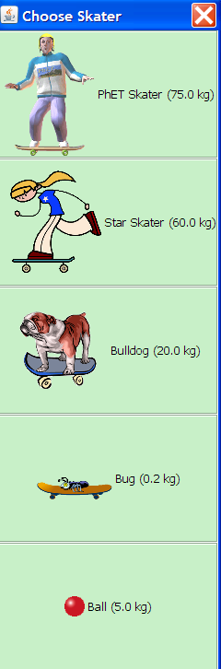Explore how the values change when you change the Skater. Remember that changing the Skater only changes the mass.

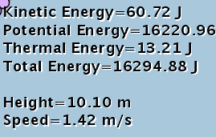
- Explain what is meant by the value called Height .

- Consider the following situation: You put the Skater on a track, Show Path and display the purple dot data. How could you predict the values for another place on the track?
  - Describe what you would have to measure.
  - Show an example of your proposed calculations for each value: KE, PE, TE, speed.
  - Test your ideas and include a screen capture with the purple dot data shown for both points that show that your calculations are correct. Show a corrected example of calculations if the data didn’t match your ideas.

- Describe what you think will change in your calculations if you move the Skater to Jupiter.
  - Describe what you would have to measure.
  - Show an example of your proposed calculations for each value: KE, PE, TE, speed.
  - Test your ideas and include a screen capture with the purple dot data shown to support your calculation or show corrected examples.
  - How do your calculations change if you take the Skater to the moon? Test your ideas and correct if necessary.

