Learning Goals: Students will be able to:
- Describe Energy -Pie, -Bar, and -Position Charts from position or selected speeds.
  - Explain how changing the Skater affects the situations above.
  - Explain how changing the surface friction affects the situations above.
- Predict position or estimate of speed from Energy -Pie, -Bar, and -Position Charts
- Look at the position of an object and use the Energy -Pie, -Bar, and -Position charts to predict direction of travel or change in speed.

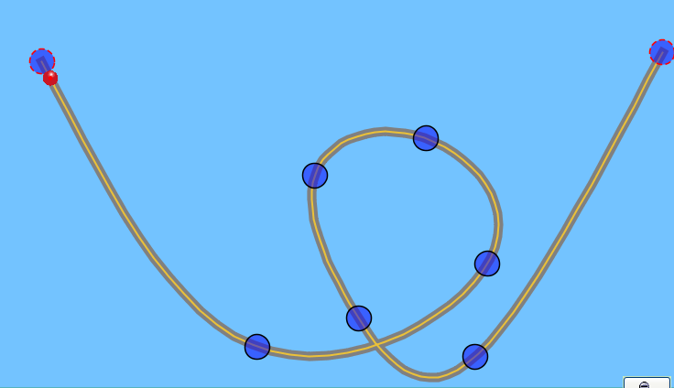
- Josie made a frictionless hot wheel track that looks like the one shown. She placed a red rubber ball on the left top of track at 1.
2
1
3
4
  - Make a data table like the one below
  - Fill in the Prediction column by sketching what you think the Pie chart will look like for the ball at points 1-4.
  - Use the Loop Track with the Ball Skater to test your ideas and make any adjustments

 | Pie chart
 | Prediction | Simulation | Explain differences
1
2
3
4

- Pretend that Josie can magically change the ball to different things like the simulation can.
  - What do you think would change about the Pie Charts?
  - Explain why you think the charts would similar or different.
  - Check your reasoning using the simulation and make corrections if necessary.

- Josie has a friend, Phillip that can magically change the friction on the track like the simulation can.
  - What do you think would change about the Pie Charts?
  - Explain why you think the charts would similar or different.
  - Check your reasoning using the simulation and make corrections if necessary.

- Work with your partner to build a track and sketch it.
  - Make a table like the one you did for question 1.
  - Predict what you think the charts will look like.
  - Use the simulation to check your ideas.
  - Test your ideas from questions 2 and 3. Make changes to your answers if necessary.

- Explain how you can use what you understand about pie charts to predict bar charts.

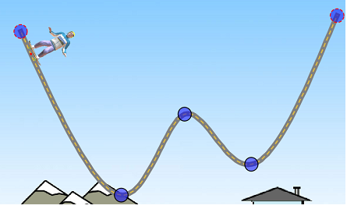
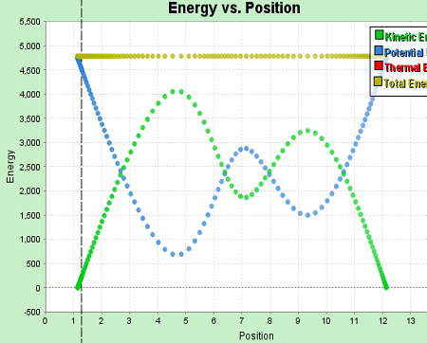
- Sketch this track and label where the 5 spots could be.

- He is at his maximum speed
- He is stopped
- He is going his average speed
- He is going slow
- He is going fast

- Sketch this energy-position graph and label where you think the same 5 spots are.
- Test your ideas using the Double Well Roller Coaster track.
- If one of your friends in the class asked you for help making sense of this type of graph, what would you say?

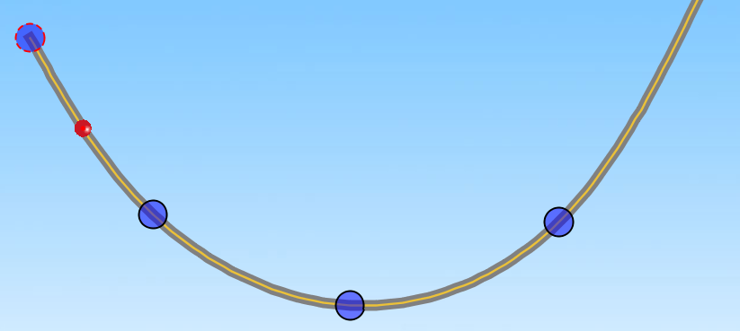8. Talk about how you could use the Energy -Pie, -Bar, and -Position charts to predict direction of the ball is rolling.
  - Check your ideas using the simulation.
  - Talk about how you could tell if the ball is going to be moving faster, the same, or slower.
  - Pretend you are writing a test for this unit.
Type a question that includes at least one type of graph and a Skater on a different track.
Then, give it to another group to see if they can predict the direction and changing speed of the ball.
Make sure to attach your question.

