Physics 2010 -- Fall 2006
Laboratory 3: Springs and Things

NAME ________________________
Section Day (circle): M Tu W Th F
Section Time: 8a 10a 12p 2p 4p
TA Name: _____________________

There is no prelab with this exercise.

Part A: Masses and Springs
This is a "virtual lab" . We will do an experiment using software which can be found at the PhET simulations page: http:phet.colorado.edu
Find the sim"Masses and Springs" and run it. You should see this:

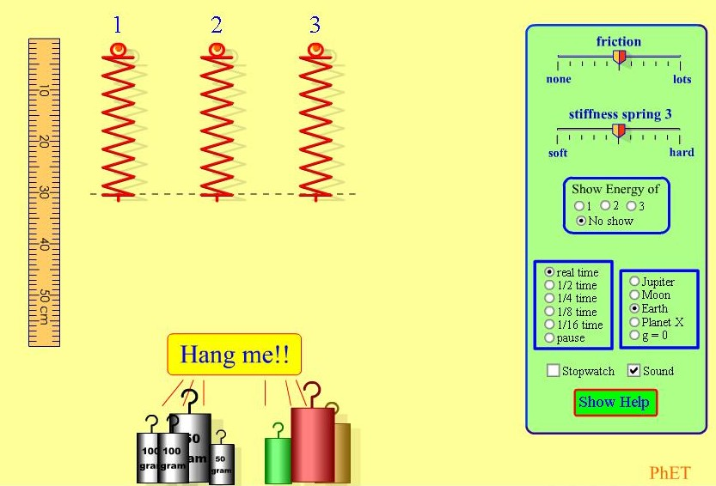

0) Play with this simulation for a while. Try to figure out what all the controls do.

1) Figure out a way to determine the spring constant k of Spring 1, and explain your reasoning.
Hints: Recall that the spring constant k is defined by Hooke's Law |F_{spring}| = k x , where x is the amount of stretch of the spring. Also, You can "zoom in" by right-clicking with the mouse The ruler can be moved by left-clicking and drag.

2) Make a graph of stretch x vs. mass hung. (Use the graph paper on next page). How could the spring constant k be determined this graph?

3) Using your results from part 1, determine the masses of the three colored unknown masses. Explain what reasoning you used to find the mass.

4) Determine the acceleration due to gravity on Planet X. Explain how you found the value.

Part B: Estimation

Many students are uncomfortable when asked to estimate some quantity. Nevertheless, being able to tell whether a number is in the right “ball-park” is a vital skill in many occupations. It's a skill that can only come with practice.

Estimating a length by comparing it to several smaller lengths, is relatively easy. For example, to find the length of a car you might count the number of paces in one car length if you know the length of your pace. Estimating an area or a volume is a bit more complex. This first section is designed to help you learn some area and volume estimation techniques.

- On the PhET website , run the Estimation simulation and select “Train” and then “Strategy Help”. Work through the area and volume examples, then explain how you could use small, easily estimated lengths to figure out the surface area of a larger object.

- Repeat the above, explaining how to estimate volume from small, easily estimated lengths.

- Your TA will ask you to estimate some physical quantities (like the distance to a wall or the number of beans in a jar). Confer with your partners, and write down your estimates, along with you reasoning.

- Now explore the “Play” feature in "Estimation" until you are comfortable with the rules. When you have practiced for a while, set the difficulty at Level 3, and make at least 20 estimates before ending the game. Your goal is to get the highest possible score/time value (highest score in the least time). You can try as many times as you like, but have your TA verify your score before you try again. Best score will receive a prize!

