ANSWERS & RUBRIC NRG SK8R 20 points
Energy Skate Park Simulation

Learning Goal:
The purpose of the energy skate park simulation is to see how energy gets transferred in a real world application. You will draw graphs to represent how energy changes. In this simulation you will manipulate the skater and friction to see the affect of these on a skater who behaves according to the laws of physics.

PART 1: Use what you already know to make predictions
Before you start playing with the simulation, you will apply what you know so far about potential, kinetic, thermal, and total energy to predict how these different types of energy will change as a skater rolls back and forth on a half-pipe.

Describe the terms listed below in a complete sentence (or complete sentences):
Potential Energy ½ point
Stored energy

Kinetic Energy ½ point
Energy of motion

Thermal Energy ½ point
Heat energy—often from friction

Total Energy ½ point
Sum of all energies

Energy Transfer without Friction
If there is no friction, what type of energy do we not have? 1 point
Thermal energy

Energy Transfer with Friction
How will the presence of friction affect the skater and the energies you described above? 1 point
The skater will not roll back and forth forever. He will eventually come to a stop. There will be thermal energy which keeps increasing. Over time, the kinetic energy and potential energies will decrease too (but still oscillate), until he stops at the bottom and then they will be 0.
Without Friction
Predict what an energy-time graph for each type of energy would look like as the skater goes back and forth on the half-pipe without friction. You will draw two full cycles (back and forth, back and forth). A grid is provided for you so you can think of scale when drawing all of the graphs. Top Right (TR), Bottom (B), and TL (Top Left) are where the skater is at that time.

TR
TL
B

1.5 points per graph—6 points total
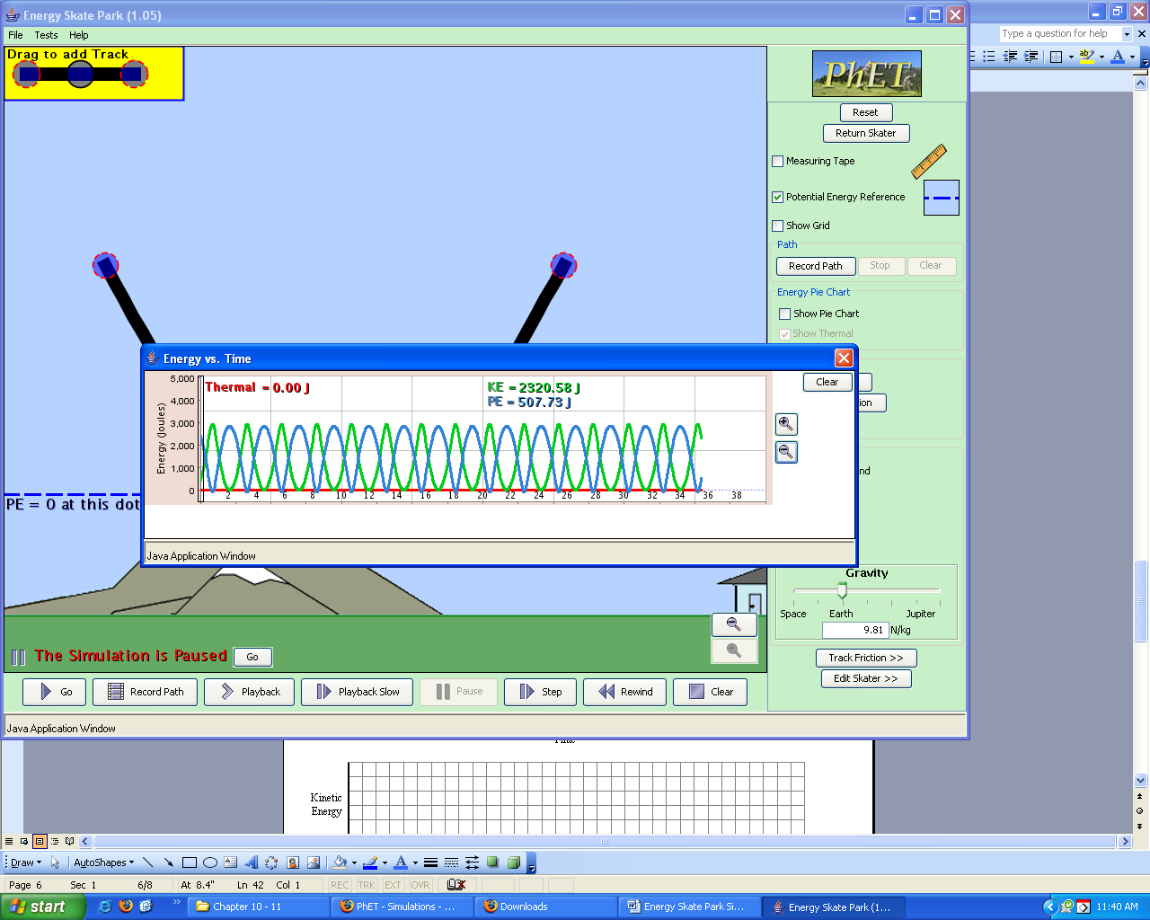
Total Energy
Kinetic Energy
Potential Energy
Thermal Energy

With Friction

TR
TL
B
Now in an environment with friction, some of the energy is converted (or some say “lost”) to heat (thermal energy). Again, you will predict the energy graphs, but this time with friction. You will draw four full cycles (back and forth four times). A grid is provided for you so you can think of scale when drawing all of the graphs. (The Total Thermal Energy graph is all of the heat created so far. This graph can only go up, not down!)

1.5 points per graph—6 points total

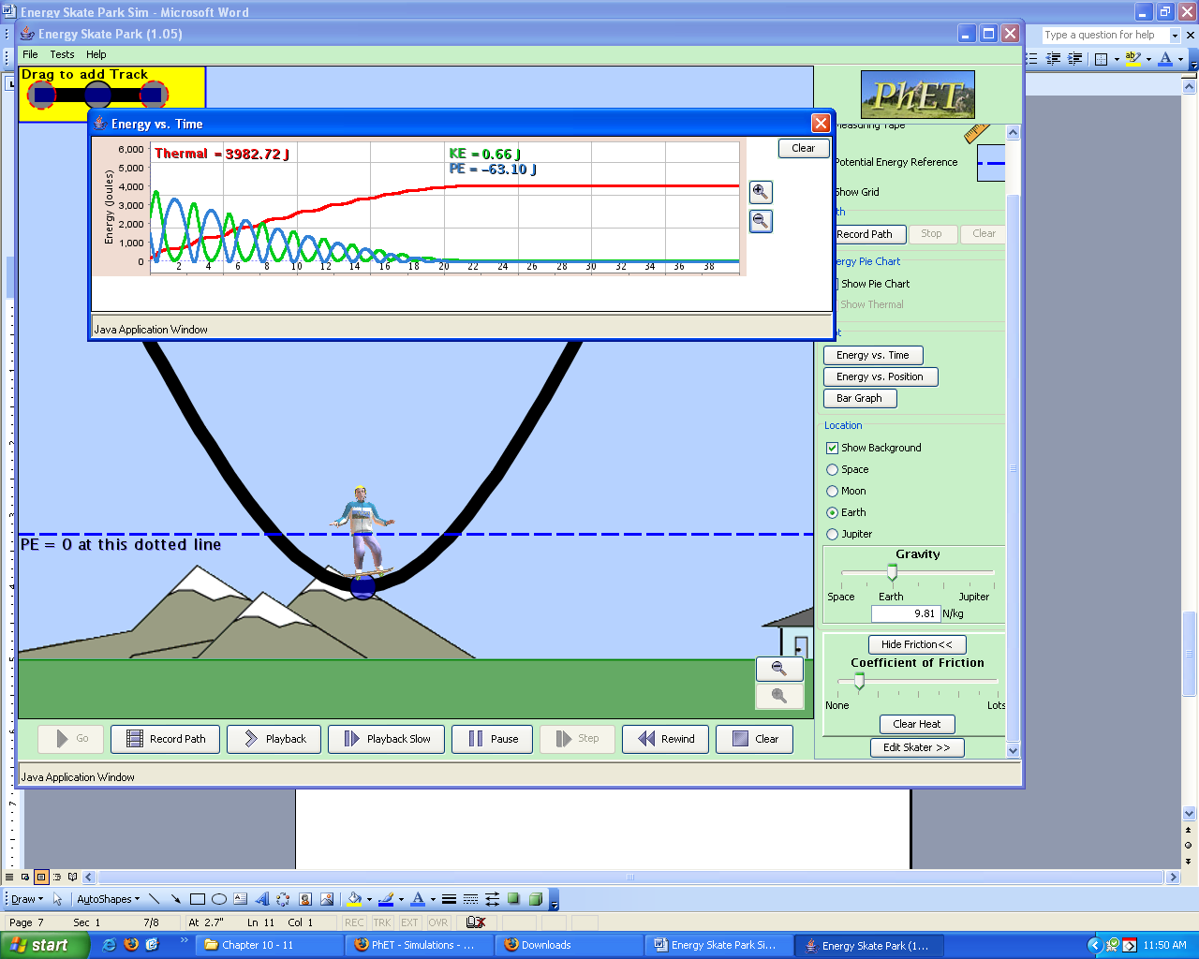
Total Energy
Kinetic Energy
Potential Energy
Thermal Energy

PART 2: Check your predictions with the Energy Skate Park Simulation

Open FIREFOX only. Either type in: http://www.colorado.edu/physics/phet or Google “phet”.
Click on Simulations, then Work, Energy, and Power on the left side. Click on Energy Skate Park.

SIMULUATION TIME!
Take some time (~5 minutes) to play with the simulation, keeping just the plain half-pipe given for now. Check out all of the features!

- According to your predictions, what do you think the potential energy of the skater is at the bottom of the half-pipe? ½ point
Zero

- Using the energy bar graph, does the simulation agree with your answer? Explain. ½ point
No, it never drops all the way to zero.

- You will probably discover that it doesn’t. Play around with the potential energy reference until you and the simulation agree. What did you need to do to make you and the simulation agree? Why? 1 point
You need to move the potential energy reference line to his center of gravity. Then, his potential energy will be zero at the bottom of the track.
OR
You can move the bottom of the track to the ground.

- Now go back and simulate the motion both without friction and check your graph predictions. (Make sure you leave the potential energy reference line where you set it in #3.) In another color, fix your graphs. Do NOT erase your original predictions!

- Now go back and simulate the motion both with friction and check your graph predictions. (Make sure you leave the potential energy reference line where you set it in #3.) In another color, fix your graphs. Do NOT erase your original predictions!

- What does this simulation tell you about conservation of energy? Explain in detail what conservation of energy means and how the simulation shows that energy is conserved. 1 point
While each individual energy fluctuates, the total energy always remains the same. It is just transferred between other energies.

- If energy needs to be conserved, how can the kinetic energy of the skater change throughout his motion? Explain in detail! 1 point
His kinetic energy can go down because the potential energy is going up. Each energy doesn’t need to stay the same, just the SUM of the energies.

PART 3: Building a Cool Skate Track
Build a cool track and make sure it works well! You can turn friction on or off—doesn’t matter. When you have something cool, show me!

