Photoelectric Effect with PhET simulation

Background:
Students should be familiar with the work of Max Planck.

Learning goals:

1. Freely explore the Photoelectric Effect Simulation. The screen should look like this.

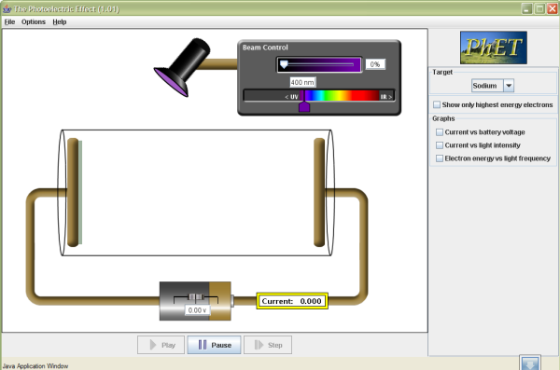

- Can you think of any application of this effect in your daily life, or can you imagine some uses for it?
- What variables can you change in this simulation?
- From your knowledge of light energy, electrons, wavelength, and frequency, predict the graph of the electron energy as function of wavelength by sketching
the graph below. 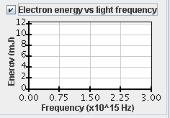

- Set the wavelength to 500 nm, calculate the frequency from the relation between wavelength, speed and frequency.
- Use the simulation to do a controlled experiment to verify your prediction. Beginning with the plates made of sodium, keep all the parameters constant except for the color (frequency) of the light. You can then enable the graph of the electron energy vs. light frequency.

The activities above come from Donald Collins a member of the PhET TEAM.

6. List other physics concepts that have been confirmed or learned after your free exploration of this simulation.

If you have trouble answering the following questions, investigate the simulation again, look in your text, use the internet, look in the Handbook of Chemistry and Physics, or check with your neighbor.

- Have the light source turned on and battery set to zero volts. Adjust the color of the source until electrons just begin to be ejected from the sodium surface. Note their speed. As you shorten the wavelength of the light source, what change did you notice about electron speed? Explain the cause of the change.
- Define electric current.
- Investigate which of the 6 available surfaces (sodium, zinc, copper, etc.) is most optically sensitive. That is, which surface ejects electrons with the longest wavelength, lowest energy, light source? Be sure battery voltage is set to zero. Make a table of surface type versus wavelength required to just start a current flow.
10.Which surface is must sensitive?
11.What is the probable composition of the unknown surface?
- An options choice is available on the menu bar at the top of the screen. Photons can be toggled on or off. What is the purpose of this option?
- Lets check the accuracy of this simulation. The battery can supply either an accelerating (+) or a “bucking” (-) voltage. Shine a 400 nm bright light on a sodium surface. What is the bucking voltage that will just turn off current flow?
14.Using the above data and the formula E = hf, find Planck’s constant → h.
15.What is the percent of error in the calculation of h?
- With a light shining on the photoelectric tube and electrons being ejected, what connection, if any, should there be between battery voltage and current?
17.Turn on the current vs. battery voltage graph and see if you were correct.
18. You probably noticed the graph has a knee where the slope goes to zero. What is the explanation for this?
19. What should be the connection, if any, between electric current and light intensity?
20.Turn on the current vs. intensity graph. Does it behave as you expected?
21. This graph has no knee. Why?
22. What other new physics, if any, did you learn while using this simulation?

