Learning Goals: Students will be able to
- Explain vector representations in their own words
- Convert between the of angular form of vectors and the component form
- Add vectors
- Calculate % error using the best measurement for the expected value

Background:
My students did my first Vector Addition activity: Introduction to Vector math, then we did this lab. I have done this lab for many years and students struggle with making sense of how two forces like 1.2n and 1.3n can add to 1.4n. This year, using the simulation, went much better. My vector addition quiz had very high scores.
As I mentioned in the other lesson plan, my students do not have much exposure to vector math from math classes even if they have had calculus. I do not have a student handout, but I explain how to do the lab.

Materials: Three spring scales, protractors, rulers and a computer with Vector Math for each group. If you have force tables, they would work very well.

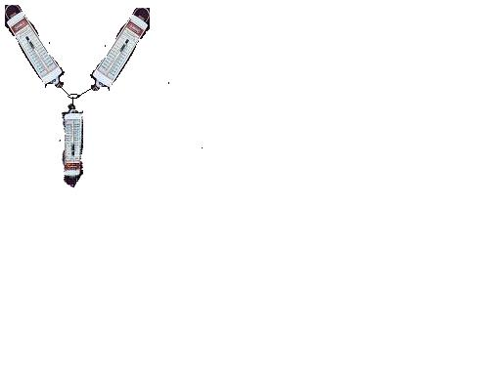
Class discussion: I connect three scales and then duct-tape them to a piece of cardboard as shown in the figure to the left. We talk about the fact that the forces should add to zero. In my class, we use % error to make sense out of how well experiments match ideal physics relationships:
1
2
3
We discuss that using the fact that the sum of the three should be zero would lead to an undefined answer. So we use the idea that the sum of two of the vectors should equal the third. ie:

I draw this on the board making sure that I use the same colors as the simulation. We discuss that the sum should have the same magnitude as the third force (We ignore the angle for this experiment because it is only the second day of vector math).
1
2
sum
Then we discuss how the students might add the two vectors by breaking the vectors into components. (I do not have them add vectors by construction because I have found that their drawing skills interfere with understanding the basic idea of vector addition). I project the simulation and ask the students how they could use the sim to help them make sense of the addition (turning off the Show sum). I start with Style 2 as shown on the right , but go through all three styles emphasizing that students can chose any style that helps them make sense of vector addition. We discuss the math that we will do and the fact that we can check each step using the display │R│, θ, R_{x}, R_{y}.
1
2
For example: R_{x1}= Force reading on scale 1* cosθ (θ measured acutely from –y axis).
From there I let them work in groups, taping down a set of scales to their tabletops. I require that each person record the data and show the work required to find the % error. They are to use the simulation to check their reasoning. I move around the room asking probing questions and helping students with measuring angles.
The groups are instructed to have me check their work after they finish a trial. Then they do another trial. In addition, they are asked to write a summary paragraph of their results including a description of why the error is not zero.

The next day: I handed out the problems worksheet. They worked on 1 and 2 while I went around the room checking for learning. After that, they put up the sheet to finish at home.

