Name______________________________ Teacher________ Per____ Date______________________
Moving Man Graphs: Accelerating and Decelerating
Learning goals: Students will be able to
- describe how a person moved by looking at motion graphs
- sketch the motion graphs when the person’s motion is described

- Joe is training for the “Race for the Cure” run. His coach wants him to get better at starting. He practices speeding up from the start to a running speed of 10 m/s. His coach records his motion using a motion detector. After his run, Joe and his coach will use the graphs to analyze his starts. Sketch what you think the motion graphs will look like.
Motion graphs | Why do you think they will look like this?
time
time
time
position
velocity
acceleration

- Open Moving Man. Check your understanding by using the acceleration slider.
- Make any changes to your graphs using a different color pen or pencil.
- After practice, Joe and his coach look at the graphs and notice that it shows Joe speeding up. Finish their comments.
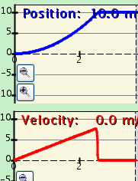
Look, Joe – the velocity graph is …
You’re right, Coach. Also, the position graph shows that I’m speeding up because it …
- The coach tells Joe to run again, and to accelerate more this time. That is, she wants him to try to speed up more quickly this time.
Motion Graphs
time
time
time
position
velocity
acceleration
- Sketch what you predict the graphs will look like.
- Check your prediction using the Moving Man.
- Make any changes to your graphs using a different color pen or pencil.

- The coach explains to Joe why the graphs above look different than the first set. Finish their conversation.
Yes, and the velocity graph…

because…

Look, Joe – the position graph…

because…

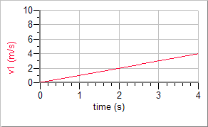
- These graph show the velocity of two different people. Draw a picture to go along with the graph. Then write a story that describes their different motions.
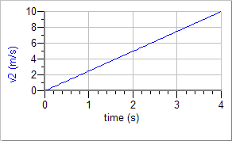
Picture | Story
- Draw what you think the position-time graphs would look like for the story you just wrote.
position First Person’s Motion
position Second Person’s Motion

time
time

- At the end of the race, Joe gradually slows down to a stop. Draw what you think the graphs will look like. Explain why you think they will look that way.

Position graph | Velocity Graph | Acceleration Graph
position  time  velocity  time | acceleration | time
Why do you think it will look like this? | Why do you think it will look like this? | Why do you think it will look like this?

- Now use Moving Man. Were your graphs both correct? ____ If not, go back, and draw the correct curve in a different color pencil or pen.

- Take out your Warm-Up activity for today and check your answer to the last problem. Now that you’ve studied graphs of “speeding up”, do you need to change your answer?_____. Change it in a different color pencil or pen, if you need to.

