Name __________________________ Teacher_________ Per_____ Date__________________
The Lifelike Moving Man

Learning goals: Students will be able to identify the following types of motion -- constant nonzero velocity, constant acceleration, not moving -- from graphs that are not smooth.
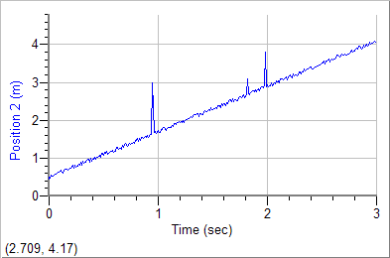
- Your friend was moving in front of the motion detector and you saw a graph like the one here.

  - How do you think your friend was moving?

  - Talk to your neighbors and compare thoughts.

  - What do you think might have caused the spikes?

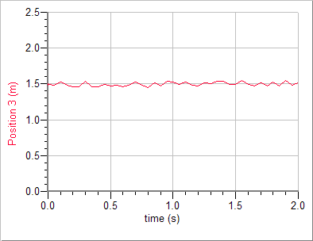
- Your classmate has just did the motion graph lab, and shows you this graph on her computer.
  - How do you think she was moving?

  - What do you think caused the “wiggles” in her graph?

- Open the Moving Man simulator.
  - For the left column, move the man using the sliders. Then draw your graph.
  - For the middle column, move him by dragging him. Then draw your graph.
Motion: The man walks forward at a constant speed.
Sliders (simplified motion) | Dragging (lifelike motion) | How are these graphs different? How are they similar?
Position-time | Position-time | Different:  Similar:
Velocity-time | Velocity-time | Different:  Similar:
Acceleration-time | Acceleration-time | Different:  Similar:

Motion: The man is hanging out by the tree, not moving.
Sliders (simplified motion) | Dragging (lifelike motion) | How are these graphs different? How are they similar?
Position-time | Position-time | Different:  Similar:
Velocity-time | Velocity-time | Different:  Similar:
Acceleration-time | Acceleration-time | Different:  Similar:
Motion: The man is a track runner, training for a race. He starts at rest at the tree, and then starts running faster and faster (accelerating) until he is at the house.
Sliders (simplified motion) | Dragging (lifelike motion) | How are these graphs different? How are they similar?
Position-time | Position-time | Different:  Similar:
Velocity-time | Velocity-time | Different:  Similar:
Acceleration-time | Acceleration-time | Different:  Similar:

- These plots were created by dragging the man.
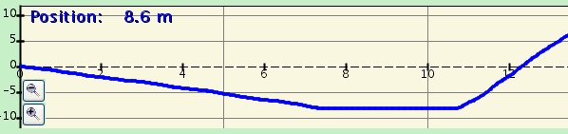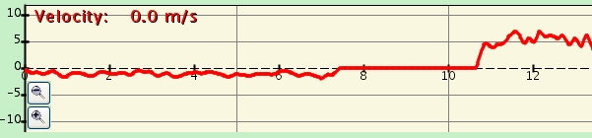
  - Write a story about the man’s movement.

  - Which graph helped you the most to understand the motion? Why was it helpful?

- Get out your “warm-up” graphs. Fill in the right column with more lifelike graphs.

