Photoelectric Effect with PhET simulations.

Learning goals:

1. Freely explore the Photoelectric Effect Simulation. The screen should look like this.

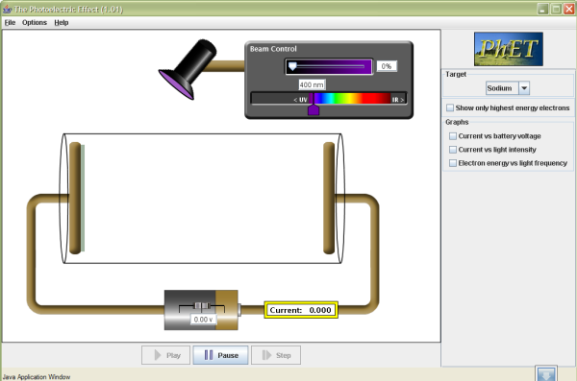

- Can you think of any application of this effect in your daily life, or can you imagine some uses for it?

- What variables can you change in this simulation? List the answers below.

- From your knowledge of light energy, electrons, wavelength, and frequency, predict the graph of the electron energy as function of wavelength by sketching the graph below. 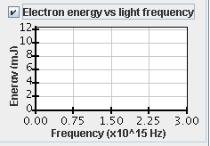

- Set the wavelength to 500 nm, calculate the frequency from the relation between wavelength, speed and frequency.

- Use the simulation to do a controlled experiment to verify your prediction. Beginning with the plates made of sodium, keep all the parameters constant except for the color (frequency) of the light. You can then enable the graph of the electron energy vs. light frequency.

