Learning Goals: Students will be able to explain (my notes in italics)
- How a converging lens makes images. (real and virtual using ray diagrams)
- How changing the lens (radius, index and diameter) effects where the image appears and how it looks (magnification and inversion, Brightness and clarity may be easily addressed by demonstration, but I did not include any student directions). What features a lens would need for real applications?

Things that are well demonstrated by the sim are:
- Effects of curvature and index: the change in focal length, the image position and size
- Diameter effects brightness of image.
- Ray bending.
- Inversion well.
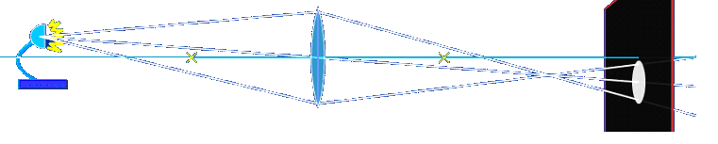
- With the Rays off, and the Screen on, you can show how the image is visible but not clear except at one point. The screen feature may give students some things that are difficult to understand like this:

- Show guides doesn’t seem to have a use for my class

Background: I’ll show a real image formed by a convex lens by projecting something outside through the window onto a note card and also use a light bulb to project an image. The class will do a converging lens lab. I’ll attach my lab to this activity. They will then use this activity to help explain the results of the lab.

Lesson: The students will need their lens lab results. The activity calls for having magnifying lenses available.

Geometric Optics Introduction: I’ll project the sim with Screen on and NO Rays. I’ll show how the image is visible but not clear except at one point where the light is small and bright. I will also turn the Screen off and talk about light is also coming off objects that don’t have their own light source. I’ll demonstrate again how a magnifying lens makes an image and point out that the light form outside is visible on the card often, but that there is only one position that gives a clear image.

After the activity, good discussion questions would be: Why can’t you make projections with a flat piece of glass? I want to project a picture of a small demonstration on the wall for you to see. If I use a magnifying lens, how do I decide where to hold the lens?

