Learning Goals:
Students will be able to:
- Define harmonic, determine the relationship between the harmonics,
- Explain the relationship between harmonics and the corresponding wave function.
- Predict what happens when more than one wave is present.

- Investigate what harmonics are and describe in your own words what harmonic means to you. (You can use the Wavelength tool to determine a mathematical relationship between harmonics)

- Investigate Functions using the Select Function tool and Harmonics slider. Describe the findings of your investigation.

- Use the simulation to make a Sum Graph that looks like the graph below using only 2 harmonics. It’s important to match both the x and y axes. Draw your Harmonics Graph, record the Amplitudes that you used, and describe what you thought about as you tried to match the graph.
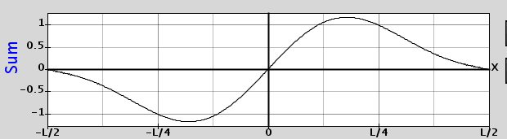
- Use your thoughts from the previous questions to draw what you think the Sum Graph will look like for the harmonics displayed below.
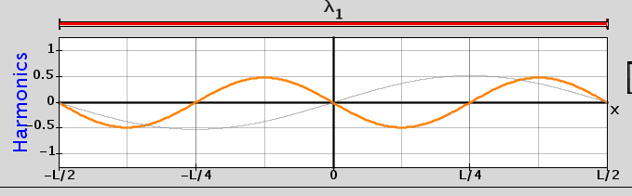
Use the simulation to test your prediction and make corrections with a different color pen. Record the amplitudes that you used and write a plan for how you could predict the sum of waves.

- Use your predictions ideas to draw the sum of these waves.
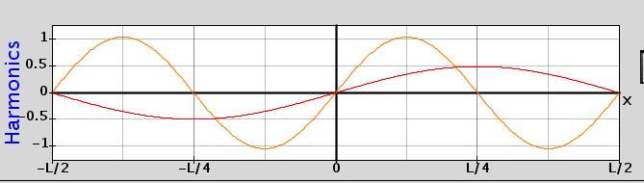

Test your ideas using the simulation. Make corrections on the predicted graph with a different color pen. Correct your plans for prediction also.

- Design a test for your ideas on wave addition. Explain in detail your experiment and the results. Include evidence that your prediction method is repeatable.

